[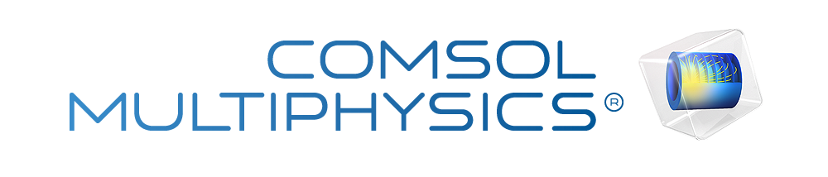](http://www.comsol.com/)

Untitled

|  |  |
| --- | --- |
| Report date | Apr 18, 2025 11:45:43 AM |

Contents

1. Global Definitions

1.1. Parameters 1

2. Component 1

2.1. Definitions

2.2. Geometry 1

2.3. Materials

2.4. Solid Mechanics

2.5. Electrostatics

2.6. Electrical Circuit

2.7. Multiphysics

2.8. Mesh 1

3. Study 1

3.1. Parametric Sweep

3.2. Stationary

3.3. Solver Configurations

4. Results

4.1. Data Sets

4.2. Plot Groups

1. Global Definitions

|  |  |
| --- | --- |
| Date | Apr 14, 2025 11:29:56 AM |

Global settings

|  |  |
| --- | --- |
| Name | PEG analysis.mph |
| Path | C:\Users\saite\Documents\PEG analysis.mph |
| COMSOL version | COMSOL 5.2a (Build: 152) |
| Unit system | SI |

Used products

|  |
| --- |
| COMSOL Multiphysics |
| CAD Import Module |
| MEMS Module |

* 1. Parameters 1

Parameters

| **Name** | **Expression** | **Value** | **Description** |
| --- | --- | --- | --- |
| R_load | 12[kohm] | 12000 Ω | load resistance |
| acc | 1 | 1 | acceleration |

1. Component 1

|  |  |
| --- | --- |
| Date | Apr 14, 2025 10:33:34 AM |

Component settings

|  |  |
| --- | --- |
| Unit system | SI |
| Geometry shape order | automatic |

* 1. Definitions
     1. Coordinate Systems

#### Boundary System 1

|  |  |
| --- | --- |
| Coordinate system type | Boundary system |
| Tag | sys1 |

Coordinate names

| **First** | **Second** | **Third** |
| --- | --- | --- |
| t1 | t2 | n |

* 1. Geometry 1

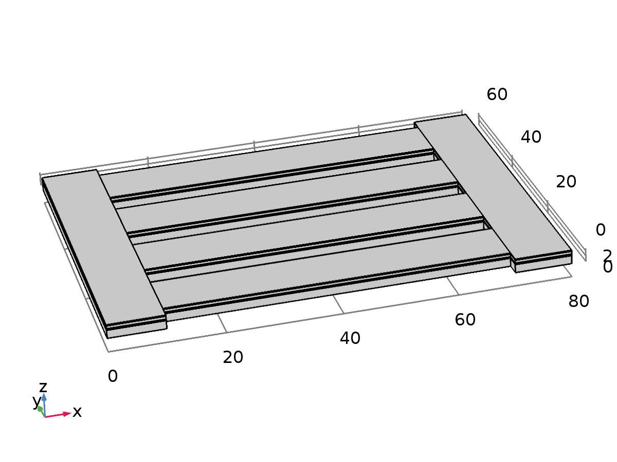

Geometry 1

Units

|  |  |
| --- | --- |
| Length unit | µm |
| Angular unit | deg |

Geometry statistics

| **Description** | **Value** |
| --- | --- |
| Space dimension | 3 |
| Number of domains | 30 |
| Number of boundaries | 196 |
| Number of edges | 312 |
| Number of vertices | 144 |

* + 1. silicon (blk1)

Position

| **Description** | **Value** |
| --- | --- |
| Position | {0, 0, 0} |

Axis

| **Description** | **Value** |
| --- | --- |
| Axis type | z - axis |

Size and shape

| **Description** | **Value** |
| --- | --- |
| Width | 10 |
| Depth | 60 |
| Height | 1.5 |

* + 1. free base si (blk2)

Position

| **Description** | **Value** |
| --- | --- |
| Position | {10, 2.5, 0} |

Axis

| **Description** | **Value** |
| --- | --- |
| Axis type | z - axis |

Size and shape

| **Description** | **Value** |
| --- | --- |
| Width | 60 |
| Depth | 10 |
| Height | 1.5 |

* + 1. Sio2 (blk3)

Position

| **Description** | **Value** |
| --- | --- |
| Position | {10, 2.5, 1.5} |

Axis

| **Description** | **Value** |
| --- | --- |
| Axis type | z - axis |

Size and shape

| **Description** | **Value** |
| --- | --- |
| Width | 60 |
| Depth | 10 |
| Height | 0.1 |

* + 1. BE (blk4)

Position

| **Description** | **Value** |
| --- | --- |
| Position | {10, 2.5, 1.6} |

Axis

| **Description** | **Value** |
| --- | --- |
| Axis type | z - axis |

Size and shape

| **Description** | **Value** |
| --- | --- |
| Width | 60 |
| Depth | 10 |
| Height | 0.2 |

* + 1. PEM (blk5)

Position

| **Description** | **Value** |
| --- | --- |
| Position | {10, 2.5, 1.8} |

Axis

| **Description** | **Value** |
| --- | --- |
| Axis type | z - axis |

Size and shape

| **Description** | **Value** |
| --- | --- |
| Width | 60 |
| Depth | 10 |
| Height | 0.5 |

* + 1. TE (blk6)

Position

| **Description** | **Value** |
| --- | --- |
| Position | {10, 2.5, 2.3} |

Axis

| **Description** | **Value** |
| --- | --- |
| Axis type | z - axis |

Size and shape

| **Description** | **Value** |
| --- | --- |
| Width | 60 |
| Depth | 10 |
| Height | 0.2 |

* + 1. Union 1 (uni1)

Settings

| **Description** | **Value** |
| --- | --- |
| Keep input objects | On |

* + 1. Array 1 (arr1)

Settings

| **Description** | **Value** |
| --- | --- |
| Size | 4 |
| Array type | Linear |
| Displacement | {0, 15, 0} |

* + 1. base Sio2 (blk7)

Position

| **Description** | **Value** |
| --- | --- |
| Position | {0, 0, 1.5} |

Axis

| **Description** | **Value** |
| --- | --- |
| Axis type | z - axis |

Size and shape

| **Description** | **Value** |
| --- | --- |
| Width | 10 |
| Depth | 60 |
| Height | 0.1 |

* + 1. base BE (blk8)

Position

| **Description** | **Value** |
| --- | --- |
| Position | {0, 0, 1.6} |

Axis

| **Description** | **Value** |
| --- | --- |
| Axis type | z - axis |

Size and shape

| **Description** | **Value** |
| --- | --- |
| Width | 10 |
| Depth | 60 |
| Height | 0.2 |

* + 1. PEM 1 (blk9)

Position

| **Description** | **Value** |
| --- | --- |
| Position | {0, 0, 1.8} |

Axis

| **Description** | **Value** |
| --- | --- |
| Axis type | z - axis |

Size and shape

| **Description** | **Value** |
| --- | --- |
| Width | 10 |
| Depth | 60 |
| Height | 0.5 |

* + 1. TE 1 (blk10)

Position

| **Description** | **Value** |
| --- | --- |
| Position | {0, 0, 2.3} |

Axis

| **Description** | **Value** |
| --- | --- |
| Axis type | z - axis |

Size and shape

| **Description** | **Value** |
| --- | --- |
| Width | 10 |
| Depth | 60 |
| Height | 0.2 |

* + 1. Mirror 1 (mir1)

Settings

| **Description** | **Value** |
| --- | --- |
| Keep input objects | On |

Point on plane of reflection

| **Description** | **Value** |
| --- | --- |
| Point in plane | {40, 0, 0} |

Normal vector to plane of reflection

| **Description** | **Value** |
| --- | --- |
| Plane normal | {1, 0, 0} |

* 1. Materials
     1. Si - Polycrystalline Silicon

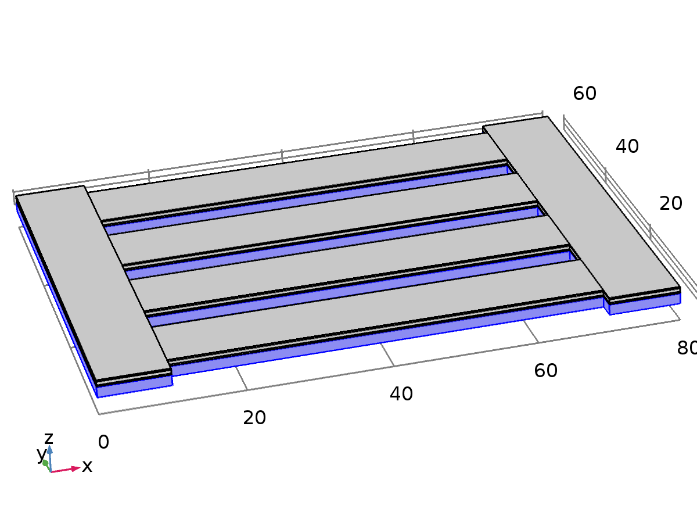

Si - Polycrystalline Silicon

Selection

|  |  |
| --- | --- |
| Geometric entity level | Domain |
| Selection | Domains 1, 6, 11, 16, 21, 26 |

Material parameters

| **Name** | **Value** | **Unit** |
| --- | --- | --- |
| Relative permittivity | 4.5 | 1 |
| Density | 2320[kg/m^3] | kg/m³ |
| Young's modulus | 160e9[Pa] | Pa |
| Poisson's ratio | 0.22 | 1 |

Basic Settings

| **Description** | **Value** |
| --- | --- |
| Coefficient of thermal expansion | {{2.6e-6[1/K], 0, 0}, {0, 2.6e-6[1/K], 0}, {0, 0, 2.6e-6[1/K]}} |
| Heat capacity at constant pressure | 678[J/(kg*K)] |
| Relative permittivity | {{4.5, 0, 0}, {0, 4.5, 0}, {0, 0, 4.5}} |
| Density | 2320[kg/m^3] |
| Thermal conductivity | {{34[W/(m*K)], 0, 0}, {0, 34[W/(m*K)], 0}, {0, 0, 34[W/(m*K)]}} |

Young's modulus and Poisson's ratio Settings

| **Description** | **Value** |
| --- | --- |
| Young's modulus | 160e9[Pa] |
| Poisson's ratio | 0.22 |

* + 1. Au - Gold

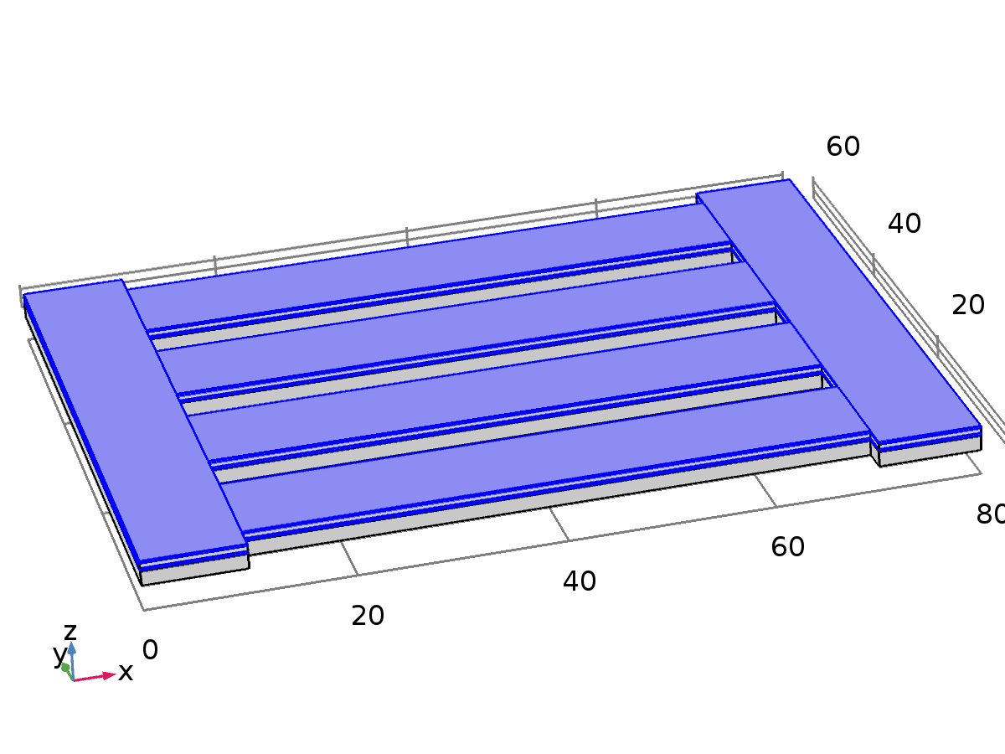

Au - Gold

Selection

|  |  |
| --- | --- |
| Geometric entity level | Domain |
| Selection | Domains 3, 5, 8, 10, 13, 15, 18, 20, 23, 25, 28, 30 |

Material parameters

| **Name** | **Value** | **Unit** |
| --- | --- | --- |
| Density | 19300[kg/m^3] | kg/m³ |
| Relative permittivity | 6.9 | 1 |
| Young's modulus | 70e9[Pa] | Pa |
| Poisson's ratio | 0.44 | 1 |

Basic Settings

| **Description** | **Value** |
| --- | --- |
| Electrical conductivity | {{45.6e6[S/m], 0, 0}, {0, 45.6e6[S/m], 0}, {0, 0, 45.6e6[S/m]}} |
| Coefficient of thermal expansion | {{14.2e-6[1/K], 0, 0}, {0, 14.2e-6[1/K], 0}, {0, 0, 14.2e-6[1/K]}} |
| Heat capacity at constant pressure | 129[J/(kg*K)] |
| Density | 19300[kg/m^3] |
| Thermal conductivity | {{317[W/(m*K)], 0, 0}, {0, 317[W/(m*K)], 0}, {0, 0, 317[W/(m*K)]}} |
| Relative permittivity | {{6.9, 0, 0}, {0, 6.9, 0}, {0, 0, 6.9}} |

Young's modulus and Poisson's ratio Settings

| **Description** | **Value** |
| --- | --- |
| Young's modulus | 70e9[Pa] |
| Poisson's ratio | 0.44 |

Stress-charge form Settings

| **Description** | **Value** |
| --- | --- |
| Elasticity matrix (ordering: xx, yy, zz, yz, xz, xy) | {{, 0, 0, 0, 0, 0}, {0, , 0, 0, 0, 0}, {0, 0, , 0, 0, 0}, {0, 0, 0, , 0, 0}, {0, 0, 0, 0, , 0}, {0, 0, 0, 0, 0, }} |
| Coupling matrix | {{, , , , , }, {, , , , , }, {, , , , , }} |
| Relative permittivity | {{6.9, 0, 0}, {0, 6.9, 0}, {0, 0, 6.9}} |
| Loss factor for elasticity matrix cE | {{0, 0, 0, 0, 0, 0}, {0, 0, 0, 0, 0, 0}, {0, 0, 0, 0, 0, 0}, {0, 0, 0, 0, 0, 0}, {0, 0, 0, 0, 0, 0}, {0, 0, 0, 0, 0, 0}} |
| Loss factor for coupling matrix e | {{0, 0, 0, 0, 0, 0}, {0, 0, 0, 0, 0, 0}, {0, 0, 0, 0, 0, 0}} |
| Loss factor for electrical permittivity εS | {{0, 0, 0}, {0, 0, 0}, {0, 0, 0}} |

* + 1. SiO2 - Silicon oxide

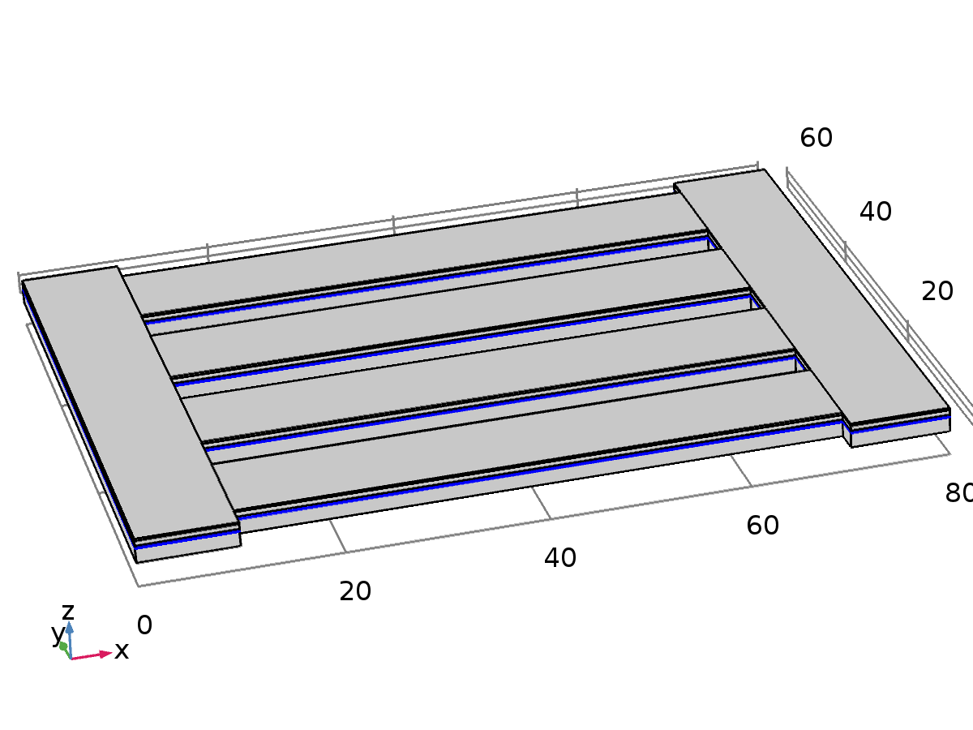

SiO2 - Silicon oxide

Selection

|  |  |
| --- | --- |
| Geometric entity level | Domain |
| Selection | Domains 2, 7, 12, 17, 22, 27 |

Material parameters

| **Name** | **Value** | **Unit** |
| --- | --- | --- |
| Relative permittivity | 4.2 | 1 |
| Density | 2200[kg/m^3] | kg/m³ |
| Young's modulus | 70e9[Pa] | Pa |
| Poisson's ratio | 0.17 | 1 |

Basic Settings

| **Description** | **Value** |
| --- | --- |
| Electrical conductivity | {{0[S/m], 0, 0}, {0, 0[S/m], 0}, {0, 0, 0[S/m]}} |
| Coefficient of thermal expansion | {{0.5e-6[1/K], 0, 0}, {0, 0.5e-6[1/K], 0}, {0, 0, 0.5e-6[1/K]}} |
| Heat capacity at constant pressure | 730[J/(kg*K)] |
| Relative permittivity | {{4.2, 0, 0}, {0, 4.2, 0}, {0, 0, 4.2}} |
| Density | 2200[kg/m^3] |
| Thermal conductivity | {{1.4[W/(m*K)], 0, 0}, {0, 1.4[W/(m*K)], 0}, {0, 0, 1.4[W/(m*K)]}} |

Young's modulus and Poisson's ratio Settings

| **Description** | **Value** |
| --- | --- |
| Young's modulus | 70e9[Pa] |
| Poisson's ratio | 0.17 |

* + 1. Lead Zirconate Titanate (PZT-5H)

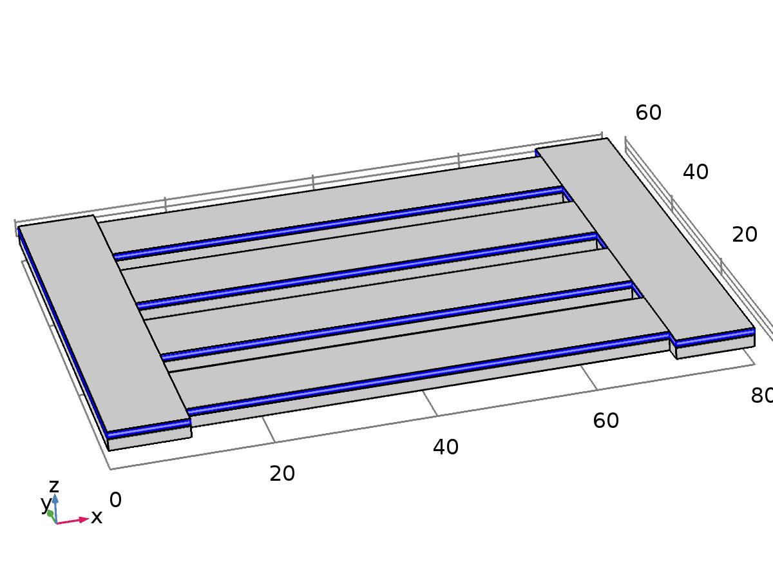

Lead Zirconate Titanate (PZT-5H)

Selection

|  |  |
| --- | --- |
| Geometric entity level | Domain |
| Selection | Domains 4, 9, 14, 19, 24, 29 |

Material parameters

| **Name** | **Value** | **Unit** |
| --- | --- | --- |
| Density | 7500[kg/m^3] | kg/m³ |
| Elasticity matrix (ordering: xx, yy, zz, yz, xz, xy) | {1.27205e+011[Pa], 8.02122e+010[Pa], 1.27205e+011[Pa], 8.46702e+010[Pa], 8.46702e+010[Pa], 1.17436e+011[Pa], 0[Pa], 0[Pa], 0[Pa], 2.29885e+010[Pa], 0[Pa], 0[Pa], 0[Pa], 0[Pa], 2.29885e+010[Pa], 0[Pa], 0[Pa], 0[Pa], 0[Pa], 0[Pa], 2.34742e+010[Pa]} | Pa |
| Coupling matrix | {0[C/m^2], 0[C/m^2], -6.62281[C/m^2], 0[C/m^2], 0[C/m^2], -6.62281[C/m^2], 0[C/m^2], 0[C/m^2], 23.2403[C/m^2], 0[C/m^2], 17.0345[C/m^2], 0[C/m^2], 17.0345[C/m^2], 0[C/m^2], 0[C/m^2], 0[C/m^2], 0[C/m^2], 0[C/m^2]} | C/m² |
| Relative permittivity | {1704.4, 1704.4, 1433.6} | 1 |

Basic Settings

| **Description** | **Value** |
| --- | --- |
| Relative permittivity | {{1704.4, 0, 0}, {0, 1704.4, 0}, {0, 0, 1433.6}} |
| Density | 7500[kg/m^3] |

Strain-charge form Settings

| **Description** | **Value** |
| --- | --- |
| Compliance matrix (ordering: xx, yy, zz, yz, xz, xy) | {{1.65e-011[1/Pa], -4.78e-012[1/Pa], -8.45e-012[1/Pa], 0[1/Pa], 0[1/Pa], 0[1/Pa]}, {-4.78e-012[1/Pa], 1.65e-011[1/Pa], -8.45e-012[1/Pa], 0[1/Pa], 0[1/Pa], 0[1/Pa]}, {-8.45e-012[1/Pa], -8.45e-012[1/Pa], 2.07e-011[1/Pa], 0[1/Pa], 0[1/Pa], 0[1/Pa]}, {0[1/Pa], 0[1/Pa], 0[1/Pa], 4.35e-011[1/Pa], 0[1/Pa], 0[1/Pa]}, {0[1/Pa], 0[1/Pa], 0[1/Pa], 0[1/Pa], 4.35e-011[1/Pa], 0[1/Pa]}, {0[1/Pa], 0[1/Pa], 0[1/Pa], 0[1/Pa], 0[1/Pa], 4.26e-011[1/Pa]}} |
| Coupling matrix (ordering: xx, yy, zz, yz, xz, xy) | {{0[C/N], 0[C/N], -2.74e-010[C/N], 0[C/N], 0[C/N], -2.74e-010[C/N]}, {0[C/N], 0[C/N], 5.93e-010[C/N], 0[C/N], 7.41e-010[C/N], 0[C/N]}, {7.41e-010[C/N], 0[C/N], 0[C/N], 0[C/N], 0[C/N], 0[C/N]}} |
| Relative permittivity | {{3130, 0, 0}, {0, 3130, 0}, {0, 0, 3400}} |
| Loss factor for compliance matrix sE | {{0, 0, 0, 0, 0, 0}, {0, 0, 0, 0, 0, 0}, {0, 0, 0, 0, 0, 0}, {0, 0, 0, 0, 0, 0}, {0, 0, 0, 0, 0, 0}, {0, 0, 0, 0, 0, 0}} |
| Loss factor for coupling matrix d | {{0, 0, 0, 0, 0, 0}, {0, 0, 0, 0, 0, 0}, {0, 0, 0, 0, 0, 0}} |
| Loss factor for electrical permittivity εT | {{0, 0, 0}, {0, 0, 0}, {0, 0, 0}} |

Stress-charge form Settings

| **Description** | **Value** |
| --- | --- |
| Elasticity matrix (ordering: xx, yy, zz, yz, xz, xy) | {{1.27205e+011[Pa], 8.02122e+010[Pa], 8.46702e+010[Pa], 0[Pa], 0[Pa], 0[Pa]}, {8.02122e+010[Pa], 1.27205e+011[Pa], 8.46702e+010[Pa], 0[Pa], 0[Pa], 0[Pa]}, {8.46702e+010[Pa], 8.46702e+010[Pa], 1.17436e+011[Pa], 0[Pa], 0[Pa], 0[Pa]}, {0[Pa], 0[Pa], 0[Pa], 2.29885e+010[Pa], 0[Pa], 0[Pa]}, {0[Pa], 0[Pa], 0[Pa], 0[Pa], 2.29885e+010[Pa], 0[Pa]}, {0[Pa], 0[Pa], 0[Pa], 0[Pa], 0[Pa], 2.34742e+010[Pa]}} |
| Coupling matrix | {{0[C/m^2], 0[C/m^2], -6.62281[C/m^2], 0[C/m^2], 0[C/m^2], -6.62281[C/m^2]}, {0[C/m^2], 0[C/m^2], 23.2403[C/m^2], 0[C/m^2], 17.0345[C/m^2], 0[C/m^2]}, {17.0345[C/m^2], 0[C/m^2], 0[C/m^2], 0[C/m^2], 0[C/m^2], 0[C/m^2]}} |
| Relative permittivity | {{1704.4, 0, 0}, {0, 1704.4, 0}, {0, 0, 1433.6}} |
| Loss factor for elasticity matrix cE | {{0, 0, 0, 0, 0, 0}, {0, 0, 0, 0, 0, 0}, {0, 0, 0, 0, 0, 0}, {0, 0, 0, 0, 0, 0}, {0, 0, 0, 0, 0, 0}, {0, 0, 0, 0, 0, 0}} |
| Loss factor for coupling matrix e | {{0, 0, 0, 0, 0, 0}, {0, 0, 0, 0, 0, 0}, {0, 0, 0, 0, 0, 0}} |
| Loss factor for electrical permittivity εS | {{0, 0, 0}, {0, 0, 0}, {0, 0, 0}} |

* 1. Solid Mechanics

Used products

|  |
| --- |
| COMSOL Multiphysics |
| MEMS Module |

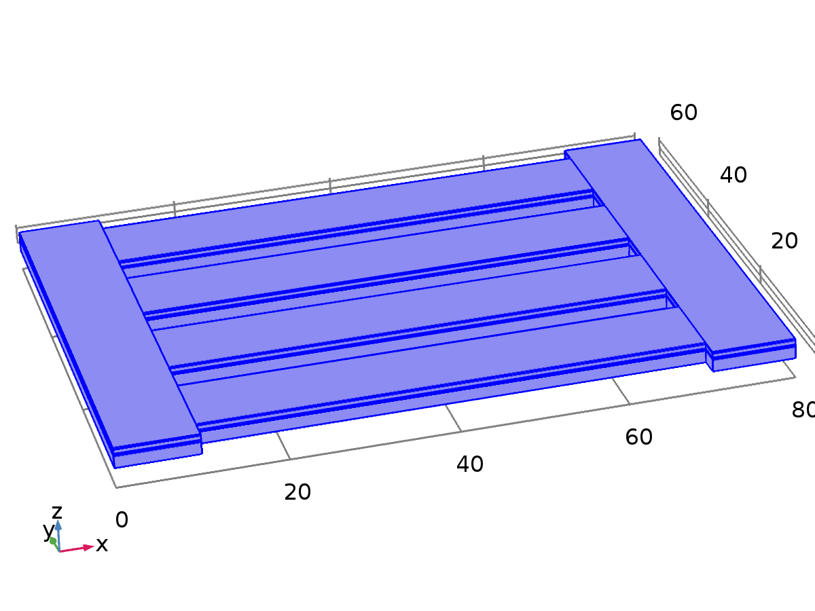

Solid Mechanics

Selection

|  |  |
| --- | --- |
| Geometric entity level | Domain |
| Selection | Domains 1–30 |

Equations



Settings

| **Description** | **Value** |
| --- | --- |
| Displacement field | Quadratic serendipity |
| Compute boundary fluxes | Off |
| Value type when using splitting of complex variables | Complex |
| Typical wave speed for perfectly matched layers | solid.cp |

Variables

| **Name** | **Expression** | **Unit** | **Description** | **Selection** |
| --- | --- | --- | --- | --- |
| solid.nX | nX | 1 | Normal vector, X component | Boundaries 6, 9, 12, 15, 27, 30, 32–33, 35–36, 38–39, 41, 53, 56, 58–59, 61–62, 64–65, 67, 79, 82, 84–85, 87–88, 90–91, 93, 105, 108, 110–111, 113–114, 116–117, 119, 136, 139, 142, 145, 147–151, 157–161, 167–171, 177–181 |
| solid.nY | nY | 1 | Normal vector, Y component | Boundaries 6, 9, 12, 15, 27, 30, 32–33, 35–36, 38–39, 41, 53, 56, 58–59, 61–62, 64–65, 67, 79, 82, 84–85, 87–88, 90–91, 93, 105, 108, 110–111, 113–114, 116–117, 119, 136, 139, 142, 145, 147–151, 157–161, 167–171, 177–181 |
| solid.nZ | nZ | 1 | Normal vector, Z component | Boundaries 6, 9, 12, 15, 27, 30, 32–33, 35–36, 38–39, 41, 53, 56, 58–59, 61–62, 64–65, 67, 79, 82, 84–85, 87–88, 90–91, 93, 105, 108, 110–111, 113–114, 116–117, 119, 136, 139, 142, 145, 147–151, 157–161, 167–171, 177–181 |
| solid.nX | dnX | 1 | Normal vector, X component | Boundaries 1–5, 7–8, 10–11, 13–14, 16–26, 28–29, 31, 34, 37, 40, 42–52, 54–55, 57, 60, 63, 66, 68–78, 80–81, 83, 86, 89, 92, 94–104, 106–107, 109, 112, 115, 118, 120–135, 137–138, 140–141, 143–144, 146, 152–156, 162–166, 172–176, 182–196 |
| solid.nY | dnY | 1 | Normal vector, Y component | Boundaries 1–5, 7–8, 10–11, 13–14, 16–26, 28–29, 31, 34, 37, 40, 42–52, 54–55, 57, 60, 63, 66, 68–78, 80–81, 83, 86, 89, 92, 94–104, 106–107, 109, 112, 115, 118, 120–135, 137–138, 140–141, 143–144, 146, 152–156, 162–166, 172–176, 182–196 |
| solid.nZ | dnZ | 1 | Normal vector, Z component | Boundaries 1–5, 7–8, 10–11, 13–14, 16–26, 28–29, 31, 34, 37, 40, 42–52, 54–55, 57, 60, 63, 66, 68–78, 80–81, 83, 86, 89, 92, 94–104, 106–107, 109, 112, 115, 118, 120–135, 137–138, 140–141, 143–144, 146, 152–156, 162–166, 172–176, 182–196 |
| solid.nx | nx | 1 | Normal vector, x component | Boundaries 6, 9, 12, 15, 27, 30, 32–33, 35–36, 38–39, 41, 53, 56, 58–59, 61–62, 64–65, 67, 79, 82, 84–85, 87–88, 90–91, 93, 105, 108, 110–111, 113–114, 116–117, 119, 136, 139, 142, 145, 147–151, 157–161, 167–171, 177–181 |
| solid.ny | ny | 1 | Normal vector, y component | Boundaries 6, 9, 12, 15, 27, 30, 32–33, 35–36, 38–39, 41, 53, 56, 58–59, 61–62, 64–65, 67, 79, 82, 84–85, 87–88, 90–91, 93, 105, 108, 110–111, 113–114, 116–117, 119, 136, 139, 142, 145, 147–151, 157–161, 167–171, 177–181 |
| solid.nz | nz | 1 | Normal vector, z component | Boundaries 6, 9, 12, 15, 27, 30, 32–33, 35–36, 38–39, 41, 53, 56, 58–59, 61–62, 64–65, 67, 79, 82, 84–85, 87–88, 90–91, 93, 105, 108, 110–111, 113–114, 116–117, 119, 136, 139, 142, 145, 147–151, 157–161, 167–171, 177–181 |
| solid.nx | dnx | 1 | Normal vector, x component | Boundaries 1–5, 7–8, 10–11, 13–14, 16–26, 28–29, 31, 34, 37, 40, 42–52, 54–55, 57, 60, 63, 66, 68–78, 80–81, 83, 86, 89, 92, 94–104, 106–107, 109, 112, 115, 118, 120–135, 137–138, 140–141, 143–144, 146, 152–156, 162–166, 172–176, 182–196 |
| solid.ny | dny | 1 | Normal vector, y component | Boundaries 1–5, 7–8, 10–11, 13–14, 16–26, 28–29, 31, 34, 37, 40, 42–52, 54–55, 57, 60, 63, 66, 68–78, 80–81, 83, 86, 89, 92, 94–104, 106–107, 109, 112, 115, 118, 120–135, 137–138, 140–141, 143–144, 146, 152–156, 162–166, 172–176, 182–196 |
| solid.nz | dnz | 1 | Normal vector, z component | Boundaries 1–5, 7–8, 10–11, 13–14, 16–26, 28–29, 31, 34, 37, 40, 42–52, 54–55, 57, 60, 63, 66, 68–78, 80–81, 83, 86, 89, 92, 94–104, 106–107, 109, 112, 115, 118, 120–135, 137–138, 140–141, 143–144, 146, 152–156, 162–166, 172–176, 182–196 |
| solid.nXmesh | root.nXmesh | 1 | Normal vector (mesh), X component | Boundaries 6, 9, 12, 15, 27, 30, 32–33, 35–36, 38–39, 41, 53, 56, 58–59, 61–62, 64–65, 67, 79, 82, 84–85, 87–88, 90–91, 93, 105, 108, 110–111, 113–114, 116–117, 119, 136, 139, 142, 145, 147–151, 157–161, 167–171, 177–181 |
| solid.nYmesh | root.nYmesh | 1 | Normal vector (mesh), Y component | Boundaries 6, 9, 12, 15, 27, 30, 32–33, 35–36, 38–39, 41, 53, 56, 58–59, 61–62, 64–65, 67, 79, 82, 84–85, 87–88, 90–91, 93, 105, 108, 110–111, 113–114, 116–117, 119, 136, 139, 142, 145, 147–151, 157–161, 167–171, 177–181 |
| solid.nZmesh | root.nZmesh | 1 | Normal vector (mesh), Z component | Boundaries 6, 9, 12, 15, 27, 30, 32–33, 35–36, 38–39, 41, 53, 56, 58–59, 61–62, 64–65, 67, 79, 82, 84–85, 87–88, 90–91, 93, 105, 108, 110–111, 113–114, 116–117, 119, 136, 139, 142, 145, 147–151, 157–161, 167–171, 177–181 |
| solid.nXmesh | dnXmesh | 1 | Normal vector (mesh), X component | Boundaries 1–5, 7–8, 10–11, 13–14, 16–26, 28–29, 31, 34, 37, 40, 42–52, 54–55, 57, 60, 63, 66, 68–78, 80–81, 83, 86, 89, 92, 94–104, 106–107, 109, 112, 115, 118, 120–135, 137–138, 140–141, 143–144, 146, 152–156, 162–166, 172–176, 182–196 |
| solid.nYmesh | dnYmesh | 1 | Normal vector (mesh), Y component | Boundaries 1–5, 7–8, 10–11, 13–14, 16–26, 28–29, 31, 34, 37, 40, 42–52, 54–55, 57, 60, 63, 66, 68–78, 80–81, 83, 86, 89, 92, 94–104, 106–107, 109, 112, 115, 118, 120–135, 137–138, 140–141, 143–144, 146, 152–156, 162–166, 172–176, 182–196 |
| solid.nZmesh | dnZmesh | 1 | Normal vector (mesh), Z component | Boundaries 1–5, 7–8, 10–11, 13–14, 16–26, 28–29, 31, 34, 37, 40, 42–52, 54–55, 57, 60, 63, 66, 68–78, 80–81, 83, 86, 89, 92, 94–104, 106–107, 109, 112, 115, 118, 120–135, 137–138, 140–141, 143–144, 146, 152–156, 162–166, 172–176, 182–196 |
| solid.nxmesh | nxmesh | 1 | Normal vector (mesh), x component | Boundaries 6, 9, 12, 15, 27, 30, 32–33, 35–36, 38–39, 41, 53, 56, 58–59, 61–62, 64–65, 67, 79, 82, 84–85, 87–88, 90–91, 93, 105, 108, 110–111, 113–114, 116–117, 119, 136, 139, 142, 145, 147–151, 157–161, 167–171, 177–181 |
| solid.nymesh | nymesh | 1 | Normal vector (mesh), y component | Boundaries 6, 9, 12, 15, 27, 30, 32–33, 35–36, 38–39, 41, 53, 56, 58–59, 61–62, 64–65, 67, 79, 82, 84–85, 87–88, 90–91, 93, 105, 108, 110–111, 113–114, 116–117, 119, 136, 139, 142, 145, 147–151, 157–161, 167–171, 177–181 |
| solid.nzmesh | nzmesh | 1 | Normal vector (mesh), z component | Boundaries 6, 9, 12, 15, 27, 30, 32–33, 35–36, 38–39, 41, 53, 56, 58–59, 61–62, 64–65, 67, 79, 82, 84–85, 87–88, 90–91, 93, 105, 108, 110–111, 113–114, 116–117, 119, 136, 139, 142, 145, 147–151, 157–161, 167–171, 177–181 |
| solid.nxmesh | dnxmesh | 1 | Normal vector (mesh), x component | Boundaries 1–5, 7–8, 10–11, 13–14, 16–26, 28–29, 31, 34, 37, 40, 42–52, 54–55, 57, 60, 63, 66, 68–78, 80–81, 83, 86, 89, 92, 94–104, 106–107, 109, 112, 115, 118, 120–135, 137–138, 140–141, 143–144, 146, 152–156, 162–166, 172–176, 182–196 |
| solid.nymesh | dnymesh | 1 | Normal vector (mesh), y component | Boundaries 1–5, 7–8, 10–11, 13–14, 16–26, 28–29, 31, 34, 37, 40, 42–52, 54–55, 57, 60, 63, 66, 68–78, 80–81, 83, 86, 89, 92, 94–104, 106–107, 109, 112, 115, 118, 120–135, 137–138, 140–141, 143–144, 146, 152–156, 162–166, 172–176, 182–196 |
| solid.nzmesh | dnzmesh | 1 | Normal vector (mesh), z component | Boundaries 1–5, 7–8, 10–11, 13–14, 16–26, 28–29, 31, 34, 37, 40, 42–52, 54–55, 57, 60, 63, 66, 68–78, 80–81, 83, 86, 89, 92, 94–104, 106–107, 109, 112, 115, 118, 120–135, 137–138, 140–141, 143–144, 146, 152–156, 162–166, 172–176, 182–196 |
| solid.refpntx | 0 | m | Reference point for moment computation, x component | Global |
| solid.refpnty | 0 | m | Reference point for moment computation, y component | Global |
| solid.refpntz | 0 | m | Reference point for moment computation, z component | Global |
| solid.cref | solid.cp | m/s | Typical wave speed for perfectly matched layers | Domains 1–30 |
| xt | d(x,TIME) | m/s | Mesh velocity, x component | Global |
| yt | d(y,TIME) | m/s | Mesh velocity, y component | Global |
| zt | d(z,TIME) | m/s | Mesh velocity, z component | Global |

* + 1. Linear Elastic Material 1

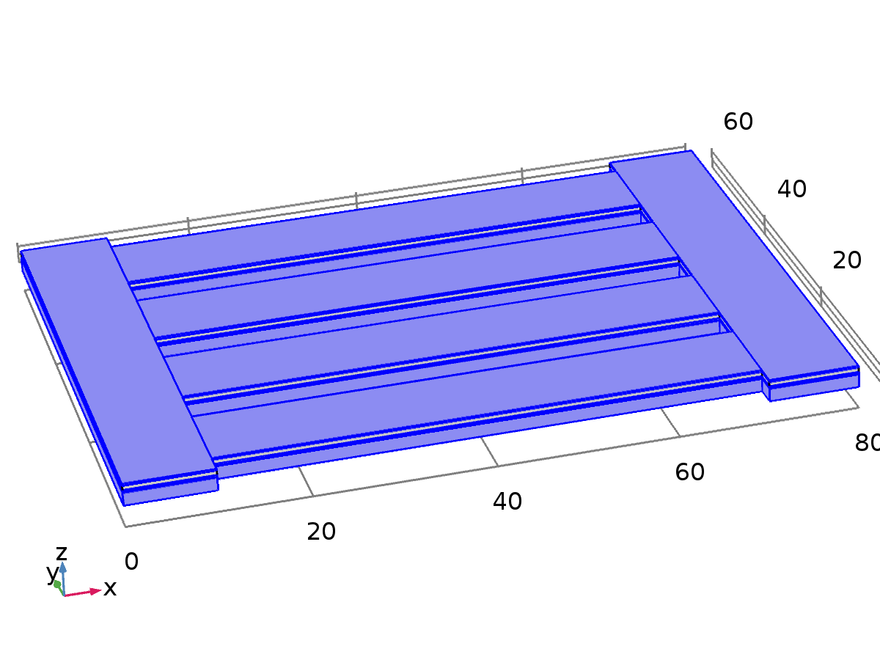

Linear Elastic Material 1

Selection

|  |  |
| --- | --- |
| Geometric entity level | Domain |
| Selection | Domains 1–3, 5–8, 10–13, 15–18, 20–23, 25–28, 30 |

Equations











Settings

| **Description** | **Value** |
| --- | --- |
| Nearly incompressible material | Off |
| Solid model | Isotropic |
| Specify | Young's modulus and Poisson's ratio |
| Young's modulus | From material |
| Poisson's ratio | From material |
| Density | From material |
| Force linear strains | Off |
| Calculate dissipated energy | Off |

Used products

|  |
| --- |
| COMSOL Multiphysics |

Properties from material

| **Property** | **Material** | **Property group** |
| --- | --- | --- |
| Young's modulus | Si - Polycrystalline Silicon | Young's modulus and Poisson's ratio |
| Poisson's ratio | Si - Polycrystalline Silicon | Young's modulus and Poisson's ratio |
| Density | Si - Polycrystalline Silicon | Basic |
| Young's modulus | Au - Gold | Young's modulus and Poisson's ratio |
| Poisson's ratio | Au - Gold | Young's modulus and Poisson's ratio |
| Density | Au - Gold | Basic |
| Young's modulus | SiO2 - Silicon oxide | Young's modulus and Poisson's ratio |
| Poisson's ratio | SiO2 - Silicon oxide | Young's modulus and Poisson's ratio |
| Density | SiO2 - Silicon oxide | Basic |

#### Variables

| **Name** | **Expression** | **Unit** | **Description** | **Selection** |
| --- | --- | --- | --- | --- |
| solid.rho | material.rho | kg/m³ | Density | Domains 1–3, 5–8, 10–13, 15–18, 20–23, 25–28, 30 |
| solid.Qh | 0 | W/m³ | Total power dissipation density | Domains 1–3, 5–8, 10–13, 15–18, 20–23, 25–28, 30 |
| uTXt | uTXTIME | 1/s | Tangential gradient of u, X component, first time derivative | Boundaries 1–9, 12–19, 21–24, 26–35, 38–48, 51–61, 64–74, 77–87, 90–100, 103–113, 116–126, 129–139, 142–149, 151–154, 156–159, 161–164, 166–169, 171–174, 176–179, 181–184, 186–189, 191–194, 196 |
| uTYt | uTYTIME | 1/s | Tangential gradient of u, Y component, first time derivative | Boundaries 1–9, 12–19, 21–24, 26–35, 38–48, 51–61, 64–74, 77–87, 90–100, 103–113, 116–126, 129–139, 142–149, 151–154, 156–159, 161–164, 166–169, 171–174, 176–179, 181–184, 186–189, 191–194, 196 |
| uTZt | uTZTIME | 1/s | Tangential gradient of u, Z component, first time derivative | Boundaries 1–9, 12–19, 21–24, 26–35, 38–48, 51–61, 64–74, 77–87, 90–100, 103–113, 116–126, 129–139, 142–149, 151–154, 156–159, 161–164, 166–169, 171–174, 176–179, 181–184, 186–189, 191–194, 196 |
| uTXtt | uTXTIMETIME | 1/s² | Tangential gradient of u, X component, second time derivative | Boundaries 1–9, 12–19, 21–24, 26–35, 38–48, 51–61, 64–74, 77–87, 90–100, 103–113, 116–126, 129–139, 142–149, 151–154, 156–159, 161–164, 166–169, 171–174, 176–179, 181–184, 186–189, 191–194, 196 |
| uTYtt | uTYTIMETIME | 1/s² | Tangential gradient of u, Y component, second time derivative | Boundaries 1–9, 12–19, 21–24, 26–35, 38–48, 51–61, 64–74, 77–87, 90–100, 103–113, 116–126, 129–139, 142–149, 151–154, 156–159, 161–164, 166–169, 171–174, 176–179, 181–184, 186–189, 191–194, 196 |
| uTZtt | uTZTIMETIME | 1/s² | Tangential gradient of u, Z component, second time derivative | Boundaries 1–9, 12–19, 21–24, 26–35, 38–48, 51–61, 64–74, 77–87, 90–100, 103–113, 116–126, 129–139, 142–149, 151–154, 156–159, 161–164, 166–169, 171–174, 176–179, 181–184, 186–189, 191–194, 196 |
| uXt | uXTIME | 1/s | Gradient of u, X component, first time derivative | Domains 1–3, 5–8, 10–13, 15–18, 20–23, 25–28, 30 |
| uYt | uYTIME | 1/s | Gradient of u, Y component, first time derivative | Domains 1–3, 5–8, 10–13, 15–18, 20–23, 25–28, 30 |
| uZt | uZTIME | 1/s | Gradient of u, Z component, first time derivative | Domains 1–3, 5–8, 10–13, 15–18, 20–23, 25–28, 30 |
| uXtt | uXTIMETIME | 1/s² | Gradient of u, X component, second time derivative | Domains 1–3, 5–8, 10–13, 15–18, 20–23, 25–28, 30 |
| uYtt | uYTIMETIME | 1/s² | Gradient of u, Y component, second time derivative | Domains 1–3, 5–8, 10–13, 15–18, 20–23, 25–28, 30 |
| uZtt | uZTIMETIME | 1/s² | Gradient of u, Z component, second time derivative | Domains 1–3, 5–8, 10–13, 15–18, 20–23, 25–28, 30 |
| vTXt | vTXTIME | 1/s | Tangential gradient of v, X component, first time derivative | Boundaries 1–9, 12–19, 21–24, 26–35, 38–48, 51–61, 64–74, 77–87, 90–100, 103–113, 116–126, 129–139, 142–149, 151–154, 156–159, 161–164, 166–169, 171–174, 176–179, 181–184, 186–189, 191–194, 196 |
| vTYt | vTYTIME | 1/s | Tangential gradient of v, Y component, first time derivative | Boundaries 1–9, 12–19, 21–24, 26–35, 38–48, 51–61, 64–74, 77–87, 90–100, 103–113, 116–126, 129–139, 142–149, 151–154, 156–159, 161–164, 166–169, 171–174, 176–179, 181–184, 186–189, 191–194, 196 |
| vTZt | vTZTIME | 1/s | Tangential gradient of v, Z component, first time derivative | Boundaries 1–9, 12–19, 21–24, 26–35, 38–48, 51–61, 64–74, 77–87, 90–100, 103–113, 116–126, 129–139, 142–149, 151–154, 156–159, 161–164, 166–169, 171–174, 176–179, 181–184, 186–189, 191–194, 196 |
| vTXtt | vTXTIMETIME | 1/s² | Tangential gradient of v, X component, second time derivative | Boundaries 1–9, 12–19, 21–24, 26–35, 38–48, 51–61, 64–74, 77–87, 90–100, 103–113, 116–126, 129–139, 142–149, 151–154, 156–159, 161–164, 166–169, 171–174, 176–179, 181–184, 186–189, 191–194, 196 |
| vTYtt | vTYTIMETIME | 1/s² | Tangential gradient of v, Y component, second time derivative | Boundaries 1–9, 12–19, 21–24, 26–35, 38–48, 51–61, 64–74, 77–87, 90–100, 103–113, 116–126, 129–139, 142–149, 151–154, 156–159, 161–164, 166–169, 171–174, 176–179, 181–184, 186–189, 191–194, 196 |
| vTZtt | vTZTIMETIME | 1/s² | Tangential gradient of v, Z component, second time derivative | Boundaries 1–9, 12–19, 21–24, 26–35, 38–48, 51–61, 64–74, 77–87, 90–100, 103–113, 116–126, 129–139, 142–149, 151–154, 156–159, 161–164, 166–169, 171–174, 176–179, 181–184, 186–189, 191–194, 196 |
| vXt | vXTIME | 1/s | Gradient of v, X component, first time derivative | Domains 1–3, 5–8, 10–13, 15–18, 20–23, 25–28, 30 |
| vYt | vYTIME | 1/s | Gradient of v, Y component, first time derivative | Domains 1–3, 5–8, 10–13, 15–18, 20–23, 25–28, 30 |
| vZt | vZTIME | 1/s | Gradient of v, Z component, first time derivative | Domains 1–3, 5–8, 10–13, 15–18, 20–23, 25–28, 30 |
| vXtt | vXTIMETIME | 1/s² | Gradient of v, X component, second time derivative | Domains 1–3, 5–8, 10–13, 15–18, 20–23, 25–28, 30 |
| vYtt | vYTIMETIME | 1/s² | Gradient of v, Y component, second time derivative | Domains 1–3, 5–8, 10–13, 15–18, 20–23, 25–28, 30 |
| vZtt | vZTIMETIME | 1/s² | Gradient of v, Z component, second time derivative | Domains 1–3, 5–8, 10–13, 15–18, 20–23, 25–28, 30 |
| wTXt | wTXTIME | 1/s | Tangential gradient of w, X component, first time derivative | Boundaries 1–9, 12–19, 21–24, 26–35, 38–48, 51–61, 64–74, 77–87, 90–100, 103–113, 116–126, 129–139, 142–149, 151–154, 156–159, 161–164, 166–169, 171–174, 176–179, 181–184, 186–189, 191–194, 196 |
| wTYt | wTYTIME | 1/s | Tangential gradient of w, Y component, first time derivative | Boundaries 1–9, 12–19, 21–24, 26–35, 38–48, 51–61, 64–74, 77–87, 90–100, 103–113, 116–126, 129–139, 142–149, 151–154, 156–159, 161–164, 166–169, 171–174, 176–179, 181–184, 186–189, 191–194, 196 |
| wTZt | wTZTIME | 1/s | Tangential gradient of w, Z component, first time derivative | Boundaries 1–9, 12–19, 21–24, 26–35, 38–48, 51–61, 64–74, 77–87, 90–100, 103–113, 116–126, 129–139, 142–149, 151–154, 156–159, 161–164, 166–169, 171–174, 176–179, 181–184, 186–189, 191–194, 196 |
| wTXtt | wTXTIMETIME | 1/s² | Tangential gradient of w, X component, second time derivative | Boundaries 1–9, 12–19, 21–24, 26–35, 38–48, 51–61, 64–74, 77–87, 90–100, 103–113, 116–126, 129–139, 142–149, 151–154, 156–159, 161–164, 166–169, 171–174, 176–179, 181–184, 186–189, 191–194, 196 |
| wTYtt | wTYTIMETIME | 1/s² | Tangential gradient of w, Y component, second time derivative | Boundaries 1–9, 12–19, 21–24, 26–35, 38–48, 51–61, 64–74, 77–87, 90–100, 103–113, 116–126, 129–139, 142–149, 151–154, 156–159, 161–164, 166–169, 171–174, 176–179, 181–184, 186–189, 191–194, 196 |
| wTZtt | wTZTIMETIME | 1/s² | Tangential gradient of w, Z component, second time derivative | Boundaries 1–9, 12–19, 21–24, 26–35, 38–48, 51–61, 64–74, 77–87, 90–100, 103–113, 116–126, 129–139, 142–149, 151–154, 156–159, 161–164, 166–169, 171–174, 176–179, 181–184, 186–189, 191–194, 196 |
| wXt | wXTIME | 1/s | Gradient of w, X component, first time derivative | Domains 1–3, 5–8, 10–13, 15–18, 20–23, 25–28, 30 |
| wYt | wYTIME | 1/s | Gradient of w, Y component, first time derivative | Domains 1–3, 5–8, 10–13, 15–18, 20–23, 25–28, 30 |
| wZt | wZTIME | 1/s | Gradient of w, Z component, first time derivative | Domains 1–3, 5–8, 10–13, 15–18, 20–23, 25–28, 30 |
| wXtt | wXTIMETIME | 1/s² | Gradient of w, X component, second time derivative | Domains 1–3, 5–8, 10–13, 15–18, 20–23, 25–28, 30 |
| wYtt | wYTIMETIME | 1/s² | Gradient of w, Y component, second time derivative | Domains 1–3, 5–8, 10–13, 15–18, 20–23, 25–28, 30 |
| wZtt | wZTIMETIME | 1/s² | Gradient of w, Z component, second time derivative | Domains 1–3, 5–8, 10–13, 15–18, 20–23, 25–28, 30 |
| ut | uTIME | m/s | Structural velocity field, X component | Domains 1–3, 5–8, 10–13, 15–18, 20–23, 25–28, 30 |
| vt | vTIME | m/s | Structural velocity field, Y component | Domains 1–3, 5–8, 10–13, 15–18, 20–23, 25–28, 30 |
| wt | wTIME | m/s | Structural velocity field, Z component | Domains 1–3, 5–8, 10–13, 15–18, 20–23, 25–28, 30 |
| utt | uTIMETIME | m/s² | Acceleration field, X component | Domains 1–3, 5–8, 10–13, 15–18, 20–23, 25–28, 30 |
| vtt | vTIMETIME | m/s² | Acceleration field, Y component | Domains 1–3, 5–8, 10–13, 15–18, 20–23, 25–28, 30 |
| wtt | wTIMETIME | m/s² | Acceleration field, Z component | Domains 1–3, 5–8, 10–13, 15–18, 20–23, 25–28, 30 |
| solid.gradUxX | uX | 1 | Displacement gradient, xX component | Domains 1–3, 5–8, 10–13, 15–18, 20–23, 25–28, 30 |
| solid.gradUyX | vX | 1 | Displacement gradient, yX component | Domains 1–3, 5–8, 10–13, 15–18, 20–23, 25–28, 30 |
| solid.gradUzX | wX | 1 | Displacement gradient, zX component | Domains 1–3, 5–8, 10–13, 15–18, 20–23, 25–28, 30 |
| solid.gradUxY | uY | 1 | Displacement gradient, xY component | Domains 1–3, 5–8, 10–13, 15–18, 20–23, 25–28, 30 |
| solid.gradUyY | vY | 1 | Displacement gradient, yY component | Domains 1–3, 5–8, 10–13, 15–18, 20–23, 25–28, 30 |
| solid.gradUzY | wY | 1 | Displacement gradient, zY component | Domains 1–3, 5–8, 10–13, 15–18, 20–23, 25–28, 30 |
| solid.gradUxZ | uZ | 1 | Displacement gradient, xZ component | Domains 1–3, 5–8, 10–13, 15–18, 20–23, 25–28, 30 |
| solid.gradUyZ | vZ | 1 | Displacement gradient, yZ component | Domains 1–3, 5–8, 10–13, 15–18, 20–23, 25–28, 30 |
| solid.gradUzZ | wZ | 1 | Displacement gradient, zZ component | Domains 1–3, 5–8, 10–13, 15–18, 20–23, 25–28, 30 |
| solid.FdxX | 1+solid.gradUxX | 1 | Deformation gradient, xX component | Domains 1–3, 5–8, 10–13, 15–18, 20–23, 25–28, 30 |
| solid.FdyX | solid.gradUyX | 1 | Deformation gradient, yX component | Domains 1–3, 5–8, 10–13, 15–18, 20–23, 25–28, 30 |
| solid.FdzX | solid.gradUzX | 1 | Deformation gradient, zX component | Domains 1–3, 5–8, 10–13, 15–18, 20–23, 25–28, 30 |
| solid.FdxY | solid.gradUxY | 1 | Deformation gradient, xY component | Domains 1–3, 5–8, 10–13, 15–18, 20–23, 25–28, 30 |
| solid.FdyY | 1+solid.gradUyY | 1 | Deformation gradient, yY component | Domains 1–3, 5–8, 10–13, 15–18, 20–23, 25–28, 30 |
| solid.FdzY | solid.gradUzY | 1 | Deformation gradient, zY component | Domains 1–3, 5–8, 10–13, 15–18, 20–23, 25–28, 30 |
| solid.FdxZ | solid.gradUxZ | 1 | Deformation gradient, xZ component | Domains 1–3, 5–8, 10–13, 15–18, 20–23, 25–28, 30 |
| solid.FdyZ | solid.gradUyZ | 1 | Deformation gradient, yZ component | Domains 1–3, 5–8, 10–13, 15–18, 20–23, 25–28, 30 |
| solid.FdzZ | 1+solid.gradUzZ | 1 | Deformation gradient, zZ component | Domains 1–3, 5–8, 10–13, 15–18, 20–23, 25–28, 30 |
| solid.Fdlx1 | solid.FdxX | 1 | Deformation gradient, local, x1 component | Domains 1–3, 5–8, 10–13, 15–18, 20–23, 25–28, 30 |
| solid.Fdly1 | solid.FdyX | 1 | Deformation gradient, local, y1 component | Domains 1–3, 5–8, 10–13, 15–18, 20–23, 25–28, 30 |
| solid.Fdlz1 | solid.FdzX | 1 | Deformation gradient, local, z1 component | Domains 1–3, 5–8, 10–13, 15–18, 20–23, 25–28, 30 |
| solid.Fdlx2 | solid.FdxY | 1 | Deformation gradient, local, x2 component | Domains 1–3, 5–8, 10–13, 15–18, 20–23, 25–28, 30 |
| solid.Fdly2 | solid.FdyY | 1 | Deformation gradient, local, y2 component | Domains 1–3, 5–8, 10–13, 15–18, 20–23, 25–28, 30 |
| solid.Fdlz2 | solid.FdzY | 1 | Deformation gradient, local, z2 component | Domains 1–3, 5–8, 10–13, 15–18, 20–23, 25–28, 30 |
| solid.Fdlx3 | solid.FdxZ | 1 | Deformation gradient, local, x3 component | Domains 1–3, 5–8, 10–13, 15–18, 20–23, 25–28, 30 |
| solid.Fdly3 | solid.FdyZ | 1 | Deformation gradient, local, y3 component | Domains 1–3, 5–8, 10–13, 15–18, 20–23, 25–28, 30 |
| solid.Fdlz3 | solid.FdzZ | 1 | Deformation gradient, local, z3 component | Domains 1–3, 5–8, 10–13, 15–18, 20–23, 25–28, 30 |
| solid.D11 | solid.E*(1-solid.nu)/((1+solid.nu)*(1-2*solid.nu)) | Pa | Elasticity matrix, 11 component | Domains 1–3, 5–8, 10–13, 15–18, 20–23, 25–28, 30 |
| solid.D12 | solid.E*solid.nu/((1+solid.nu)*(1-2*solid.nu)) | Pa | Elasticity matrix, 12 component | Domains 1–3, 5–8, 10–13, 15–18, 20–23, 25–28, 30 |
| solid.D13 | solid.E*solid.nu/((1+solid.nu)*(1-2*solid.nu)) | Pa | Elasticity matrix, 13 component | Domains 1–3, 5–8, 10–13, 15–18, 20–23, 25–28, 30 |
| solid.D14 | 0 | Pa | Elasticity matrix, 14 component | Domains 1–3, 5–8, 10–13, 15–18, 20–23, 25–28, 30 |
| solid.D15 | 0 | Pa | Elasticity matrix, 15 component | Domains 1–3, 5–8, 10–13, 15–18, 20–23, 25–28, 30 |
| solid.D16 | 0 | Pa | Elasticity matrix, 16 component | Domains 1–3, 5–8, 10–13, 15–18, 20–23, 25–28, 30 |
| solid.D22 | solid.E*(1-solid.nu)/((1+solid.nu)*(1-2*solid.nu)) | Pa | Elasticity matrix, 22 component | Domains 1–3, 5–8, 10–13, 15–18, 20–23, 25–28, 30 |
| solid.D23 | solid.E*solid.nu/((1+solid.nu)*(1-2*solid.nu)) | Pa | Elasticity matrix, 23 component | Domains 1–3, 5–8, 10–13, 15–18, 20–23, 25–28, 30 |
| solid.D24 | 0 | Pa | Elasticity matrix, 24 component | Domains 1–3, 5–8, 10–13, 15–18, 20–23, 25–28, 30 |
| solid.D25 | 0 | Pa | Elasticity matrix, 25 component | Domains 1–3, 5–8, 10–13, 15–18, 20–23, 25–28, 30 |
| solid.D26 | 0 | Pa | Elasticity matrix, 26 component | Domains 1–3, 5–8, 10–13, 15–18, 20–23, 25–28, 30 |
| solid.D33 | solid.E*(1-solid.nu)/((1+solid.nu)*(1-2*solid.nu)) | Pa | Elasticity matrix, 33 component | Domains 1–3, 5–8, 10–13, 15–18, 20–23, 25–28, 30 |
| solid.D34 | 0 | Pa | Elasticity matrix, 34 component | Domains 1–3, 5–8, 10–13, 15–18, 20–23, 25–28, 30 |
| solid.D35 | 0 | Pa | Elasticity matrix, 35 component | Domains 1–3, 5–8, 10–13, 15–18, 20–23, 25–28, 30 |
| solid.D36 | 0 | Pa | Elasticity matrix, 36 component | Domains 1–3, 5–8, 10–13, 15–18, 20–23, 25–28, 30 |
| solid.D44 | 0.5*solid.E/(1+solid.nu) | Pa | Elasticity matrix, 44 component | Domains 1–3, 5–8, 10–13, 15–18, 20–23, 25–28, 30 |
| solid.D45 | 0 | Pa | Elasticity matrix, 45 component | Domains 1–3, 5–8, 10–13, 15–18, 20–23, 25–28, 30 |
| solid.D46 | 0 | Pa | Elasticity matrix, 46 component | Domains 1–3, 5–8, 10–13, 15–18, 20–23, 25–28, 30 |
| solid.D55 | 0.5*solid.E/(1+solid.nu) | Pa | Elasticity matrix, 55 component | Domains 1–3, 5–8, 10–13, 15–18, 20–23, 25–28, 30 |
| solid.D56 | 0 | Pa | Elasticity matrix, 56 component | Domains 1–3, 5–8, 10–13, 15–18, 20–23, 25–28, 30 |
| solid.D66 | 0.5*solid.E/(1+solid.nu) | Pa | Elasticity matrix, 66 component | Domains 1–3, 5–8, 10–13, 15–18, 20–23, 25–28, 30 |
| solid.K | solid.E/(3*(1-2*solid.nu)) | N/m² | Bulk modulus | Domains 1–3, 5–8, 10–13, 15–18, 20–23, 25–28, 30 |
| solid.Eequ | solid.E | Pa | Equivalent Young's modulus | Domains 1–3, 5–8, 10–13, 15–18, 20–23, 25–28, 30 |
| solid.nuequ | solid.nu | 1 | Equivalent Poisson's ratio | Domains 1–3, 5–8, 10–13, 15–18, 20–23, 25–28, 30 |
| solid.Gequ | solid.G | N/m² | Equivalent shear modulus | Domains 1–3, 5–8, 10–13, 15–18, 20–23, 25–28, 30 |
| solid.cp | sqrt((solid.K+4*solid.G/3)/solid.rho) | m/s | Pressure-wave speed | Domains 1–3, 5–8, 10–13, 15–18, 20–23, 25–28, 30 |
| solid.cs | sqrt(solid.G/solid.rho) | m/s | Shear-wave speed | Domains 1–3, 5–8, 10–13, 15–18, 20–23, 25–28, 30 |
| solid.Cgl11 | solid.D11+solid.D12+solid.D13 | Pa | C:g tensor, local coordinate system, 11 component | Domains 1–3, 5–8, 10–13, 15–18, 20–23, 25–28, 30 |
| solid.Cgl12 | solid.D14+solid.D24+solid.D34 | Pa | C:g tensor, local coordinate system, 12 component | Domains 1–3, 5–8, 10–13, 15–18, 20–23, 25–28, 30 |
| solid.Cgl13 | solid.D16+solid.D26+solid.D36 | Pa | C:g tensor, local coordinate system, 13 component | Domains 1–3, 5–8, 10–13, 15–18, 20–23, 25–28, 30 |
| solid.Cgl22 | solid.D12+solid.D22+solid.D23 | Pa | C:g tensor, local coordinate system, 22 component | Domains 1–3, 5–8, 10–13, 15–18, 20–23, 25–28, 30 |
| solid.Cgl23 | solid.D15+solid.D25+solid.D35 | Pa | C:g tensor, local coordinate system, 23 component | Domains 1–3, 5–8, 10–13, 15–18, 20–23, 25–28, 30 |
| solid.Cgl33 | solid.D13+solid.D23+solid.D33 | Pa | C:g tensor, local coordinate system, 33 component | Domains 1–3, 5–8, 10–13, 15–18, 20–23, 25–28, 30 |
| solid.eXX | uX | 1 | Strain tensor, XX component | Domains 1–3, 5–8, 10–13, 15–18, 20–23, 25–28, 30 |
| solid.eXY | 0.5*(uY+vX) | 1 | Strain tensor, XY component | Domains 1–3, 5–8, 10–13, 15–18, 20–23, 25–28, 30 |
| solid.eXZ | 0.5*(uZ+wX) | 1 | Strain tensor, XZ component | Domains 1–3, 5–8, 10–13, 15–18, 20–23, 25–28, 30 |
| solid.eYY | vY | 1 | Strain tensor, YY component | Domains 1–3, 5–8, 10–13, 15–18, 20–23, 25–28, 30 |
| solid.eYZ | 0.5*(vZ+wY) | 1 | Strain tensor, YZ component | Domains 1–3, 5–8, 10–13, 15–18, 20–23, 25–28, 30 |
| solid.eZZ | wZ | 1 | Strain tensor, ZZ component | Domains 1–3, 5–8, 10–13, 15–18, 20–23, 25–28, 30 |
| solid.el11 | solid.eXX | 1 | Strain tensor, local coordinate system, 11 component | Domains 1–3, 5–8, 10–13, 15–18, 20–23, 25–28, 30 |
| solid.el12 | solid.eXY | 1 | Strain tensor, local coordinate system, 12 component | Domains 1–3, 5–8, 10–13, 15–18, 20–23, 25–28, 30 |
| solid.el13 | solid.eXZ | 1 | Strain tensor, local coordinate system, 13 component | Domains 1–3, 5–8, 10–13, 15–18, 20–23, 25–28, 30 |
| solid.el22 | solid.eYY | 1 | Strain tensor, local coordinate system, 22 component | Domains 1–3, 5–8, 10–13, 15–18, 20–23, 25–28, 30 |
| solid.el23 | solid.eYZ | 1 | Strain tensor, local coordinate system, 23 component | Domains 1–3, 5–8, 10–13, 15–18, 20–23, 25–28, 30 |
| solid.el33 | solid.eZZ | 1 | Strain tensor, local coordinate system, 33 component | Domains 1–3, 5–8, 10–13, 15–18, 20–23, 25–28, 30 |
| solid.eel11 | solid.el11-solid.eil11-solid.eiel11 | 1 | Elastic strain tensor, local coordinate system, 11 component | Domains 1–3, 5–8, 10–13, 15–18, 20–23, 25–28, 30 |
| solid.eel12 | solid.el12-solid.eil12-solid.eiel12 | 1 | Elastic strain tensor, local coordinate system, 12 component | Domains 1–3, 5–8, 10–13, 15–18, 20–23, 25–28, 30 |
| solid.eel13 | solid.el13-solid.eil13-solid.eiel13 | 1 | Elastic strain tensor, local coordinate system, 13 component | Domains 1–3, 5–8, 10–13, 15–18, 20–23, 25–28, 30 |
| solid.eel22 | solid.el22-solid.eil22-solid.eiel22 | 1 | Elastic strain tensor, local coordinate system, 22 component | Domains 1–3, 5–8, 10–13, 15–18, 20–23, 25–28, 30 |
| solid.eel23 | solid.el23-solid.eil23-solid.eiel23 | 1 | Elastic strain tensor, local coordinate system, 23 component | Domains 1–3, 5–8, 10–13, 15–18, 20–23, 25–28, 30 |
| solid.eel33 | solid.el33-solid.eil33-solid.eiel33 | 1 | Elastic strain tensor, local coordinate system, 33 component | Domains 1–3, 5–8, 10–13, 15–18, 20–23, 25–28, 30 |
| solid.Cel11 | 1+2*solid.eel11 | 1 | Elastic Cauchy-Green tensor, local coordinate system, 11 component | Domains 1–3, 5–8, 10–13, 15–18, 20–23, 25–28, 30 |
| solid.Cel12 | 2*solid.eel12 | 1 | Elastic Cauchy-Green tensor, local coordinate system, 12 component | Domains 1–3, 5–8, 10–13, 15–18, 20–23, 25–28, 30 |
| solid.Cel13 | 2*solid.eel13 | 1 | Elastic Cauchy-Green tensor, local coordinate system, 13 component | Domains 1–3, 5–8, 10–13, 15–18, 20–23, 25–28, 30 |
| solid.Cel22 | 1+2*solid.eel22 | 1 | Elastic Cauchy-Green tensor, local coordinate system, 22 component | Domains 1–3, 5–8, 10–13, 15–18, 20–23, 25–28, 30 |
| solid.Cel23 | 2*solid.eel23 | 1 | Elastic Cauchy-Green tensor, local coordinate system, 23 component | Domains 1–3, 5–8, 10–13, 15–18, 20–23, 25–28, 30 |
| solid.Cel33 | 1+2*solid.eel33 | 1 | Elastic Cauchy-Green tensor, local coordinate system, 33 component | Domains 1–3, 5–8, 10–13, 15–18, 20–23, 25–28, 30 |
| solid.eil11 | 0 | 1 | Initial strain tensor, local coordinate system, 11 component | Domains 1–3, 5–8, 10–13, 15–18, 20–23, 25–28, 30 |
| solid.eil12 | 0 | 1 | Initial strain tensor, local coordinate system, 12 component | Domains 1–3, 5–8, 10–13, 15–18, 20–23, 25–28, 30 |
| solid.eil13 | 0 | 1 | Initial strain tensor, local coordinate system, 13 component | Domains 1–3, 5–8, 10–13, 15–18, 20–23, 25–28, 30 |
| solid.eil22 | 0 | 1 | Initial strain tensor, local coordinate system, 22 component | Domains 1–3, 5–8, 10–13, 15–18, 20–23, 25–28, 30 |
| solid.eil23 | 0 | 1 | Initial strain tensor, local coordinate system, 23 component | Domains 1–3, 5–8, 10–13, 15–18, 20–23, 25–28, 30 |
| solid.eil33 | 0 | 1 | Initial strain tensor, local coordinate system, 33 component | Domains 1–3, 5–8, 10–13, 15–18, 20–23, 25–28, 30 |
| solid.eiel11 | 0 | 1 | Inelastic strain tensor, local coordinate system, 11 component | Domains 1–3, 5–8, 10–13, 15–18, 20–23, 25–28, 30 |
| solid.eiel12 | 0 | 1 | Inelastic strain tensor, local coordinate system, 12 component | Domains 1–3, 5–8, 10–13, 15–18, 20–23, 25–28, 30 |
| solid.eiel13 | 0 | 1 | Inelastic strain tensor, local coordinate system, 13 component | Domains 1–3, 5–8, 10–13, 15–18, 20–23, 25–28, 30 |
| solid.eiel22 | 0 | 1 | Inelastic strain tensor, local coordinate system, 22 component | Domains 1–3, 5–8, 10–13, 15–18, 20–23, 25–28, 30 |
| solid.eiel23 | 0 | 1 | Inelastic strain tensor, local coordinate system, 23 component | Domains 1–3, 5–8, 10–13, 15–18, 20–23, 25–28, 30 |
| solid.eiel33 | 0 | 1 | Inelastic strain tensor, local coordinate system, 33 component | Domains 1–3, 5–8, 10–13, 15–18, 20–23, 25–28, 30 |
| solid.evol | solid.eXX+solid.eYY+solid.eZZ | 1 | Volumetric strain | Domains 1–3, 5–8, 10–13, 15–18, 20–23, 25–28, 30 |
| solid.J | solid.FdxX*solid.FdyY*solid.FdzZ+solid.FdxY*solid.FdyZ*solid.FdzX+solid.FdxZ*solid.FdyX*solid.FdzY-solid.FdxX*solid.FdyZ*solid.FdzY-solid.FdxY*solid.FdyX*solid.FdzZ-solid.FdxZ*solid.FdyY*solid.FdzX | 1 | Volume ratio | Domains 1–3, 5–8, 10–13, 15–18, 20–23, 25–28, 30 |
| solid.Ceil11 | (solid.Cel22*solid.Cel33-solid.Cel23^2)/(solid.Cel11*solid.Cel22*solid.Cel33+2*solid.Cel12*solid.Cel23*solid.Cel13-solid.Cel11*solid.Cel23^2-solid.Cel12^2*solid.Cel33-solid.Cel22*solid.Cel13^2) | 1 | Elastic Cauchy-Green tensor inverse, local coordinate system, 11 component | Domains 1–3, 5–8, 10–13, 15–18, 20–23, 25–28, 30 |
| solid.Ceil12 | (solid.Cel23*solid.Cel13-solid.Cel12*solid.Cel33)/(solid.Cel11*solid.Cel22*solid.Cel33+2*solid.Cel12*solid.Cel23*solid.Cel13-solid.Cel11*solid.Cel23^2-solid.Cel12^2*solid.Cel33-solid.Cel22*solid.Cel13^2) | 1 | Elastic Cauchy-Green tensor inverse, local coordinate system, 12 component | Domains 1–3, 5–8, 10–13, 15–18, 20–23, 25–28, 30 |
| solid.Ceil13 | (solid.Cel12*solid.Cel23-solid.Cel22*solid.Cel13)/(solid.Cel11*solid.Cel22*solid.Cel33+2*solid.Cel12*solid.Cel23*solid.Cel13-solid.Cel11*solid.Cel23^2-solid.Cel12^2*solid.Cel33-solid.Cel22*solid.Cel13^2) | 1 | Elastic Cauchy-Green tensor inverse, local coordinate system, 13 component | Domains 1–3, 5–8, 10–13, 15–18, 20–23, 25–28, 30 |
| solid.Ceil22 | (solid.Cel11*solid.Cel33-solid.Cel13^2)/(solid.Cel11*solid.Cel22*solid.Cel33+2*solid.Cel12*solid.Cel23*solid.Cel13-solid.Cel11*solid.Cel23^2-solid.Cel12^2*solid.Cel33-solid.Cel22*solid.Cel13^2) | 1 | Elastic Cauchy-Green tensor inverse, local coordinate system, 22 component | Domains 1–3, 5–8, 10–13, 15–18, 20–23, 25–28, 30 |
| solid.Ceil23 | (solid.Cel12*solid.Cel13-solid.Cel11*solid.Cel23)/(solid.Cel11*solid.Cel22*solid.Cel33+2*solid.Cel12*solid.Cel23*solid.Cel13-solid.Cel11*solid.Cel23^2-solid.Cel12^2*solid.Cel33-solid.Cel22*solid.Cel13^2) | 1 | Elastic Cauchy-Green tensor inverse, local coordinate system, 23 component | Domains 1–3, 5–8, 10–13, 15–18, 20–23, 25–28, 30 |
| solid.Ceil33 | (solid.Cel11*solid.Cel22-solid.Cel12^2)/(solid.Cel11*solid.Cel22*solid.Cel33+2*solid.Cel12*solid.Cel23*solid.Cel13-solid.Cel11*solid.Cel23^2-solid.Cel12^2*solid.Cel33-solid.Cel22*solid.Cel13^2) | 1 | Elastic Cauchy-Green tensor inverse, local coordinate system, 33 component | Domains 1–3, 5–8, 10–13, 15–18, 20–23, 25–28, 30 |
| solid.Jel | sqrt(solid.Cel11*solid.Cel22*solid.Cel33+2*solid.Cel12*solid.Cel23*solid.Cel13-solid.Cel11*solid.Cel23^2-solid.Cel12^2*solid.Cel33-solid.Cel22*solid.Cel13^2) | 1 | Elastic volume ratio | Domains 1–3, 5–8, 10–13, 15–18, 20–23, 25–28, 30 |
| solid.eX | solid.eXX | 1 | Strain tensor, X component | Domains 1–3, 5–8, 10–13, 15–18, 20–23, 25–28, 30 |
| solid.eY | solid.eYY | 1 | Strain tensor, Y component | Domains 1–3, 5–8, 10–13, 15–18, 20–23, 25–28, 30 |
| solid.eZ | solid.eZZ | 1 | Strain tensor, Z component | Domains 1–3, 5–8, 10–13, 15–18, 20–23, 25–28, 30 |
| solid.Sil11 | 0 | N/m² | Initial stress tensor, local coordinate system, 11 component | Domains 1–3, 5–8, 10–13, 15–18, 20–23, 25–28, 30 |
| solid.Sil12 | 0 | N/m² | Initial stress tensor, local coordinate system, 12 component | Domains 1–3, 5–8, 10–13, 15–18, 20–23, 25–28, 30 |
| solid.Sil13 | 0 | N/m² | Initial stress tensor, local coordinate system, 13 component | Domains 1–3, 5–8, 10–13, 15–18, 20–23, 25–28, 30 |
| solid.Sil22 | 0 | N/m² | Initial stress tensor, local coordinate system, 22 component | Domains 1–3, 5–8, 10–13, 15–18, 20–23, 25–28, 30 |
| solid.Sil23 | 0 | N/m² | Initial stress tensor, local coordinate system, 23 component | Domains 1–3, 5–8, 10–13, 15–18, 20–23, 25–28, 30 |
| solid.Sil33 | 0 | N/m² | Initial stress tensor, local coordinate system, 33 component | Domains 1–3, 5–8, 10–13, 15–18, 20–23, 25–28, 30 |
| solid.Fiil11 | 1 | 1 | Inelastic deformation gradient inverse, local coordinate system, 11 component | Domains 1–3, 5–8, 10–13, 15–18, 20–23, 25–28, 30 |
| solid.Fiil21 | 0 | 1 | Inelastic deformation gradient inverse, local coordinate system, 21 component | Domains 1–3, 5–8, 10–13, 15–18, 20–23, 25–28, 30 |
| solid.Fiil31 | 0 | 1 | Inelastic deformation gradient inverse, local coordinate system, 31 component | Domains 1–3, 5–8, 10–13, 15–18, 20–23, 25–28, 30 |
| solid.Fiil12 | 0 | 1 | Inelastic deformation gradient inverse, local coordinate system, 12 component | Domains 1–3, 5–8, 10–13, 15–18, 20–23, 25–28, 30 |
| solid.Fiil22 | 1 | 1 | Inelastic deformation gradient inverse, local coordinate system, 22 component | Domains 1–3, 5–8, 10–13, 15–18, 20–23, 25–28, 30 |
| solid.Fiil32 | 0 | 1 | Inelastic deformation gradient inverse, local coordinate system, 32 component | Domains 1–3, 5–8, 10–13, 15–18, 20–23, 25–28, 30 |
| solid.Fiil13 | 0 | 1 | Inelastic deformation gradient inverse, local coordinate system, 13 component | Domains 1–3, 5–8, 10–13, 15–18, 20–23, 25–28, 30 |
| solid.Fiil23 | 0 | 1 | Inelastic deformation gradient inverse, local coordinate system, 23 component | Domains 1–3, 5–8, 10–13, 15–18, 20–23, 25–28, 30 |
| solid.Fiil33 | 1 | 1 | Inelastic deformation gradient inverse, local coordinate system, 33 component | Domains 1–3, 5–8, 10–13, 15–18, 20–23, 25–28, 30 |
| solid.Sl11 | solid.Sil11+(solid.Fiil11*(solid.D11*solid.eel11+solid.D12*solid.eel22+solid.D13*solid.eel33+2*solid.D14*solid.eel12+2*solid.D15*solid.eel23+2*solid.D16*solid.eel13)+solid.Fiil12*(solid.D14*solid.eel11+solid.D24*solid.eel22+solid.D34*solid.eel33+2*solid.D44*solid.eel12+2*solid.D45*solid.eel23+2*solid.D46*solid.eel13)+solid.Fiil13*(solid.D16*solid.eel11+solid.D26*solid.eel22+solid.D36*solid.eel33+2*solid.D46*solid.eel12+2*solid.D56*solid.eel23+2*solid.D66*solid.eel13))*solid.Fiil11+(solid.Fiil11*(solid.D14*solid.eel11+solid.D24*solid.eel22+solid.D34*solid.eel33+2*solid.D44*solid.eel12+2*solid.D45*solid.eel23+2*solid.D46*solid.eel13)+solid.Fiil12*(solid.D12*solid.eel11+solid.D22*solid.eel22+solid.D23*solid.eel33+2*solid.D24*solid.eel12+2*solid.D25*solid.eel23+2*solid.D26*solid.eel13)+solid.Fiil13*(solid.D15*solid.eel11+solid.D25*solid.eel22+solid.D35*solid.eel33+2*solid.D45*solid.eel12+2*solid.D55*solid.eel23+2*solid.D56*solid.eel13))*solid.Fiil12+(solid.Fiil11*(solid.D16*solid.eel11+solid.D26*solid.eel22+solid.D36*solid.eel33+2*solid.D46*solid.eel12+2*solid.D56*solid.eel23+2*solid.D66*solid.eel13)+solid.Fiil12*(solid.D15*solid.eel11+solid.D25*solid.eel22+solid.D35*solid.eel33+2*solid.D45*solid.eel12+2*solid.D55*solid.eel23+2*solid.D56*solid.eel13)+solid.Fiil13*(solid.D13*solid.eel11+solid.D23*solid.eel22+solid.D33*solid.eel33+2*solid.D34*solid.eel12+2*solid.D35*solid.eel23+2*solid.D36*solid.eel13))*solid.Fiil13 | N/m² | Second Piola-Kirchhoff stress, local coordinate system, 11 component | Domains 1–3, 5–8, 10–13, 15–18, 20–23, 25–28, 30 |
| solid.Sl12 | solid.Sil12+(solid.Fiil11*(solid.D11*solid.eel11+solid.D12*solid.eel22+solid.D13*solid.eel33+2*solid.D14*solid.eel12+2*solid.D15*solid.eel23+2*solid.D16*solid.eel13)+solid.Fiil12*(solid.D14*solid.eel11+solid.D24*solid.eel22+solid.D34*solid.eel33+2*solid.D44*solid.eel12+2*solid.D45*solid.eel23+2*solid.D46*solid.eel13)+solid.Fiil13*(solid.D16*solid.eel11+solid.D26*solid.eel22+solid.D36*solid.eel33+2*solid.D46*solid.eel12+2*solid.D56*solid.eel23+2*solid.D66*solid.eel13))*solid.Fiil21+(solid.Fiil11*(solid.D14*solid.eel11+solid.D24*solid.eel22+solid.D34*solid.eel33+2*solid.D44*solid.eel12+2*solid.D45*solid.eel23+2*solid.D46*solid.eel13)+solid.Fiil12*(solid.D12*solid.eel11+solid.D22*solid.eel22+solid.D23*solid.eel33+2*solid.D24*solid.eel12+2*solid.D25*solid.eel23+2*solid.D26*solid.eel13)+solid.Fiil13*(solid.D15*solid.eel11+solid.D25*solid.eel22+solid.D35*solid.eel33+2*solid.D45*solid.eel12+2*solid.D55*solid.eel23+2*solid.D56*solid.eel13))*solid.Fiil22+(solid.Fiil11*(solid.D16*solid.eel11+solid.D26*solid.eel22+solid.D36*solid.eel33+2*solid.D46*solid.eel12+2*solid.D56*solid.eel23+2*solid.D66*solid.eel13)+solid.Fiil12*(solid.D15*solid.eel11+solid.D25*solid.eel22+solid.D35*solid.eel33+2*solid.D45*solid.eel12+2*solid.D55*solid.eel23+2*solid.D56*solid.eel13)+solid.Fiil13*(solid.D13*solid.eel11+solid.D23*solid.eel22+solid.D33*solid.eel33+2*solid.D34*solid.eel12+2*solid.D35*solid.eel23+2*solid.D36*solid.eel13))*solid.Fiil23 | N/m² | Second Piola-Kirchhoff stress, local coordinate system, 12 component | Domains 1–3, 5–8, 10–13, 15–18, 20–23, 25–28, 30 |
| solid.Sl13 | solid.Sil13+(solid.Fiil11*(solid.D11*solid.eel11+solid.D12*solid.eel22+solid.D13*solid.eel33+2*solid.D14*solid.eel12+2*solid.D15*solid.eel23+2*solid.D16*solid.eel13)+solid.Fiil12*(solid.D14*solid.eel11+solid.D24*solid.eel22+solid.D34*solid.eel33+2*solid.D44*solid.eel12+2*solid.D45*solid.eel23+2*solid.D46*solid.eel13)+solid.Fiil13*(solid.D16*solid.eel11+solid.D26*solid.eel22+solid.D36*solid.eel33+2*solid.D46*solid.eel12+2*solid.D56*solid.eel23+2*solid.D66*solid.eel13))*solid.Fiil31+(solid.Fiil11*(solid.D14*solid.eel11+solid.D24*solid.eel22+solid.D34*solid.eel33+2*solid.D44*solid.eel12+2*solid.D45*solid.eel23+2*solid.D46*solid.eel13)+solid.Fiil12*(solid.D12*solid.eel11+solid.D22*solid.eel22+solid.D23*solid.eel33+2*solid.D24*solid.eel12+2*solid.D25*solid.eel23+2*solid.D26*solid.eel13)+solid.Fiil13*(solid.D15*solid.eel11+solid.D25*solid.eel22+solid.D35*solid.eel33+2*solid.D45*solid.eel12+2*solid.D55*solid.eel23+2*solid.D56*solid.eel13))*solid.Fiil32+(solid.Fiil11*(solid.D16*solid.eel11+solid.D26*solid.eel22+solid.D36*solid.eel33+2*solid.D46*solid.eel12+2*solid.D56*solid.eel23+2*solid.D66*solid.eel13)+solid.Fiil12*(solid.D15*solid.eel11+solid.D25*solid.eel22+solid.D35*solid.eel33+2*solid.D45*solid.eel12+2*solid.D55*solid.eel23+2*solid.D56*solid.eel13)+solid.Fiil13*(solid.D13*solid.eel11+solid.D23*solid.eel22+solid.D33*solid.eel33+2*solid.D34*solid.eel12+2*solid.D35*solid.eel23+2*solid.D36*solid.eel13))*solid.Fiil33 | N/m² | Second Piola-Kirchhoff stress, local coordinate system, 13 component | Domains 1–3, 5–8, 10–13, 15–18, 20–23, 25–28, 30 |
| solid.Sl22 | solid.Sil22+(solid.Fiil21*(solid.D11*solid.eel11+solid.D12*solid.eel22+solid.D13*solid.eel33+2*solid.D14*solid.eel12+2*solid.D15*solid.eel23+2*solid.D16*solid.eel13)+solid.Fiil22*(solid.D14*solid.eel11+solid.D24*solid.eel22+solid.D34*solid.eel33+2*solid.D44*solid.eel12+2*solid.D45*solid.eel23+2*solid.D46*solid.eel13)+solid.Fiil23*(solid.D16*solid.eel11+solid.D26*solid.eel22+solid.D36*solid.eel33+2*solid.D46*solid.eel12+2*solid.D56*solid.eel23+2*solid.D66*solid.eel13))*solid.Fiil21+(solid.Fiil21*(solid.D14*solid.eel11+solid.D24*solid.eel22+solid.D34*solid.eel33+2*solid.D44*solid.eel12+2*solid.D45*solid.eel23+2*solid.D46*solid.eel13)+solid.Fiil22*(solid.D12*solid.eel11+solid.D22*solid.eel22+solid.D23*solid.eel33+2*solid.D24*solid.eel12+2*solid.D25*solid.eel23+2*solid.D26*solid.eel13)+solid.Fiil23*(solid.D15*solid.eel11+solid.D25*solid.eel22+solid.D35*solid.eel33+2*solid.D45*solid.eel12+2*solid.D55*solid.eel23+2*solid.D56*solid.eel13))*solid.Fiil22+(solid.Fiil21*(solid.D16*solid.eel11+solid.D26*solid.eel22+solid.D36*solid.eel33+2*solid.D46*solid.eel12+2*solid.D56*solid.eel23+2*solid.D66*solid.eel13)+solid.Fiil22*(solid.D15*solid.eel11+solid.D25*solid.eel22+solid.D35*solid.eel33+2*solid.D45*solid.eel12+2*solid.D55*solid.eel23+2*solid.D56*solid.eel13)+solid.Fiil23*(solid.D13*solid.eel11+solid.D23*solid.eel22+solid.D33*solid.eel33+2*solid.D34*solid.eel12+2*solid.D35*solid.eel23+2*solid.D36*solid.eel13))*solid.Fiil23 | N/m² | Second Piola-Kirchhoff stress, local coordinate system, 22 component | Domains 1–3, 5–8, 10–13, 15–18, 20–23, 25–28, 30 |
| solid.Sl23 | solid.Sil23+(solid.Fiil21*(solid.D11*solid.eel11+solid.D12*solid.eel22+solid.D13*solid.eel33+2*solid.D14*solid.eel12+2*solid.D15*solid.eel23+2*solid.D16*solid.eel13)+solid.Fiil22*(solid.D14*solid.eel11+solid.D24*solid.eel22+solid.D34*solid.eel33+2*solid.D44*solid.eel12+2*solid.D45*solid.eel23+2*solid.D46*solid.eel13)+solid.Fiil23*(solid.D16*solid.eel11+solid.D26*solid.eel22+solid.D36*solid.eel33+2*solid.D46*solid.eel12+2*solid.D56*solid.eel23+2*solid.D66*solid.eel13))*solid.Fiil31+(solid.Fiil21*(solid.D14*solid.eel11+solid.D24*solid.eel22+solid.D34*solid.eel33+2*solid.D44*solid.eel12+2*solid.D45*solid.eel23+2*solid.D46*solid.eel13)+solid.Fiil22*(solid.D12*solid.eel11+solid.D22*solid.eel22+solid.D23*solid.eel33+2*solid.D24*solid.eel12+2*solid.D25*solid.eel23+2*solid.D26*solid.eel13)+solid.Fiil23*(solid.D15*solid.eel11+solid.D25*solid.eel22+solid.D35*solid.eel33+2*solid.D45*solid.eel12+2*solid.D55*solid.eel23+2*solid.D56*solid.eel13))*solid.Fiil32+(solid.Fiil21*(solid.D16*solid.eel11+solid.D26*solid.eel22+solid.D36*solid.eel33+2*solid.D46*solid.eel12+2*solid.D56*solid.eel23+2*solid.D66*solid.eel13)+solid.Fiil22*(solid.D15*solid.eel11+solid.D25*solid.eel22+solid.D35*solid.eel33+2*solid.D45*solid.eel12+2*solid.D55*solid.eel23+2*solid.D56*solid.eel13)+solid.Fiil23*(solid.D13*solid.eel11+solid.D23*solid.eel22+solid.D33*solid.eel33+2*solid.D34*solid.eel12+2*solid.D35*solid.eel23+2*solid.D36*solid.eel13))*solid.Fiil33 | N/m² | Second Piola-Kirchhoff stress, local coordinate system, 23 component | Domains 1–3, 5–8, 10–13, 15–18, 20–23, 25–28, 30 |
| solid.Sl33 | solid.Sil33+(solid.Fiil31*(solid.D11*solid.eel11+solid.D12*solid.eel22+solid.D13*solid.eel33+2*solid.D14*solid.eel12+2*solid.D15*solid.eel23+2*solid.D16*solid.eel13)+solid.Fiil32*(solid.D14*solid.eel11+solid.D24*solid.eel22+solid.D34*solid.eel33+2*solid.D44*solid.eel12+2*solid.D45*solid.eel23+2*solid.D46*solid.eel13)+solid.Fiil33*(solid.D16*solid.eel11+solid.D26*solid.eel22+solid.D36*solid.eel33+2*solid.D46*solid.eel12+2*solid.D56*solid.eel23+2*solid.D66*solid.eel13))*solid.Fiil31+(solid.Fiil31*(solid.D14*solid.eel11+solid.D24*solid.eel22+solid.D34*solid.eel33+2*solid.D44*solid.eel12+2*solid.D45*solid.eel23+2*solid.D46*solid.eel13)+solid.Fiil32*(solid.D12*solid.eel11+solid.D22*solid.eel22+solid.D23*solid.eel33+2*solid.D24*solid.eel12+2*solid.D25*solid.eel23+2*solid.D26*solid.eel13)+solid.Fiil33*(solid.D15*solid.eel11+solid.D25*solid.eel22+solid.D35*solid.eel33+2*solid.D45*solid.eel12+2*solid.D55*solid.eel23+2*solid.D56*solid.eel13))*solid.Fiil32+(solid.Fiil31*(solid.D16*solid.eel11+solid.D26*solid.eel22+solid.D36*solid.eel33+2*solid.D46*solid.eel12+2*solid.D56*solid.eel23+2*solid.D66*solid.eel13)+solid.Fiil32*(solid.D15*solid.eel11+solid.D25*solid.eel22+solid.D35*solid.eel33+2*solid.D45*solid.eel12+2*solid.D55*solid.eel23+2*solid.D56*solid.eel13)+solid.Fiil33*(solid.D13*solid.eel11+solid.D23*solid.eel22+solid.D33*solid.eel33+2*solid.D34*solid.eel12+2*solid.D35*solid.eel23+2*solid.D36*solid.eel13))*solid.Fiil33 | N/m² | Second Piola-Kirchhoff stress, local coordinate system, 33 component | Domains 1–3, 5–8, 10–13, 15–18, 20–23, 25–28, 30 |
| solid.SXX | solid.Sl11 | N/m² | Second Piola-Kirchhoff stress, XX component | Domains 1–3, 5–8, 10–13, 15–18, 20–23, 25–28, 30 |
| solid.SXY | solid.Sl12 | N/m² | Second Piola-Kirchhoff stress, XY component | Domains 1–3, 5–8, 10–13, 15–18, 20–23, 25–28, 30 |
| solid.SXZ | solid.Sl13 | N/m² | Second Piola-Kirchhoff stress, XZ component | Domains 1–3, 5–8, 10–13, 15–18, 20–23, 25–28, 30 |
| solid.SYY | solid.Sl22 | N/m² | Second Piola-Kirchhoff stress, YY component | Domains 1–3, 5–8, 10–13, 15–18, 20–23, 25–28, 30 |
| solid.SYZ | solid.Sl23 | N/m² | Second Piola-Kirchhoff stress, YZ component | Domains 1–3, 5–8, 10–13, 15–18, 20–23, 25–28, 30 |
| solid.SZZ | solid.Sl33 | N/m² | Second Piola-Kirchhoff stress, ZZ component | Domains 1–3, 5–8, 10–13, 15–18, 20–23, 25–28, 30 |
| solid.u_ttX | d(uTIME,TIME) | m/s² | Acceleration, X component | Domains 1–3, 5–8, 10–13, 15–18, 20–23, 25–28, 30 |
| solid.u_ttY | d(vTIME,TIME) | m/s² | Acceleration, Y component | Domains 1–3, 5–8, 10–13, 15–18, 20–23, 25–28, 30 |
| solid.u_ttZ | d(wTIME,TIME) | m/s² | Acceleration, Z component | Domains 1–3, 5–8, 10–13, 15–18, 20–23, 25–28, 30 |
| solid.u_tX | uTIME | m/s | Velocity, X component | Domains 1–3, 5–8, 10–13, 15–18, 20–23, 25–28, 30 |
| solid.u_tY | vTIME | m/s | Velocity, Y component | Domains 1–3, 5–8, 10–13, 15–18, 20–23, 25–28, 30 |
| solid.u_tZ | wTIME | m/s | Velocity, Z component | Domains 1–3, 5–8, 10–13, 15–18, 20–23, 25–28, 30 |
| solid.accX | solid.u_ttX | m/s² | Total acceleration, X component | Domains 1–3, 5–8, 10–13, 15–18, 20–23, 25–28, 30 |
| solid.accY | solid.u_ttY | m/s² | Total acceleration, Y component | Domains 1–3, 5–8, 10–13, 15–18, 20–23, 25–28, 30 |
| solid.accZ | solid.u_ttZ | m/s² | Total acceleration, Z component | Domains 1–3, 5–8, 10–13, 15–18, 20–23, 25–28, 30 |
| solid.vel | sqrt(real(solid.u_tX)^2+real(solid.u_tY)^2+real(solid.u_tZ)^2) | m/s | Velocity magnitude | Domains 1–3, 5–8, 10–13, 15–18, 20–23, 25–28, 30 |
| solid.acc | sqrt(real(solid.accX)^2+real(solid.accY)^2+real(solid.accZ)^2) | m/s² | Acceleration magnitude | Domains 1–3, 5–8, 10–13, 15–18, 20–23, 25–28, 30 |
| solid.G0 | solid.Gequ | N/m² | Instantaneous shear modulus | Domains 1–3, 5–8, 10–13, 15–18, 20–23, 25–28, 30 |
| solid.Ldx | d(solid.gradUxX,TIME) | 1/s | Rate of strain tensor, x component | Domains 1–3, 5–8, 10–13, 15–18, 20–23, 25–28, 30 |
| solid.Ldxy | 0.5*(d(solid.gradUxY,TIME)+d(solid.gradUyX,TIME)) | 1/s | Rate of strain tensor, xy component | Domains 1–3, 5–8, 10–13, 15–18, 20–23, 25–28, 30 |
| solid.Ldxz | 0.5*(d(solid.gradUxZ,TIME)+d(solid.gradUzX,TIME)) | 1/s | Rate of strain tensor, xz component | Domains 1–3, 5–8, 10–13, 15–18, 20–23, 25–28, 30 |
| solid.Ldy | d(solid.gradUyY,TIME) | 1/s | Rate of strain tensor, y component | Domains 1–3, 5–8, 10–13, 15–18, 20–23, 25–28, 30 |
| solid.Ldyz | 0.5*(d(solid.gradUyZ,TIME)+d(solid.gradUzY,TIME)) | 1/s | Rate of strain tensor, yz component | Domains 1–3, 5–8, 10–13, 15–18, 20–23, 25–28, 30 |
| solid.Ldz | d(solid.gradUzZ,TIME) | 1/s | Rate of strain tensor, z component | Domains 1–3, 5–8, 10–13, 15–18, 20–23, 25–28, 30 |
| solid.Lwx | 0 | 1/s | Spin tensor, x component | Domains 1–3, 5–8, 10–13, 15–18, 20–23, 25–28, 30 |
| solid.Lwxy | 0.5*(d(solid.gradUxY,TIME)-d(solid.gradUyX,TIME)) | 1/s | Spin tensor, xy component | Domains 1–3, 5–8, 10–13, 15–18, 20–23, 25–28, 30 |
| solid.Lwxz | 0.5*(d(solid.gradUxZ,TIME)-d(solid.gradUzX,TIME)) | 1/s | Spin tensor, xz component | Domains 1–3, 5–8, 10–13, 15–18, 20–23, 25–28, 30 |
| solid.Lwy | 0 | 1/s | Spin tensor, y component | Domains 1–3, 5–8, 10–13, 15–18, 20–23, 25–28, 30 |
| solid.Lwyz | 0.5*(d(solid.gradUyZ,TIME)-d(solid.gradUzY,TIME)) | 1/s | Spin tensor, yz component | Domains 1–3, 5–8, 10–13, 15–18, 20–23, 25–28, 30 |
| solid.Lwz | 0 | 1/s | Spin tensor, z component | Domains 1–3, 5–8, 10–13, 15–18, 20–23, 25–28, 30 |
| solid.Ws | 0.5*((solid.Sl11+solid.Sil11)*solid.eel11+2*(solid.Sl12+solid.Sil12)*solid.eel12+2*(solid.Sl13+solid.Sil13)*solid.eel13+(solid.Sl22+solid.Sil22)*solid.eel22+2*(solid.Sl23+solid.Sil23)*solid.eel23+(solid.Sl33+solid.Sil33)*solid.eel33) | J/m³ | Elastic strain energy density | Domains 1–3, 5–8, 10–13, 15–18, 20–23, 25–28, 30 |
| solid.Wh | solid.Ws | J/m³ | Stored energy density | Domains 1–3, 5–8, 10–13, 15–18, 20–23, 25–28, 30 |
| solid.Ws_tot | root.comp1.solid.lemm1.int5(solid.Ws) | J | Total elastic strain energy | Global |
| solid.Wh_tot | root.comp1.solid.lemm1.int6(solid.Ws) | J | Total stored energy | Global |
| solid.disp | sqrt(real(u)^2+real(v)^2+real(w)^2) | m | Total displacement | Domains 1–3, 5–8, 10–13, 15–18, 20–23, 25–28, 30 |
| solid.PxX | solid.FdxX*solid.SX+solid.FdxY*solid.SXY+solid.FdxZ*solid.SXZ | N/m² | First Piola-Kirchhoff stress, xX component | Domains 1–3, 5–8, 10–13, 15–18, 20–23, 25–28, 30 |
| solid.PyX | solid.FdyX*solid.SX+solid.FdyY*solid.SXY+solid.FdyZ*solid.SXZ | N/m² | First Piola-Kirchhoff stress, yX component | Domains 1–3, 5–8, 10–13, 15–18, 20–23, 25–28, 30 |
| solid.PzX | solid.FdzX*solid.SX+solid.FdzY*solid.SXY+solid.FdzZ*solid.SXZ | N/m² | First Piola-Kirchhoff stress, zX component | Domains 1–3, 5–8, 10–13, 15–18, 20–23, 25–28, 30 |
| solid.PxY | solid.FdxX*solid.SXY+solid.FdxY*solid.SY+solid.FdxZ*solid.SYZ | N/m² | First Piola-Kirchhoff stress, xY component | Domains 1–3, 5–8, 10–13, 15–18, 20–23, 25–28, 30 |
| solid.PyY | solid.FdyX*solid.SXY+solid.FdyY*solid.SY+solid.FdyZ*solid.SYZ | N/m² | First Piola-Kirchhoff stress, yY component | Domains 1–3, 5–8, 10–13, 15–18, 20–23, 25–28, 30 |
| solid.PzY | solid.FdzX*solid.SXY+solid.FdzY*solid.SY+solid.FdzZ*solid.SYZ | N/m² | First Piola-Kirchhoff stress, zY component | Domains 1–3, 5–8, 10–13, 15–18, 20–23, 25–28, 30 |
| solid.PxZ | solid.FdxX*solid.SXZ+solid.FdxY*solid.SYZ+solid.FdxZ*solid.SZ | N/m² | First Piola-Kirchhoff stress, xZ component | Domains 1–3, 5–8, 10–13, 15–18, 20–23, 25–28, 30 |
| solid.PyZ | solid.FdyX*solid.SXZ+solid.FdyY*solid.SYZ+solid.FdyZ*solid.SZ | N/m² | First Piola-Kirchhoff stress, yZ component | Domains 1–3, 5–8, 10–13, 15–18, 20–23, 25–28, 30 |
| solid.PzZ | solid.FdzX*solid.SXZ+solid.FdzY*solid.SYZ+solid.FdzZ*solid.SZ | N/m² | First Piola-Kirchhoff stress, zZ component | Domains 1–3, 5–8, 10–13, 15–18, 20–23, 25–28, 30 |
| solid.sx | solid.SX | N/m² | Stress tensor, x component | Domains 1–3, 5–8, 10–13, 15–18, 20–23, 25–28, 30 |
| solid.sxy | solid.SXY | N/m² | Stress tensor, xy component | Domains 1–3, 5–8, 10–13, 15–18, 20–23, 25–28, 30 |
| solid.sxz | solid.SXZ | N/m² | Stress tensor, xz component | Domains 1–3, 5–8, 10–13, 15–18, 20–23, 25–28, 30 |
| solid.sy | solid.SY | N/m² | Stress tensor, y component | Domains 1–3, 5–8, 10–13, 15–18, 20–23, 25–28, 30 |
| solid.syz | solid.SYZ | N/m² | Stress tensor, yz component | Domains 1–3, 5–8, 10–13, 15–18, 20–23, 25–28, 30 |
| solid.sz | solid.SZ | N/m² | Stress tensor, z component | Domains 1–3, 5–8, 10–13, 15–18, 20–23, 25–28, 30 |
| solid.sl11 | solid.Sl11 | N/m² | Stress tensor, local coordinate system, 11 component | Domains 1–3, 5–8, 10–13, 15–18, 20–23, 25–28, 30 |
| solid.sl12 | solid.Sl12 | N/m² | Stress tensor, local coordinate system, 12 component | Domains 1–3, 5–8, 10–13, 15–18, 20–23, 25–28, 30 |
| solid.sl13 | solid.Sl13 | N/m² | Stress tensor, local coordinate system, 13 component | Domains 1–3, 5–8, 10–13, 15–18, 20–23, 25–28, 30 |
| solid.sl22 | solid.Sl22 | N/m² | Stress tensor, local coordinate system, 22 component | Domains 1–3, 5–8, 10–13, 15–18, 20–23, 25–28, 30 |
| solid.sl23 | solid.Sl23 | N/m² | Stress tensor, local coordinate system, 23 component | Domains 1–3, 5–8, 10–13, 15–18, 20–23, 25–28, 30 |
| solid.sl33 | solid.Sl33 | N/m² | Stress tensor, local coordinate system, 33 component | Domains 1–3, 5–8, 10–13, 15–18, 20–23, 25–28, 30 |
| solid.sdevx | solid.sx-(solid.sx+solid.sy+solid.sz)/3 | N/m² | Deviatoric stress tensor, x component | Domains 1–3, 5–8, 10–13, 15–18, 20–23, 25–28, 30 |
| solid.sdevxy | solid.sxy | N/m² | Deviatoric stress tensor, xy component | Domains 1–3, 5–8, 10–13, 15–18, 20–23, 25–28, 30 |
| solid.sdevxz | solid.sxz | N/m² | Deviatoric stress tensor, xz component | Domains 1–3, 5–8, 10–13, 15–18, 20–23, 25–28, 30 |
| solid.sdevy | solid.sy-(solid.sx+solid.sy+solid.sz)/3 | N/m² | Deviatoric stress tensor, y component | Domains 1–3, 5–8, 10–13, 15–18, 20–23, 25–28, 30 |
| solid.sdevyz | solid.syz | N/m² | Deviatoric stress tensor, yz component | Domains 1–3, 5–8, 10–13, 15–18, 20–23, 25–28, 30 |
| solid.sdevz | solid.sz-(solid.sx+solid.sy+solid.sz)/3 | N/m² | Deviatoric stress tensor, z component | Domains 1–3, 5–8, 10–13, 15–18, 20–23, 25–28, 30 |
| solid.SdevX | solid.SX-(solid.SX+solid.SY+solid.SZ)/3 | N/m² | Deviatoric second Piola-Kirchhoff stress, X component | Domains 1–3, 5–8, 10–13, 15–18, 20–23, 25–28, 30 |
| solid.SdevXY | solid.SXY | N/m² | Deviatoric second Piola-Kirchhoff stress, XY component | Domains 1–3, 5–8, 10–13, 15–18, 20–23, 25–28, 30 |
| solid.SdevXZ | solid.SXZ | N/m² | Deviatoric second Piola-Kirchhoff stress, XZ component | Domains 1–3, 5–8, 10–13, 15–18, 20–23, 25–28, 30 |
| solid.SdevY | solid.SY-(solid.SX+solid.SY+solid.SZ)/3 | N/m² | Deviatoric second Piola-Kirchhoff stress, Y component | Domains 1–3, 5–8, 10–13, 15–18, 20–23, 25–28, 30 |
| solid.SdevYZ | solid.SYZ | N/m² | Deviatoric second Piola-Kirchhoff stress, YZ component | Domains 1–3, 5–8, 10–13, 15–18, 20–23, 25–28, 30 |
| solid.SdevZ | solid.SZ-(solid.SX+solid.SY+solid.SZ)/3 | N/m² | Deviatoric second Piola-Kirchhoff stress, Z component | Domains 1–3, 5–8, 10–13, 15–18, 20–23, 25–28, 30 |
| solid.I1s | solid.sl11+solid.sl22+solid.sl33 | N/m² | First principal invariant of stress | Domains 1–3, 5–8, 10–13, 15–18, 20–23, 25–28, 30 |
| solid.I2s | 0.5*(solid.I1s^2-solid.sl11^2-2*solid.sl12^2-2*solid.sl13^2-solid.sl22^2-2*solid.sl23^2-solid.sl33^2) | kg²/(m²·s⁴) | Second principal invariant of stress | Domains 1–3, 5–8, 10–13, 15–18, 20–23, 25–28, 30 |
| solid.I3s | solid.sl11*solid.sl22*solid.sl33+2*solid.sl12*solid.sl23*solid.sl13-solid.sl11*solid.sl23^2-solid.sl12^2*solid.sl33-solid.sl22*solid.sl13^2 | kg³/(m³·s⁶) | Third principal invariant of stress | Domains 1–3, 5–8, 10–13, 15–18, 20–23, 25–28, 30 |
| solid.II2s | 0.5*((solid.sl11-(solid.sl11+solid.sl22+solid.sl33)/3)^2+2*solid.sl12^2+2*solid.sl13^2+(solid.sl22-(solid.sl11+solid.sl22+solid.sl33)/3)^2+2*solid.sl23^2+(solid.sl33-(solid.sl11+solid.sl22+solid.sl33)/3)^2) | kg²/(m²·s⁴) | Second invariant of stress deviator | Domains 1–3, 5–8, 10–13, 15–18, 20–23, 25–28, 30 |
| solid.II3s | (solid.sl11-(solid.sl11+solid.sl22+solid.sl33)/3)*(solid.sl22-(solid.sl11+solid.sl22+solid.sl33)/3)*(solid.sl33-(solid.sl11+solid.sl22+solid.sl33)/3)+2*solid.sl12*solid.sl23*solid.sl13-(solid.sl11-(solid.sl11+solid.sl22+solid.sl33)/3)*solid.sl23^2-solid.sl12^2*(solid.sl33-(solid.sl11+solid.sl22+solid.sl33)/3)-(solid.sl22-(solid.sl11+solid.sl22+solid.sl33)/3)*solid.sl13^2 | kg³/(m³·s⁶) | Third invariant of stress deviator | Domains 1–3, 5–8, 10–13, 15–18, 20–23, 25–28, 30 |
| solid.thetaL | atan2(sqrt(max(0.14814814814814814*solid.II2s^3-solid.II3s^2,eps)),solid.II3s)/3 | rad | Lode angle | Domains 1–3, 5–8, 10–13, 15–18, 20–23, 25–28, 30 |
| solid.eelvol | solid.eel11+solid.eel22+solid.eel33 | 1 | First invariant of elastic strain tensor | Domains 1–3, 5–8, 10–13, 15–18, 20–23, 25–28, 30 |
| solid.eeldev11 | solid.eel11-(solid.eel11+solid.eel22+solid.eel33)/3 | 1 | Deviatoric elastic strain tensor, local coordinate system, 11 component | Domains 1–3, 5–8, 10–13, 15–18, 20–23, 25–28, 30 |
| solid.eeldev12 | solid.eel12 | 1 | Deviatoric elastic strain tensor, local coordinate system, 12 component | Domains 1–3, 5–8, 10–13, 15–18, 20–23, 25–28, 30 |
| solid.eeldev13 | solid.eel13 | 1 | Deviatoric elastic strain tensor, local coordinate system, 13 component | Domains 1–3, 5–8, 10–13, 15–18, 20–23, 25–28, 30 |
| solid.eeldev22 | solid.eel22-(solid.eel11+solid.eel22+solid.eel33)/3 | 1 | Deviatoric elastic strain tensor, local coordinate system, 22 component | Domains 1–3, 5–8, 10–13, 15–18, 20–23, 25–28, 30 |
| solid.eeldev23 | solid.eel23 | 1 | Deviatoric elastic strain tensor, local coordinate system, 23 component | Domains 1–3, 5–8, 10–13, 15–18, 20–23, 25–28, 30 |
| solid.eeldev33 | solid.eel33-(solid.eel11+solid.eel22+solid.eel33)/3 | 1 | Deviatoric elastic strain tensor, local coordinate system, 33 component | Domains 1–3, 5–8, 10–13, 15–18, 20–23, 25–28, 30 |
| solid.II2eel | 0.5*((solid.eel11-(solid.eel11+solid.eel22+solid.eel33)/3)^2+2*solid.eel12^2+2*solid.eel13^2+(solid.eel22-(solid.eel11+solid.eel22+solid.eel33)/3)^2+2*solid.eel23^2+(solid.eel33-(solid.eel11+solid.eel22+solid.eel33)/3)^2) | 1 | Second invariant of deviatoric elastic strain tensor | Domains 1–3, 5–8, 10–13, 15–18, 20–23, 25–28, 30 |
| solid.pm | -(solid.sl11+solid.sl22+solid.sl33)/3 | N/m² | Pressure | Domains 1–3, 5–8, 10–13, 15–18, 20–23, 25–28, 30 |
| solid.curlUX | solid.gradUzY-solid.gradUyZ | 1 | Curl of displacement, X component | Domains 1–3, 5–8, 10–13, 15–18, 20–23, 25–28, 30 |
| solid.curlUY | solid.gradUxZ-solid.gradUzX | 1 | Curl of displacement, Y component | Domains 1–3, 5–8, 10–13, 15–18, 20–23, 25–28, 30 |
| solid.curlUZ | solid.gradUyX-solid.gradUxY | 1 | Curl of displacement, Z component | Domains 1–3, 5–8, 10–13, 15–18, 20–23, 25–28, 30 |
| solid.mises | (3*solid.II2s)^0.5 | N/m² | von Mises stress | Domains 1–3, 5–8, 10–13, 15–18, 20–23, 25–28, 30 |
| solid.tresca | solid.sp1-solid.sp3 | N/m² | Tresca stress | Domains 1–3, 5–8, 10–13, 15–18, 20–23, 25–28, 30 |
| solid.RFx | reacf(u) | N | Reaction force, x component | Domains 1–3, 5–8, 10–13, 15–18, 20–23, 25–28, 30 |
| solid.RFy | reacf(v) | N | Reaction force, y component | Domains 1–3, 5–8, 10–13, 15–18, 20–23, 25–28, 30 |
| solid.RFz | reacf(w) | N | Reaction force, z component | Domains 1–3, 5–8, 10–13, 15–18, 20–23, 25–28, 30 |
| solid.RMx | solid.RFz*(y-solid.refpnty)-solid.RFy*(z-solid.refpntz) | N·m | Reaction moment, x component | Domains 1–3, 5–8, 10–13, 15–18, 20–23, 25–28, 30 |
| solid.RMy | -solid.RFz*(x-solid.refpntx)+solid.RFx*(z-solid.refpntz) | N·m | Reaction moment, y component | Domains 1–3, 5–8, 10–13, 15–18, 20–23, 25–28, 30 |
| solid.RMz | solid.RFy*(x-solid.refpntx)-solid.RFx*(y-solid.refpnty) | N·m | Reaction moment, z component | Domains 1–3, 5–8, 10–13, 15–18, 20–23, 25–28, 30 |
| solid.Tax | solid.sx*solid.nx+solid.sxy*solid.ny+solid.sxz*solid.nz | N/m² | Traction (force/area), x component | Boundaries 1–9, 12–19, 21–24, 26–35, 38–48, 51–61, 64–74, 77–87, 90–100, 103–113, 116–126, 129–139, 142–149, 151–154, 156–159, 161–164, 166–169, 171–174, 176–179, 181–184, 186–189, 191–194, 196 |
| solid.Tay | solid.sxy*solid.nx+solid.sy*solid.ny+solid.syz*solid.nz | N/m² | Traction (force/area), y component | Boundaries 1–9, 12–19, 21–24, 26–35, 38–48, 51–61, 64–74, 77–87, 90–100, 103–113, 116–126, 129–139, 142–149, 151–154, 156–159, 161–164, 166–169, 171–174, 176–179, 181–184, 186–189, 191–194, 196 |
| solid.Taz | solid.sxz*solid.nx+solid.syz*solid.ny+solid.sz*solid.nz | N/m² | Traction (force/area), z component | Boundaries 1–9, 12–19, 21–24, 26–35, 38–48, 51–61, 64–74, 77–87, 90–100, 103–113, 116–126, 129–139, 142–149, 151–154, 156–159, 161–164, 166–169, 171–174, 176–179, 181–184, 186–189, 191–194, 196 |
| solid.E | material.E | Pa | Young's modulus | Domains 1–3, 5–8, 10–13, 15–18, 20–23, 25–28, 30 |
| solid.nu | material.nu | 1 | Poisson's ratio | Domains 1–3, 5–8, 10–13, 15–18, 20–23, 25–28, 30 |
| solid.G | 0.5*solid.E/(1+solid.nu) | N/m² | Shear modulus | Domains 1–3, 5–8, 10–13, 15–18, 20–23, 25–28, 30 |
| solid.lambLame | solid.E*solid.nu/((1+solid.nu)*(1-2*solid.nu)) | N/m² | Lamé parameter λ | Domains 1–3, 5–8, 10–13, 15–18, 20–23, 25–28, 30 |
| solid.muLame | 0.5*solid.E/(1+solid.nu) | N/m² | Lamé parameter μ | Domains 1–3, 5–8, 10–13, 15–18, 20–23, 25–28, 30 |

#### Shape functions

| **Name** | **Shape function** | **Unit** | **Description** | **Shape frame** | **Selection** |
| --- | --- | --- | --- | --- | --- |
| u | Nodal serendipity (Quadratic) | m | Displacement field, X component | Material | Domains 1–3, 5–8, 10–13, 15–18, 20–23, 25–28, 30 |
| v | Nodal serendipity (Quadratic) | m | Displacement field, Y component | Material | Domains 1–3, 5–8, 10–13, 15–18, 20–23, 25–28, 30 |
| w | Nodal serendipity (Quadratic) | m | Displacement field, Z component | Material | Domains 1–3, 5–8, 10–13, 15–18, 20–23, 25–28, 30 |

#### Weak expressions

| **Weak expression** | **Integration order** | **Integration frame** | **Selection** |
| --- | --- | --- | --- |
| -solid.Sl11*test(solid.el11)-2*solid.Sl12*test(solid.el12)-2*solid.Sl13*test(solid.el13)-solid.Sl22*test(solid.el22)-2*solid.Sl23*test(solid.el23)-solid.Sl33*test(solid.el33) | 4 | Material | Domains 1–3, 5–8, 10–13, 15–18, 20–23, 25–28, 30 |

* + 1. Free 1

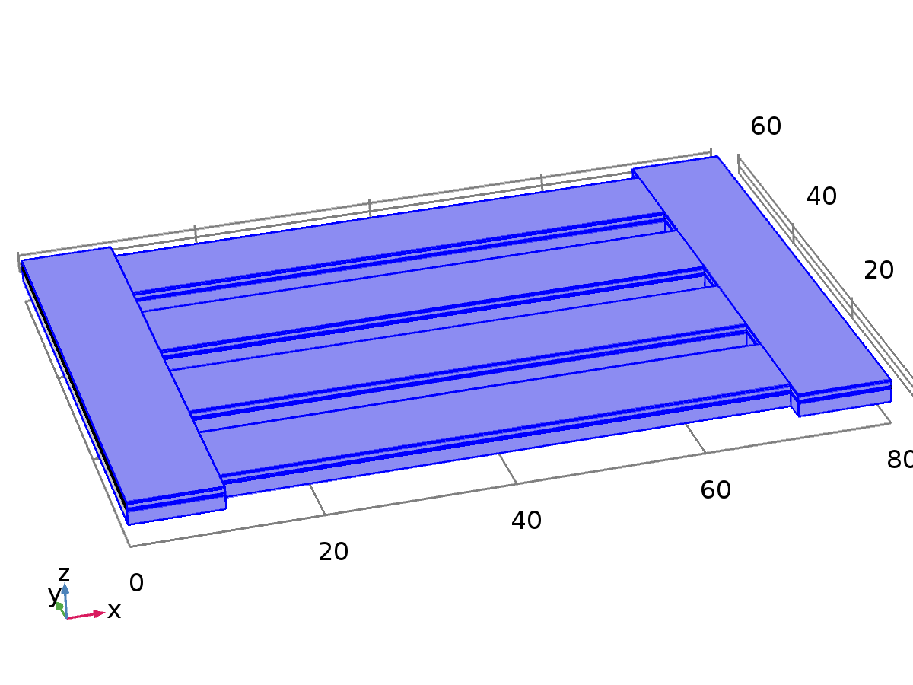

Free 1

Selection

|  |  |
| --- | --- |
| Geometric entity level | Boundary |
| Selection | Boundaries 2–3, 5, 8, 11, 14, 16–26, 28–29, 31, 34, 37, 40, 42–52, 54–55, 57, 60, 63, 66, 68–78, 80–81, 83, 86, 89, 92, 94–104, 106–107, 109, 112, 115, 118, 120–135, 137–138, 140–141, 143–144, 146, 152–156, 162–166, 172–176, 182–191 |

Used products

|  |
| --- |
| COMSOL Multiphysics |

* + 1. Initial Values 1



Initial Values 1

Selection

|  |  |
| --- | --- |
| Geometric entity level | Domain |
| Selection | Domains 1–30 |

Used products

|  |
| --- |
| COMSOL Multiphysics |

#### Variables

| **Name** | **Expression** | **Unit** | **Description** | **Selection** |
| --- | --- | --- | --- | --- |
| solid.uInitx | 0 | m | Initial value of displacement, x component | Domains 1–30 |
| solid.uInity | 0 | m | Initial value of displacement, y component | Domains 1–30 |
| solid.uInitz | 0 | m | Initial value of displacement, z component | Domains 1–30 |
| solid.utInitx | 0 | m/s | Initial value of structural velocity, x component | Domains 1–30 |
| solid.utInity | 0 | m/s | Initial value of structural velocity, y component | Domains 1–30 |
| solid.utInitz | 0 | m/s | Initial value of structural velocity, z component | Domains 1–30 |

* + 1. Piezoelectric Material 1



Piezoelectric Material 1

Selection

|  |  |
| --- | --- |
| Geometric entity level | Domain |
| Selection | Domains 4, 9, 14, 19, 24, 29 |

Equations















Settings

| **Description** | **Value** |
| --- | --- |
| Constitutive relation | Stress - charge form |
| Remanent electric displacement, X component | 0 |
| Remanent electric displacement, Y component | 0 |
| Remanent electric displacement, Z component | 0 |
| Force linear strains | Off |
| Calculate dissipated energy | Off |
| Elasticity matrix (ordering: xx, yy, zz, yz, xz, xy) | From material |
| Coupling matrix | From material |
| Relative permittivity | From material |
| Density | From material |

Properties from material

| **Property** | **Material** | **Property group** |
| --- | --- | --- |
| Elasticity matrix (ordering: xx, yy, zz, yz, xz, xy) | Lead Zirconate Titanate (PZT-5H) | Stress-charge form |
| Coupling matrix | Lead Zirconate Titanate (PZT-5H) | Stress-charge form |
| Relative permittivity | Lead Zirconate Titanate (PZT-5H) | Stress-charge form |
| Density | Lead Zirconate Titanate (PZT-5H) | Basic |

#### Variables

| **Name** | **Expression** | **Unit** | **Description** | **Selection** |
| --- | --- | --- | --- | --- |
| solid.DrX | solid.Dr1 | C/m² | Remanent electric displacement, X component | Domains 4, 9, 14, 19, 24, 29 |
| solid.DrY | solid.Dr2 | C/m² | Remanent electric displacement, Y component | Domains 4, 9, 14, 19, 24, 29 |
| solid.DrZ | solid.Dr3 | C/m² | Remanent electric displacement, Z component | Domains 4, 9, 14, 19, 24, 29 |
| solid.epsilonrXX | solid.epsilonrS11 | 1 | Relative permittivity, piezoelectric solid, XX component | Domains 4, 9, 14, 19, 24, 29 |
| solid.epsilonrYX | solid.epsilonrS21 | 1 | Relative permittivity, piezoelectric solid, YX component | Domains 4, 9, 14, 19, 24, 29 |
| solid.epsilonrZX | solid.epsilonrS31 | 1 | Relative permittivity, piezoelectric solid, ZX component | Domains 4, 9, 14, 19, 24, 29 |
| solid.epsilonrXY | solid.epsilonrS12 | 1 | Relative permittivity, piezoelectric solid, XY component | Domains 4, 9, 14, 19, 24, 29 |
| solid.epsilonrYY | solid.epsilonrS22 | 1 | Relative permittivity, piezoelectric solid, YY component | Domains 4, 9, 14, 19, 24, 29 |
| solid.epsilonrZY | solid.epsilonrS32 | 1 | Relative permittivity, piezoelectric solid, ZY component | Domains 4, 9, 14, 19, 24, 29 |
| solid.epsilonrXZ | solid.epsilonrS13 | 1 | Relative permittivity, piezoelectric solid, XZ component | Domains 4, 9, 14, 19, 24, 29 |
| solid.epsilonrYZ | solid.epsilonrS23 | 1 | Relative permittivity, piezoelectric solid, YZ component | Domains 4, 9, 14, 19, 24, 29 |
| solid.epsilonrZZ | solid.epsilonrS33 | 1 | Relative permittivity, piezoelectric solid, ZZ component | Domains 4, 9, 14, 19, 24, 29 |
| solid.PpzeX | solid.eES11*solid.eel11+solid.eES12*solid.eel22+solid.eES13*solid.eel33+2*solid.eES14*solid.eel23+2*solid.eES15*solid.eel13+2*solid.eES16*solid.eel12 | C/m² | Piezoelectric polarization, X component | Domains 4, 9, 14, 19, 24, 29 |
| solid.PpzeY | solid.eES21*solid.eel11+solid.eES22*solid.eel22+solid.eES23*solid.eel33+2*solid.eES24*solid.eel23+2*solid.eES25*solid.eel13+2*solid.eES26*solid.eel12 | C/m² | Piezoelectric polarization, Y component | Domains 4, 9, 14, 19, 24, 29 |
| solid.PpzeZ | solid.eES31*solid.eel11+solid.eES32*solid.eel22+solid.eES33*solid.eel33+2*solid.eES34*solid.eel23+2*solid.eES35*solid.eel13+2*solid.eES36*solid.eel12 | C/m² | Piezoelectric polarization, Z component | Domains 4, 9, 14, 19, 24, 29 |
| solid.EpzeX | 0 | V/m | Electric field, X component | Domains 4, 9, 14, 19, 24, 29 |
| solid.EpzeY | 0 | V/m | Electric field, Y component | Domains 4, 9, 14, 19, 24, 29 |
| solid.EpzeZ | 0 | V/m | Electric field, Z component | Domains 4, 9, 14, 19, 24, 29 |
| solid.DpzeX | 0 | C/m² | Electric displacement field, X component | Domains 4, 9, 14, 19, 24, 29 |
| solid.DpzeY | 0 | C/m² | Electric displacement field, Y component | Domains 4, 9, 14, 19, 24, 29 |
| solid.DpzeZ | 0 | C/m² | Electric displacement field, Z component | Domains 4, 9, 14, 19, 24, 29 |
| solid.rho | material.rho | kg/m³ | Density | Domains 4, 9, 14, 19, 24, 29 |
| solid.Qh | 0 | W/m³ | Total power dissipation density | Domains 4, 9, 14, 19, 24, 29 |
| uTXt | uTXTIME | 1/s | Tangential gradient of u, X component, first time derivative | Boundaries 10–12, 15, 20, 25, 36–38, 41, 49–50, 62–64, 67, 75–76, 88–90, 93, 101–102, 114–116, 119, 127–128, 140–142, 145, 150, 155, 160, 165, 170, 175, 180, 185, 190, 195 |
| uTYt | uTYTIME | 1/s | Tangential gradient of u, Y component, first time derivative | Boundaries 10–12, 15, 20, 25, 36–38, 41, 49–50, 62–64, 67, 75–76, 88–90, 93, 101–102, 114–116, 119, 127–128, 140–142, 145, 150, 155, 160, 165, 170, 175, 180, 185, 190, 195 |
| uTZt | uTZTIME | 1/s | Tangential gradient of u, Z component, first time derivative | Boundaries 10–12, 15, 20, 25, 36–38, 41, 49–50, 62–64, 67, 75–76, 88–90, 93, 101–102, 114–116, 119, 127–128, 140–142, 145, 150, 155, 160, 165, 170, 175, 180, 185, 190, 195 |
| uTXtt | uTXTIMETIME | 1/s² | Tangential gradient of u, X component, second time derivative | Boundaries 10–12, 15, 20, 25, 36–38, 41, 49–50, 62–64, 67, 75–76, 88–90, 93, 101–102, 114–116, 119, 127–128, 140–142, 145, 150, 155, 160, 165, 170, 175, 180, 185, 190, 195 |
| uTYtt | uTYTIMETIME | 1/s² | Tangential gradient of u, Y component, second time derivative | Boundaries 10–12, 15, 20, 25, 36–38, 41, 49–50, 62–64, 67, 75–76, 88–90, 93, 101–102, 114–116, 119, 127–128, 140–142, 145, 150, 155, 160, 165, 170, 175, 180, 185, 190, 195 |
| uTZtt | uTZTIMETIME | 1/s² | Tangential gradient of u, Z component, second time derivative | Boundaries 10–12, 15, 20, 25, 36–38, 41, 49–50, 62–64, 67, 75–76, 88–90, 93, 101–102, 114–116, 119, 127–128, 140–142, 145, 150, 155, 160, 165, 170, 175, 180, 185, 190, 195 |
| uXt | uXTIME | 1/s | Gradient of u, X component, first time derivative | Domains 4, 9, 14, 19, 24, 29 |
| uYt | uYTIME | 1/s | Gradient of u, Y component, first time derivative | Domains 4, 9, 14, 19, 24, 29 |
| uZt | uZTIME | 1/s | Gradient of u, Z component, first time derivative | Domains 4, 9, 14, 19, 24, 29 |
| uXtt | uXTIMETIME | 1/s² | Gradient of u, X component, second time derivative | Domains 4, 9, 14, 19, 24, 29 |
| uYtt | uYTIMETIME | 1/s² | Gradient of u, Y component, second time derivative | Domains 4, 9, 14, 19, 24, 29 |
| uZtt | uZTIMETIME | 1/s² | Gradient of u, Z component, second time derivative | Domains 4, 9, 14, 19, 24, 29 |
| vTXt | vTXTIME | 1/s | Tangential gradient of v, X component, first time derivative | Boundaries 10–12, 15, 20, 25, 36–38, 41, 49–50, 62–64, 67, 75–76, 88–90, 93, 101–102, 114–116, 119, 127–128, 140–142, 145, 150, 155, 160, 165, 170, 175, 180, 185, 190, 195 |
| vTYt | vTYTIME | 1/s | Tangential gradient of v, Y component, first time derivative | Boundaries 10–12, 15, 20, 25, 36–38, 41, 49–50, 62–64, 67, 75–76, 88–90, 93, 101–102, 114–116, 119, 127–128, 140–142, 145, 150, 155, 160, 165, 170, 175, 180, 185, 190, 195 |
| vTZt | vTZTIME | 1/s | Tangential gradient of v, Z component, first time derivative | Boundaries 10–12, 15, 20, 25, 36–38, 41, 49–50, 62–64, 67, 75–76, 88–90, 93, 101–102, 114–116, 119, 127–128, 140–142, 145, 150, 155, 160, 165, 170, 175, 180, 185, 190, 195 |
| vTXtt | vTXTIMETIME | 1/s² | Tangential gradient of v, X component, second time derivative | Boundaries 10–12, 15, 20, 25, 36–38, 41, 49–50, 62–64, 67, 75–76, 88–90, 93, 101–102, 114–116, 119, 127–128, 140–142, 145, 150, 155, 160, 165, 170, 175, 180, 185, 190, 195 |
| vTYtt | vTYTIMETIME | 1/s² | Tangential gradient of v, Y component, second time derivative | Boundaries 10–12, 15, 20, 25, 36–38, 41, 49–50, 62–64, 67, 75–76, 88–90, 93, 101–102, 114–116, 119, 127–128, 140–142, 145, 150, 155, 160, 165, 170, 175, 180, 185, 190, 195 |
| vTZtt | vTZTIMETIME | 1/s² | Tangential gradient of v, Z component, second time derivative | Boundaries 10–12, 15, 20, 25, 36–38, 41, 49–50, 62–64, 67, 75–76, 88–90, 93, 101–102, 114–116, 119, 127–128, 140–142, 145, 150, 155, 160, 165, 170, 175, 180, 185, 190, 195 |
| vXt | vXTIME | 1/s | Gradient of v, X component, first time derivative | Domains 4, 9, 14, 19, 24, 29 |
| vYt | vYTIME | 1/s | Gradient of v, Y component, first time derivative | Domains 4, 9, 14, 19, 24, 29 |
| vZt | vZTIME | 1/s | Gradient of v, Z component, first time derivative | Domains 4, 9, 14, 19, 24, 29 |
| vXtt | vXTIMETIME | 1/s² | Gradient of v, X component, second time derivative | Domains 4, 9, 14, 19, 24, 29 |
| vYtt | vYTIMETIME | 1/s² | Gradient of v, Y component, second time derivative | Domains 4, 9, 14, 19, 24, 29 |
| vZtt | vZTIMETIME | 1/s² | Gradient of v, Z component, second time derivative | Domains 4, 9, 14, 19, 24, 29 |
| wTXt | wTXTIME | 1/s | Tangential gradient of w, X component, first time derivative | Boundaries 10–12, 15, 20, 25, 36–38, 41, 49–50, 62–64, 67, 75–76, 88–90, 93, 101–102, 114–116, 119, 127–128, 140–142, 145, 150, 155, 160, 165, 170, 175, 180, 185, 190, 195 |
| wTYt | wTYTIME | 1/s | Tangential gradient of w, Y component, first time derivative | Boundaries 10–12, 15, 20, 25, 36–38, 41, 49–50, 62–64, 67, 75–76, 88–90, 93, 101–102, 114–116, 119, 127–128, 140–142, 145, 150, 155, 160, 165, 170, 175, 180, 185, 190, 195 |
| wTZt | wTZTIME | 1/s | Tangential gradient of w, Z component, first time derivative | Boundaries 10–12, 15, 20, 25, 36–38, 41, 49–50, 62–64, 67, 75–76, 88–90, 93, 101–102, 114–116, 119, 127–128, 140–142, 145, 150, 155, 160, 165, 170, 175, 180, 185, 190, 195 |
| wTXtt | wTXTIMETIME | 1/s² | Tangential gradient of w, X component, second time derivative | Boundaries 10–12, 15, 20, 25, 36–38, 41, 49–50, 62–64, 67, 75–76, 88–90, 93, 101–102, 114–116, 119, 127–128, 140–142, 145, 150, 155, 160, 165, 170, 175, 180, 185, 190, 195 |
| wTYtt | wTYTIMETIME | 1/s² | Tangential gradient of w, Y component, second time derivative | Boundaries 10–12, 15, 20, 25, 36–38, 41, 49–50, 62–64, 67, 75–76, 88–90, 93, 101–102, 114–116, 119, 127–128, 140–142, 145, 150, 155, 160, 165, 170, 175, 180, 185, 190, 195 |
| wTZtt | wTZTIMETIME | 1/s² | Tangential gradient of w, Z component, second time derivative | Boundaries 10–12, 15, 20, 25, 36–38, 41, 49–50, 62–64, 67, 75–76, 88–90, 93, 101–102, 114–116, 119, 127–128, 140–142, 145, 150, 155, 160, 165, 170, 175, 180, 185, 190, 195 |
| wXt | wXTIME | 1/s | Gradient of w, X component, first time derivative | Domains 4, 9, 14, 19, 24, 29 |
| wYt | wYTIME | 1/s | Gradient of w, Y component, first time derivative | Domains 4, 9, 14, 19, 24, 29 |
| wZt | wZTIME | 1/s | Gradient of w, Z component, first time derivative | Domains 4, 9, 14, 19, 24, 29 |
| wXtt | wXTIMETIME | 1/s² | Gradient of w, X component, second time derivative | Domains 4, 9, 14, 19, 24, 29 |
| wYtt | wYTIMETIME | 1/s² | Gradient of w, Y component, second time derivative | Domains 4, 9, 14, 19, 24, 29 |
| wZtt | wZTIMETIME | 1/s² | Gradient of w, Z component, second time derivative | Domains 4, 9, 14, 19, 24, 29 |
| ut | uTIME | m/s | Structural velocity field, X component | Domains 4, 9, 14, 19, 24, 29 |
| vt | vTIME | m/s | Structural velocity field, Y component | Domains 4, 9, 14, 19, 24, 29 |
| wt | wTIME | m/s | Structural velocity field, Z component | Domains 4, 9, 14, 19, 24, 29 |
| utt | uTIMETIME | m/s² | Acceleration field, X component | Domains 4, 9, 14, 19, 24, 29 |
| vtt | vTIMETIME | m/s² | Acceleration field, Y component | Domains 4, 9, 14, 19, 24, 29 |
| wtt | wTIMETIME | m/s² | Acceleration field, Z component | Domains 4, 9, 14, 19, 24, 29 |
| solid.gradUxX | uX | 1 | Displacement gradient, xX component | Domains 4, 9, 14, 19, 24, 29 |
| solid.gradUyX | vX | 1 | Displacement gradient, yX component | Domains 4, 9, 14, 19, 24, 29 |
| solid.gradUzX | wX | 1 | Displacement gradient, zX component | Domains 4, 9, 14, 19, 24, 29 |
| solid.gradUxY | uY | 1 | Displacement gradient, xY component | Domains 4, 9, 14, 19, 24, 29 |
| solid.gradUyY | vY | 1 | Displacement gradient, yY component | Domains 4, 9, 14, 19, 24, 29 |
| solid.gradUzY | wY | 1 | Displacement gradient, zY component | Domains 4, 9, 14, 19, 24, 29 |
| solid.gradUxZ | uZ | 1 | Displacement gradient, xZ component | Domains 4, 9, 14, 19, 24, 29 |
| solid.gradUyZ | vZ | 1 | Displacement gradient, yZ component | Domains 4, 9, 14, 19, 24, 29 |
| solid.gradUzZ | wZ | 1 | Displacement gradient, zZ component | Domains 4, 9, 14, 19, 24, 29 |
| solid.FdxX | 1+solid.gradUxX | 1 | Deformation gradient, xX component | Domains 4, 9, 14, 19, 24, 29 |
| solid.FdyX | solid.gradUyX | 1 | Deformation gradient, yX component | Domains 4, 9, 14, 19, 24, 29 |
| solid.FdzX | solid.gradUzX | 1 | Deformation gradient, zX component | Domains 4, 9, 14, 19, 24, 29 |
| solid.FdxY | solid.gradUxY | 1 | Deformation gradient, xY component | Domains 4, 9, 14, 19, 24, 29 |
| solid.FdyY | 1+solid.gradUyY | 1 | Deformation gradient, yY component | Domains 4, 9, 14, 19, 24, 29 |
| solid.FdzY | solid.gradUzY | 1 | Deformation gradient, zY component | Domains 4, 9, 14, 19, 24, 29 |
| solid.FdxZ | solid.gradUxZ | 1 | Deformation gradient, xZ component | Domains 4, 9, 14, 19, 24, 29 |
| solid.FdyZ | solid.gradUyZ | 1 | Deformation gradient, yZ component | Domains 4, 9, 14, 19, 24, 29 |
| solid.FdzZ | 1+solid.gradUzZ | 1 | Deformation gradient, zZ component | Domains 4, 9, 14, 19, 24, 29 |
| solid.Fdlx1 | solid.FdxX | 1 | Deformation gradient, local, x1 component | Domains 4, 9, 14, 19, 24, 29 |
| solid.Fdly1 | solid.FdyX | 1 | Deformation gradient, local, y1 component | Domains 4, 9, 14, 19, 24, 29 |
| solid.Fdlz1 | solid.FdzX | 1 | Deformation gradient, local, z1 component | Domains 4, 9, 14, 19, 24, 29 |
| solid.Fdlx2 | solid.FdxY | 1 | Deformation gradient, local, x2 component | Domains 4, 9, 14, 19, 24, 29 |
| solid.Fdly2 | solid.FdyY | 1 | Deformation gradient, local, y2 component | Domains 4, 9, 14, 19, 24, 29 |
| solid.Fdlz2 | solid.FdzY | 1 | Deformation gradient, local, z2 component | Domains 4, 9, 14, 19, 24, 29 |
| solid.Fdlx3 | solid.FdxZ | 1 | Deformation gradient, local, x3 component | Domains 4, 9, 14, 19, 24, 29 |
| solid.Fdly3 | solid.FdyZ | 1 | Deformation gradient, local, y3 component | Domains 4, 9, 14, 19, 24, 29 |
| solid.Fdlz3 | solid.FdzZ | 1 | Deformation gradient, local, z3 component | Domains 4, 9, 14, 19, 24, 29 |
| solid.D11 | solid.cE11 | Pa | Elasticity matrix, 11 component | Domains 4, 9, 14, 19, 24, 29 |
| solid.D12 | solid.cE12 | Pa | Elasticity matrix, 12 component | Domains 4, 9, 14, 19, 24, 29 |
| solid.D13 | solid.cE13 | Pa | Elasticity matrix, 13 component | Domains 4, 9, 14, 19, 24, 29 |
| solid.D14 | solid.cE16 | Pa | Elasticity matrix, 14 component | Domains 4, 9, 14, 19, 24, 29 |
| solid.D15 | solid.cE14 | Pa | Elasticity matrix, 15 component | Domains 4, 9, 14, 19, 24, 29 |
| solid.D16 | solid.cE15 | Pa | Elasticity matrix, 16 component | Domains 4, 9, 14, 19, 24, 29 |
| solid.D22 | solid.cE22 | Pa | Elasticity matrix, 22 component | Domains 4, 9, 14, 19, 24, 29 |
| solid.D23 | solid.cE23 | Pa | Elasticity matrix, 23 component | Domains 4, 9, 14, 19, 24, 29 |
| solid.D24 | solid.cE26 | Pa | Elasticity matrix, 24 component | Domains 4, 9, 14, 19, 24, 29 |
| solid.D25 | solid.cE24 | Pa | Elasticity matrix, 25 component | Domains 4, 9, 14, 19, 24, 29 |
| solid.D26 | solid.cE25 | Pa | Elasticity matrix, 26 component | Domains 4, 9, 14, 19, 24, 29 |
| solid.D33 | solid.cE33 | Pa | Elasticity matrix, 33 component | Domains 4, 9, 14, 19, 24, 29 |
| solid.D34 | solid.cE36 | Pa | Elasticity matrix, 34 component | Domains 4, 9, 14, 19, 24, 29 |
| solid.D35 | solid.cE34 | Pa | Elasticity matrix, 35 component | Domains 4, 9, 14, 19, 24, 29 |
| solid.D36 | solid.cE35 | Pa | Elasticity matrix, 36 component | Domains 4, 9, 14, 19, 24, 29 |
| solid.D44 | solid.cE66 | Pa | Elasticity matrix, 44 component | Domains 4, 9, 14, 19, 24, 29 |
| solid.D45 | solid.cE46 | Pa | Elasticity matrix, 45 component | Domains 4, 9, 14, 19, 24, 29 |
| solid.D46 | solid.cE56 | Pa | Elasticity matrix, 46 component | Domains 4, 9, 14, 19, 24, 29 |
| solid.D55 | solid.cE44 | Pa | Elasticity matrix, 55 component | Domains 4, 9, 14, 19, 24, 29 |
| solid.D56 | solid.cE45 | Pa | Elasticity matrix, 56 component | Domains 4, 9, 14, 19, 24, 29 |
| solid.D66 | solid.cE55 | Pa | Elasticity matrix, 66 component | Domains 4, 9, 14, 19, 24, 29 |
| solid.K | (solid.Cgl11+solid.Cgl22+solid.Cgl33)/9 | N/m² | Bulk modulus | Domains 4, 9, 14, 19, 24, 29 |
| solid.Eequ | 9*solid.K*solid.Gequ/(3*solid.K+solid.Gequ) | Pa | Equivalent Young's modulus | Domains 4, 9, 14, 19, 24, 29 |
| solid.nuequ | -1+0.5*solid.Eequ/solid.Gequ | 1 | Equivalent Poisson's ratio | Domains 4, 9, 14, 19, 24, 29 |
| solid.Gequ | (solid.D11+solid.D22+solid.D33-solid.D12-solid.D23-solid.D13)/15+0.2*(solid.D44+solid.D55+solid.D66) | N/m² | Equivalent shear modulus | Domains 4, 9, 14, 19, 24, 29 |
| solid.cp | sqrt((solid.Kequ+4*solid.Gequ/3)/solid.rho) | m/s | Pressure-wave speed | Domains 4, 9, 14, 19, 24, 29 |
| solid.cs | sqrt(solid.Gequ/solid.rho) | m/s | Shear-wave speed | Domains 4, 9, 14, 19, 24, 29 |
| solid.Cgl11 | solid.D11+solid.D12+solid.D13 | Pa | C:g tensor, local coordinate system, 11 component | Domains 4, 9, 14, 19, 24, 29 |
| solid.Cgl12 | solid.D14+solid.D24+solid.D34 | Pa | C:g tensor, local coordinate system, 12 component | Domains 4, 9, 14, 19, 24, 29 |
| solid.Cgl13 | solid.D16+solid.D26+solid.D36 | Pa | C:g tensor, local coordinate system, 13 component | Domains 4, 9, 14, 19, 24, 29 |
| solid.Cgl22 | solid.D12+solid.D22+solid.D23 | Pa | C:g tensor, local coordinate system, 22 component | Domains 4, 9, 14, 19, 24, 29 |
| solid.Cgl23 | solid.D15+solid.D25+solid.D35 | Pa | C:g tensor, local coordinate system, 23 component | Domains 4, 9, 14, 19, 24, 29 |
| solid.Cgl33 | solid.D13+solid.D23+solid.D33 | Pa | C:g tensor, local coordinate system, 33 component | Domains 4, 9, 14, 19, 24, 29 |
| solid.eXX | uX | 1 | Strain tensor, XX component | Domains 4, 9, 14, 19, 24, 29 |
| solid.eXY | 0.5*(uY+vX) | 1 | Strain tensor, XY component | Domains 4, 9, 14, 19, 24, 29 |
| solid.eXZ | 0.5*(uZ+wX) | 1 | Strain tensor, XZ component | Domains 4, 9, 14, 19, 24, 29 |
| solid.eYY | vY | 1 | Strain tensor, YY component | Domains 4, 9, 14, 19, 24, 29 |
| solid.eYZ | 0.5*(vZ+wY) | 1 | Strain tensor, YZ component | Domains 4, 9, 14, 19, 24, 29 |
| solid.eZZ | wZ | 1 | Strain tensor, ZZ component | Domains 4, 9, 14, 19, 24, 29 |
| solid.el11 | solid.eXX | 1 | Strain tensor, local coordinate system, 11 component | Domains 4, 9, 14, 19, 24, 29 |
| solid.el12 | solid.eXY | 1 | Strain tensor, local coordinate system, 12 component | Domains 4, 9, 14, 19, 24, 29 |
| solid.el13 | solid.eXZ | 1 | Strain tensor, local coordinate system, 13 component | Domains 4, 9, 14, 19, 24, 29 |
| solid.el22 | solid.eYY | 1 | Strain tensor, local coordinate system, 22 component | Domains 4, 9, 14, 19, 24, 29 |
| solid.el23 | solid.eYZ | 1 | Strain tensor, local coordinate system, 23 component | Domains 4, 9, 14, 19, 24, 29 |
| solid.el33 | solid.eZZ | 1 | Strain tensor, local coordinate system, 33 component | Domains 4, 9, 14, 19, 24, 29 |
| solid.eel11 | solid.el11-solid.eil11-solid.eiel11 | 1 | Elastic strain tensor, local coordinate system, 11 component | Domains 4, 9, 14, 19, 24, 29 |
| solid.eel12 | solid.el12-solid.eil12-solid.eiel12 | 1 | Elastic strain tensor, local coordinate system, 12 component | Domains 4, 9, 14, 19, 24, 29 |
| solid.eel13 | solid.el13-solid.eil13-solid.eiel13 | 1 | Elastic strain tensor, local coordinate system, 13 component | Domains 4, 9, 14, 19, 24, 29 |
| solid.eel22 | solid.el22-solid.eil22-solid.eiel22 | 1 | Elastic strain tensor, local coordinate system, 22 component | Domains 4, 9, 14, 19, 24, 29 |
| solid.eel23 | solid.el23-solid.eil23-solid.eiel23 | 1 | Elastic strain tensor, local coordinate system, 23 component | Domains 4, 9, 14, 19, 24, 29 |
| solid.eel33 | solid.el33-solid.eil33-solid.eiel33 | 1 | Elastic strain tensor, local coordinate system, 33 component | Domains 4, 9, 14, 19, 24, 29 |
| solid.Cel11 | 1+2*solid.eel11 | 1 | Elastic Cauchy-Green tensor, local coordinate system, 11 component | Domains 4, 9, 14, 19, 24, 29 |
| solid.Cel12 | 2*solid.eel12 | 1 | Elastic Cauchy-Green tensor, local coordinate system, 12 component | Domains 4, 9, 14, 19, 24, 29 |
| solid.Cel13 | 2*solid.eel13 | 1 | Elastic Cauchy-Green tensor, local coordinate system, 13 component | Domains 4, 9, 14, 19, 24, 29 |
| solid.Cel22 | 1+2*solid.eel22 | 1 | Elastic Cauchy-Green tensor, local coordinate system, 22 component | Domains 4, 9, 14, 19, 24, 29 |
| solid.Cel23 | 2*solid.eel23 | 1 | Elastic Cauchy-Green tensor, local coordinate system, 23 component | Domains 4, 9, 14, 19, 24, 29 |
| solid.Cel33 | 1+2*solid.eel33 | 1 | Elastic Cauchy-Green tensor, local coordinate system, 33 component | Domains 4, 9, 14, 19, 24, 29 |
| solid.eil11 | 0 | 1 | Initial strain tensor, local coordinate system, 11 component | Domains 4, 9, 14, 19, 24, 29 |
| solid.eil12 | 0 | 1 | Initial strain tensor, local coordinate system, 12 component | Domains 4, 9, 14, 19, 24, 29 |
| solid.eil13 | 0 | 1 | Initial strain tensor, local coordinate system, 13 component | Domains 4, 9, 14, 19, 24, 29 |
| solid.eil22 | 0 | 1 | Initial strain tensor, local coordinate system, 22 component | Domains 4, 9, 14, 19, 24, 29 |
| solid.eil23 | 0 | 1 | Initial strain tensor, local coordinate system, 23 component | Domains 4, 9, 14, 19, 24, 29 |
| solid.eil33 | 0 | 1 | Initial strain tensor, local coordinate system, 33 component | Domains 4, 9, 14, 19, 24, 29 |
| solid.eiel11 | 0 | 1 | Inelastic strain tensor, local coordinate system, 11 component | Domains 4, 9, 14, 19, 24, 29 |
| solid.eiel12 | 0 | 1 | Inelastic strain tensor, local coordinate system, 12 component | Domains 4, 9, 14, 19, 24, 29 |
| solid.eiel13 | 0 | 1 | Inelastic strain tensor, local coordinate system, 13 component | Domains 4, 9, 14, 19, 24, 29 |
| solid.eiel22 | 0 | 1 | Inelastic strain tensor, local coordinate system, 22 component | Domains 4, 9, 14, 19, 24, 29 |
| solid.eiel23 | 0 | 1 | Inelastic strain tensor, local coordinate system, 23 component | Domains 4, 9, 14, 19, 24, 29 |
| solid.eiel33 | 0 | 1 | Inelastic strain tensor, local coordinate system, 33 component | Domains 4, 9, 14, 19, 24, 29 |
| solid.evol | solid.eXX+solid.eYY+solid.eZZ | 1 | Volumetric strain | Domains 4, 9, 14, 19, 24, 29 |
| solid.J | solid.FdxX*solid.FdyY*solid.FdzZ+solid.FdxY*solid.FdyZ*solid.FdzX+solid.FdxZ*solid.FdyX*solid.FdzY-solid.FdxX*solid.FdyZ*solid.FdzY-solid.FdxY*solid.FdyX*solid.FdzZ-solid.FdxZ*solid.FdyY*solid.FdzX | 1 | Volume ratio | Domains 4, 9, 14, 19, 24, 29 |
| solid.Ceil11 | (solid.Cel22*solid.Cel33-solid.Cel23^2)/(solid.Cel11*solid.Cel22*solid.Cel33+2*solid.Cel12*solid.Cel23*solid.Cel13-solid.Cel11*solid.Cel23^2-solid.Cel12^2*solid.Cel33-solid.Cel22*solid.Cel13^2) | 1 | Elastic Cauchy-Green tensor inverse, local coordinate system, 11 component | Domains 4, 9, 14, 19, 24, 29 |
| solid.Ceil12 | (solid.Cel23*solid.Cel13-solid.Cel12*solid.Cel33)/(solid.Cel11*solid.Cel22*solid.Cel33+2*solid.Cel12*solid.Cel23*solid.Cel13-solid.Cel11*solid.Cel23^2-solid.Cel12^2*solid.Cel33-solid.Cel22*solid.Cel13^2) | 1 | Elastic Cauchy-Green tensor inverse, local coordinate system, 12 component | Domains 4, 9, 14, 19, 24, 29 |
| solid.Ceil13 | (solid.Cel12*solid.Cel23-solid.Cel22*solid.Cel13)/(solid.Cel11*solid.Cel22*solid.Cel33+2*solid.Cel12*solid.Cel23*solid.Cel13-solid.Cel11*solid.Cel23^2-solid.Cel12^2*solid.Cel33-solid.Cel22*solid.Cel13^2) | 1 | Elastic Cauchy-Green tensor inverse, local coordinate system, 13 component | Domains 4, 9, 14, 19, 24, 29 |
| solid.Ceil22 | (solid.Cel11*solid.Cel33-solid.Cel13^2)/(solid.Cel11*solid.Cel22*solid.Cel33+2*solid.Cel12*solid.Cel23*solid.Cel13-solid.Cel11*solid.Cel23^2-solid.Cel12^2*solid.Cel33-solid.Cel22*solid.Cel13^2) | 1 | Elastic Cauchy-Green tensor inverse, local coordinate system, 22 component | Domains 4, 9, 14, 19, 24, 29 |
| solid.Ceil23 | (solid.Cel12*solid.Cel13-solid.Cel11*solid.Cel23)/(solid.Cel11*solid.Cel22*solid.Cel33+2*solid.Cel12*solid.Cel23*solid.Cel13-solid.Cel11*solid.Cel23^2-solid.Cel12^2*solid.Cel33-solid.Cel22*solid.Cel13^2) | 1 | Elastic Cauchy-Green tensor inverse, local coordinate system, 23 component | Domains 4, 9, 14, 19, 24, 29 |
| solid.Ceil33 | (solid.Cel11*solid.Cel22-solid.Cel12^2)/(solid.Cel11*solid.Cel22*solid.Cel33+2*solid.Cel12*solid.Cel23*solid.Cel13-solid.Cel11*solid.Cel23^2-solid.Cel12^2*solid.Cel33-solid.Cel22*solid.Cel13^2) | 1 | Elastic Cauchy-Green tensor inverse, local coordinate system, 33 component | Domains 4, 9, 14, 19, 24, 29 |
| solid.Jel | sqrt(solid.Cel11*solid.Cel22*solid.Cel33+2*solid.Cel12*solid.Cel23*solid.Cel13-solid.Cel11*solid.Cel23^2-solid.Cel12^2*solid.Cel33-solid.Cel22*solid.Cel13^2) | 1 | Elastic volume ratio | Domains 4, 9, 14, 19, 24, 29 |
| solid.eX | solid.eXX | 1 | Strain tensor, X component | Domains 4, 9, 14, 19, 24, 29 |
| solid.eY | solid.eYY | 1 | Strain tensor, Y component | Domains 4, 9, 14, 19, 24, 29 |
| solid.eZ | solid.eZZ | 1 | Strain tensor, Z component | Domains 4, 9, 14, 19, 24, 29 |
| solid.Sil11 | 0 | N/m² | Initial stress tensor, local coordinate system, 11 component | Domains 4, 9, 14, 19, 24, 29 |
| solid.Sil12 | 0 | N/m² | Initial stress tensor, local coordinate system, 12 component | Domains 4, 9, 14, 19, 24, 29 |
| solid.Sil13 | 0 | N/m² | Initial stress tensor, local coordinate system, 13 component | Domains 4, 9, 14, 19, 24, 29 |
| solid.Sil22 | 0 | N/m² | Initial stress tensor, local coordinate system, 22 component | Domains 4, 9, 14, 19, 24, 29 |
| solid.Sil23 | 0 | N/m² | Initial stress tensor, local coordinate system, 23 component | Domains 4, 9, 14, 19, 24, 29 |
| solid.Sil33 | 0 | N/m² | Initial stress tensor, local coordinate system, 33 component | Domains 4, 9, 14, 19, 24, 29 |
| solid.Fiil11 | 1 | 1 | Inelastic deformation gradient inverse, local coordinate system, 11 component | Domains 4, 9, 14, 19, 24, 29 |
| solid.Fiil21 | 0 | 1 | Inelastic deformation gradient inverse, local coordinate system, 21 component | Domains 4, 9, 14, 19, 24, 29 |
| solid.Fiil31 | 0 | 1 | Inelastic deformation gradient inverse, local coordinate system, 31 component | Domains 4, 9, 14, 19, 24, 29 |
| solid.Fiil12 | 0 | 1 | Inelastic deformation gradient inverse, local coordinate system, 12 component | Domains 4, 9, 14, 19, 24, 29 |
| solid.Fiil22 | 1 | 1 | Inelastic deformation gradient inverse, local coordinate system, 22 component | Domains 4, 9, 14, 19, 24, 29 |
| solid.Fiil32 | 0 | 1 | Inelastic deformation gradient inverse, local coordinate system, 32 component | Domains 4, 9, 14, 19, 24, 29 |
| solid.Fiil13 | 0 | 1 | Inelastic deformation gradient inverse, local coordinate system, 13 component | Domains 4, 9, 14, 19, 24, 29 |
| solid.Fiil23 | 0 | 1 | Inelastic deformation gradient inverse, local coordinate system, 23 component | Domains 4, 9, 14, 19, 24, 29 |
| solid.Fiil33 | 1 | 1 | Inelastic deformation gradient inverse, local coordinate system, 33 component | Domains 4, 9, 14, 19, 24, 29 |
| solid.Sl11 | solid.Sil11+(solid.Fiil11*(solid.D11*solid.eel11+solid.D12*solid.eel22+solid.D13*solid.eel33+2*solid.D14*solid.eel12+2*solid.D15*solid.eel23+2*solid.D16*solid.eel13)+solid.Fiil12*(solid.D14*solid.eel11+solid.D24*solid.eel22+solid.D34*solid.eel33+2*solid.D44*solid.eel12+2*solid.D45*solid.eel23+2*solid.D46*solid.eel13)+solid.Fiil13*(solid.D16*solid.eel11+solid.D26*solid.eel22+solid.D36*solid.eel33+2*solid.D46*solid.eel12+2*solid.D56*solid.eel23+2*solid.D66*solid.eel13))*solid.Fiil11+(solid.Fiil11*(solid.D14*solid.eel11+solid.D24*solid.eel22+solid.D34*solid.eel33+2*solid.D44*solid.eel12+2*solid.D45*solid.eel23+2*solid.D46*solid.eel13)+solid.Fiil12*(solid.D12*solid.eel11+solid.D22*solid.eel22+solid.D23*solid.eel33+2*solid.D24*solid.eel12+2*solid.D25*solid.eel23+2*solid.D26*solid.eel13)+solid.Fiil13*(solid.D15*solid.eel11+solid.D25*solid.eel22+solid.D35*solid.eel33+2*solid.D45*solid.eel12+2*solid.D55*solid.eel23+2*solid.D56*solid.eel13))*solid.Fiil12+(solid.Fiil11*(solid.D16*solid.eel11+solid.D26*solid.eel22+solid.D36*solid.eel33+2*solid.D46*solid.eel12+2*solid.D56*solid.eel23+2*solid.D66*solid.eel13)+solid.Fiil12*(solid.D15*solid.eel11+solid.D25*solid.eel22+solid.D35*solid.eel33+2*solid.D45*solid.eel12+2*solid.D55*solid.eel23+2*solid.D56*solid.eel13)+solid.Fiil13*(solid.D13*solid.eel11+solid.D23*solid.eel22+solid.D33*solid.eel33+2*solid.D34*solid.eel12+2*solid.D35*solid.eel23+2*solid.D36*solid.eel13))*solid.Fiil13+solid.Spze11 | N/m² | Second Piola-Kirchhoff stress, local coordinate system, 11 component | Domains 4, 9, 14, 19, 24, 29 |
| solid.Sl12 | solid.Sil12+(solid.Fiil11*(solid.D11*solid.eel11+solid.D12*solid.eel22+solid.D13*solid.eel33+2*solid.D14*solid.eel12+2*solid.D15*solid.eel23+2*solid.D16*solid.eel13)+solid.Fiil12*(solid.D14*solid.eel11+solid.D24*solid.eel22+solid.D34*solid.eel33+2*solid.D44*solid.eel12+2*solid.D45*solid.eel23+2*solid.D46*solid.eel13)+solid.Fiil13*(solid.D16*solid.eel11+solid.D26*solid.eel22+solid.D36*solid.eel33+2*solid.D46*solid.eel12+2*solid.D56*solid.eel23+2*solid.D66*solid.eel13))*solid.Fiil21+(solid.Fiil11*(solid.D14*solid.eel11+solid.D24*solid.eel22+solid.D34*solid.eel33+2*solid.D44*solid.eel12+2*solid.D45*solid.eel23+2*solid.D46*solid.eel13)+solid.Fiil12*(solid.D12*solid.eel11+solid.D22*solid.eel22+solid.D23*solid.eel33+2*solid.D24*solid.eel12+2*solid.D25*solid.eel23+2*solid.D26*solid.eel13)+solid.Fiil13*(solid.D15*solid.eel11+solid.D25*solid.eel22+solid.D35*solid.eel33+2*solid.D45*solid.eel12+2*solid.D55*solid.eel23+2*solid.D56*solid.eel13))*solid.Fiil22+(solid.Fiil11*(solid.D16*solid.eel11+solid.D26*solid.eel22+solid.D36*solid.eel33+2*solid.D46*solid.eel12+2*solid.D56*solid.eel23+2*solid.D66*solid.eel13)+solid.Fiil12*(solid.D15*solid.eel11+solid.D25*solid.eel22+solid.D35*solid.eel33+2*solid.D45*solid.eel12+2*solid.D55*solid.eel23+2*solid.D56*solid.eel13)+solid.Fiil13*(solid.D13*solid.eel11+solid.D23*solid.eel22+solid.D33*solid.eel33+2*solid.D34*solid.eel12+2*solid.D35*solid.eel23+2*solid.D36*solid.eel13))*solid.Fiil23+solid.Spze12 | N/m² | Second Piola-Kirchhoff stress, local coordinate system, 12 component | Domains 4, 9, 14, 19, 24, 29 |
| solid.Sl13 | solid.Sil13+(solid.Fiil11*(solid.D11*solid.eel11+solid.D12*solid.eel22+solid.D13*solid.eel33+2*solid.D14*solid.eel12+2*solid.D15*solid.eel23+2*solid.D16*solid.eel13)+solid.Fiil12*(solid.D14*solid.eel11+solid.D24*solid.eel22+solid.D34*solid.eel33+2*solid.D44*solid.eel12+2*solid.D45*solid.eel23+2*solid.D46*solid.eel13)+solid.Fiil13*(solid.D16*solid.eel11+solid.D26*solid.eel22+solid.D36*solid.eel33+2*solid.D46*solid.eel12+2*solid.D56*solid.eel23+2*solid.D66*solid.eel13))*solid.Fiil31+(solid.Fiil11*(solid.D14*solid.eel11+solid.D24*solid.eel22+solid.D34*solid.eel33+2*solid.D44*solid.eel12+2*solid.D45*solid.eel23+2*solid.D46*solid.eel13)+solid.Fiil12*(solid.D12*solid.eel11+solid.D22*solid.eel22+solid.D23*solid.eel33+2*solid.D24*solid.eel12+2*solid.D25*solid.eel23+2*solid.D26*solid.eel13)+solid.Fiil13*(solid.D15*solid.eel11+solid.D25*solid.eel22+solid.D35*solid.eel33+2*solid.D45*solid.eel12+2*solid.D55*solid.eel23+2*solid.D56*solid.eel13))*solid.Fiil32+(solid.Fiil11*(solid.D16*solid.eel11+solid.D26*solid.eel22+solid.D36*solid.eel33+2*solid.D46*solid.eel12+2*solid.D56*solid.eel23+2*solid.D66*solid.eel13)+solid.Fiil12*(solid.D15*solid.eel11+solid.D25*solid.eel22+solid.D35*solid.eel33+2*solid.D45*solid.eel12+2*solid.D55*solid.eel23+2*solid.D56*solid.eel13)+solid.Fiil13*(solid.D13*solid.eel11+solid.D23*solid.eel22+solid.D33*solid.eel33+2*solid.D34*solid.eel12+2*solid.D35*solid.eel23+2*solid.D36*solid.eel13))*solid.Fiil33+solid.Spze13 | N/m² | Second Piola-Kirchhoff stress, local coordinate system, 13 component | Domains 4, 9, 14, 19, 24, 29 |
| solid.Sl22 | solid.Sil22+(solid.Fiil21*(solid.D11*solid.eel11+solid.D12*solid.eel22+solid.D13*solid.eel33+2*solid.D14*solid.eel12+2*solid.D15*solid.eel23+2*solid.D16*solid.eel13)+solid.Fiil22*(solid.D14*solid.eel11+solid.D24*solid.eel22+solid.D34*solid.eel33+2*solid.D44*solid.eel12+2*solid.D45*solid.eel23+2*solid.D46*solid.eel13)+solid.Fiil23*(solid.D16*solid.eel11+solid.D26*solid.eel22+solid.D36*solid.eel33+2*solid.D46*solid.eel12+2*solid.D56*solid.eel23+2*solid.D66*solid.eel13))*solid.Fiil21+(solid.Fiil21*(solid.D14*solid.eel11+solid.D24*solid.eel22+solid.D34*solid.eel33+2*solid.D44*solid.eel12+2*solid.D45*solid.eel23+2*solid.D46*solid.eel13)+solid.Fiil22*(solid.D12*solid.eel11+solid.D22*solid.eel22+solid.D23*solid.eel33+2*solid.D24*solid.eel12+2*solid.D25*solid.eel23+2*solid.D26*solid.eel13)+solid.Fiil23*(solid.D15*solid.eel11+solid.D25*solid.eel22+solid.D35*solid.eel33+2*solid.D45*solid.eel12+2*solid.D55*solid.eel23+2*solid.D56*solid.eel13))*solid.Fiil22+(solid.Fiil21*(solid.D16*solid.eel11+solid.D26*solid.eel22+solid.D36*solid.eel33+2*solid.D46*solid.eel12+2*solid.D56*solid.eel23+2*solid.D66*solid.eel13)+solid.Fiil22*(solid.D15*solid.eel11+solid.D25*solid.eel22+solid.D35*solid.eel33+2*solid.D45*solid.eel12+2*solid.D55*solid.eel23+2*solid.D56*solid.eel13)+solid.Fiil23*(solid.D13*solid.eel11+solid.D23*solid.eel22+solid.D33*solid.eel33+2*solid.D34*solid.eel12+2*solid.D35*solid.eel23+2*solid.D36*solid.eel13))*solid.Fiil23+solid.Spze22 | N/m² | Second Piola-Kirchhoff stress, local coordinate system, 22 component | Domains 4, 9, 14, 19, 24, 29 |
| solid.Sl23 | solid.Sil23+(solid.Fiil21*(solid.D11*solid.eel11+solid.D12*solid.eel22+solid.D13*solid.eel33+2*solid.D14*solid.eel12+2*solid.D15*solid.eel23+2*solid.D16*solid.eel13)+solid.Fiil22*(solid.D14*solid.eel11+solid.D24*solid.eel22+solid.D34*solid.eel33+2*solid.D44*solid.eel12+2*solid.D45*solid.eel23+2*solid.D46*solid.eel13)+solid.Fiil23*(solid.D16*solid.eel11+solid.D26*solid.eel22+solid.D36*solid.eel33+2*solid.D46*solid.eel12+2*solid.D56*solid.eel23+2*solid.D66*solid.eel13))*solid.Fiil31+(solid.Fiil21*(solid.D14*solid.eel11+solid.D24*solid.eel22+solid.D34*solid.eel33+2*solid.D44*solid.eel12+2*solid.D45*solid.eel23+2*solid.D46*solid.eel13)+solid.Fiil22*(solid.D12*solid.eel11+solid.D22*solid.eel22+solid.D23*solid.eel33+2*solid.D24*solid.eel12+2*solid.D25*solid.eel23+2*solid.D26*solid.eel13)+solid.Fiil23*(solid.D15*solid.eel11+solid.D25*solid.eel22+solid.D35*solid.eel33+2*solid.D45*solid.eel12+2*solid.D55*solid.eel23+2*solid.D56*solid.eel13))*solid.Fiil32+(solid.Fiil21*(solid.D16*solid.eel11+solid.D26*solid.eel22+solid.D36*solid.eel33+2*solid.D46*solid.eel12+2*solid.D56*solid.eel23+2*solid.D66*solid.eel13)+solid.Fiil22*(solid.D15*solid.eel11+solid.D25*solid.eel22+solid.D35*solid.eel33+2*solid.D45*solid.eel12+2*solid.D55*solid.eel23+2*solid.D56*solid.eel13)+solid.Fiil23*(solid.D13*solid.eel11+solid.D23*solid.eel22+solid.D33*solid.eel33+2*solid.D34*solid.eel12+2*solid.D35*solid.eel23+2*solid.D36*solid.eel13))*solid.Fiil33+solid.Spze23 | N/m² | Second Piola-Kirchhoff stress, local coordinate system, 23 component | Domains 4, 9, 14, 19, 24, 29 |
| solid.Sl33 | solid.Sil33+(solid.Fiil31*(solid.D11*solid.eel11+solid.D12*solid.eel22+solid.D13*solid.eel33+2*solid.D14*solid.eel12+2*solid.D15*solid.eel23+2*solid.D16*solid.eel13)+solid.Fiil32*(solid.D14*solid.eel11+solid.D24*solid.eel22+solid.D34*solid.eel33+2*solid.D44*solid.eel12+2*solid.D45*solid.eel23+2*solid.D46*solid.eel13)+solid.Fiil33*(solid.D16*solid.eel11+solid.D26*solid.eel22+solid.D36*solid.eel33+2*solid.D46*solid.eel12+2*solid.D56*solid.eel23+2*solid.D66*solid.eel13))*solid.Fiil31+(solid.Fiil31*(solid.D14*solid.eel11+solid.D24*solid.eel22+solid.D34*solid.eel33+2*solid.D44*solid.eel12+2*solid.D45*solid.eel23+2*solid.D46*solid.eel13)+solid.Fiil32*(solid.D12*solid.eel11+solid.D22*solid.eel22+solid.D23*solid.eel33+2*solid.D24*solid.eel12+2*solid.D25*solid.eel23+2*solid.D26*solid.eel13)+solid.Fiil33*(solid.D15*solid.eel11+solid.D25*solid.eel22+solid.D35*solid.eel33+2*solid.D45*solid.eel12+2*solid.D55*solid.eel23+2*solid.D56*solid.eel13))*solid.Fiil32+(solid.Fiil31*(solid.D16*solid.eel11+solid.D26*solid.eel22+solid.D36*solid.eel33+2*solid.D46*solid.eel12+2*solid.D56*solid.eel23+2*solid.D66*solid.eel13)+solid.Fiil32*(solid.D15*solid.eel11+solid.D25*solid.eel22+solid.D35*solid.eel33+2*solid.D45*solid.eel12+2*solid.D55*solid.eel23+2*solid.D56*solid.eel13)+solid.Fiil33*(solid.D13*solid.eel11+solid.D23*solid.eel22+solid.D33*solid.eel33+2*solid.D34*solid.eel12+2*solid.D35*solid.eel23+2*solid.D36*solid.eel13))*solid.Fiil33+solid.Spze33 | N/m² | Second Piola-Kirchhoff stress, local coordinate system, 33 component | Domains 4, 9, 14, 19, 24, 29 |
| solid.SXX | solid.Sl11 | N/m² | Second Piola-Kirchhoff stress, XX component | Domains 4, 9, 14, 19, 24, 29 |
| solid.SXY | solid.Sl12 | N/m² | Second Piola-Kirchhoff stress, XY component | Domains 4, 9, 14, 19, 24, 29 |
| solid.SXZ | solid.Sl13 | N/m² | Second Piola-Kirchhoff stress, XZ component | Domains 4, 9, 14, 19, 24, 29 |
| solid.SYY | solid.Sl22 | N/m² | Second Piola-Kirchhoff stress, YY component | Domains 4, 9, 14, 19, 24, 29 |
| solid.SYZ | solid.Sl23 | N/m² | Second Piola-Kirchhoff stress, YZ component | Domains 4, 9, 14, 19, 24, 29 |
| solid.SZZ | solid.Sl33 | N/m² | Second Piola-Kirchhoff stress, ZZ component | Domains 4, 9, 14, 19, 24, 29 |
| solid.u_ttX | d(uTIME,TIME) | m/s² | Acceleration, X component | Domains 4, 9, 14, 19, 24, 29 |
| solid.u_ttY | d(vTIME,TIME) | m/s² | Acceleration, Y component | Domains 4, 9, 14, 19, 24, 29 |
| solid.u_ttZ | d(wTIME,TIME) | m/s² | Acceleration, Z component | Domains 4, 9, 14, 19, 24, 29 |
| solid.u_tX | uTIME | m/s | Velocity, X component | Domains 4, 9, 14, 19, 24, 29 |
| solid.u_tY | vTIME | m/s | Velocity, Y component | Domains 4, 9, 14, 19, 24, 29 |
| solid.u_tZ | wTIME | m/s | Velocity, Z component | Domains 4, 9, 14, 19, 24, 29 |
| solid.accX | solid.u_ttX | m/s² | Total acceleration, X component | Domains 4, 9, 14, 19, 24, 29 |
| solid.accY | solid.u_ttY | m/s² | Total acceleration, Y component | Domains 4, 9, 14, 19, 24, 29 |
| solid.accZ | solid.u_ttZ | m/s² | Total acceleration, Z component | Domains 4, 9, 14, 19, 24, 29 |
| solid.vel | sqrt(real(solid.u_tX)^2+real(solid.u_tY)^2+real(solid.u_tZ)^2) | m/s | Velocity magnitude | Domains 4, 9, 14, 19, 24, 29 |
| solid.acc | sqrt(real(solid.accX)^2+real(solid.accY)^2+real(solid.accZ)^2) | m/s² | Acceleration magnitude | Domains 4, 9, 14, 19, 24, 29 |
| solid.G0 | solid.Gequ | N/m² | Instantaneous shear modulus | Domains 4, 9, 14, 19, 24, 29 |
| solid.Ldx | d(solid.gradUxX,TIME) | 1/s | Rate of strain tensor, x component | Domains 4, 9, 14, 19, 24, 29 |
| solid.Ldxy | 0.5*(d(solid.gradUxY,TIME)+d(solid.gradUyX,TIME)) | 1/s | Rate of strain tensor, xy component | Domains 4, 9, 14, 19, 24, 29 |
| solid.Ldxz | 0.5*(d(solid.gradUxZ,TIME)+d(solid.gradUzX,TIME)) | 1/s | Rate of strain tensor, xz component | Domains 4, 9, 14, 19, 24, 29 |
| solid.Ldy | d(solid.gradUyY,TIME) | 1/s | Rate of strain tensor, y component | Domains 4, 9, 14, 19, 24, 29 |
| solid.Ldyz | 0.5*(d(solid.gradUyZ,TIME)+d(solid.gradUzY,TIME)) | 1/s | Rate of strain tensor, yz component | Domains 4, 9, 14, 19, 24, 29 |
| solid.Ldz | d(solid.gradUzZ,TIME) | 1/s | Rate of strain tensor, z component | Domains 4, 9, 14, 19, 24, 29 |
| solid.Lwx | 0 | 1/s | Spin tensor, x component | Domains 4, 9, 14, 19, 24, 29 |
| solid.Lwxy | 0.5*(d(solid.gradUxY,TIME)-d(solid.gradUyX,TIME)) | 1/s | Spin tensor, xy component | Domains 4, 9, 14, 19, 24, 29 |
| solid.Lwxz | 0.5*(d(solid.gradUxZ,TIME)-d(solid.gradUzX,TIME)) | 1/s | Spin tensor, xz component | Domains 4, 9, 14, 19, 24, 29 |
| solid.Lwy | 0 | 1/s | Spin tensor, y component | Domains 4, 9, 14, 19, 24, 29 |
| solid.Lwyz | 0.5*(d(solid.gradUyZ,TIME)-d(solid.gradUzY,TIME)) | 1/s | Spin tensor, yz component | Domains 4, 9, 14, 19, 24, 29 |
| solid.Lwz | 0 | 1/s | Spin tensor, z component | Domains 4, 9, 14, 19, 24, 29 |
| solid.Ws | 0.5*((solid.Sl11-solid.Spze11+solid.Sil11)*solid.eel11+2*(solid.Sl12-solid.Spze12+solid.Sil12)*solid.eel12+2*(solid.Sl13-solid.Spze13+solid.Sil13)*solid.eel13+(solid.Sl22-solid.Spze22+solid.Sil22)*solid.eel22+2*(solid.Sl23-solid.Spze23+solid.Sil23)*solid.eel23+(solid.Sl33-solid.Spze33+solid.Sil33)*solid.eel33) | J/m³ | Elastic strain energy density | Domains 4, 9, 14, 19, 24, 29 |
| solid.Wh | solid.Ws | J/m³ | Stored energy density | Domains 4, 9, 14, 19, 24, 29 |
| solid.Ws_tot | root.comp1.solid.pzm1.int7(solid.Ws) | J | Total elastic strain energy | Global |
| solid.Wh_tot | root.comp1.solid.pzm1.int8(solid.Ws) | J | Total stored energy | Global |
| solid.disp | sqrt(real(u)^2+real(v)^2+real(w)^2) | m | Total displacement | Domains 4, 9, 14, 19, 24, 29 |
| solid.PxX | solid.FdxX*solid.SX+solid.FdxY*solid.SXY+solid.FdxZ*solid.SXZ | N/m² | First Piola-Kirchhoff stress, xX component | Domains 4, 9, 14, 19, 24, 29 |
| solid.PyX | solid.FdyX*solid.SX+solid.FdyY*solid.SXY+solid.FdyZ*solid.SXZ | N/m² | First Piola-Kirchhoff stress, yX component | Domains 4, 9, 14, 19, 24, 29 |
| solid.PzX | solid.FdzX*solid.SX+solid.FdzY*solid.SXY+solid.FdzZ*solid.SXZ | N/m² | First Piola-Kirchhoff stress, zX component | Domains 4, 9, 14, 19, 24, 29 |
| solid.PxY | solid.FdxX*solid.SXY+solid.FdxY*solid.SY+solid.FdxZ*solid.SYZ | N/m² | First Piola-Kirchhoff stress, xY component | Domains 4, 9, 14, 19, 24, 29 |
| solid.PyY | solid.FdyX*solid.SXY+solid.FdyY*solid.SY+solid.FdyZ*solid.SYZ | N/m² | First Piola-Kirchhoff stress, yY component | Domains 4, 9, 14, 19, 24, 29 |
| solid.PzY | solid.FdzX*solid.SXY+solid.FdzY*solid.SY+solid.FdzZ*solid.SYZ | N/m² | First Piola-Kirchhoff stress, zY component | Domains 4, 9, 14, 19, 24, 29 |
| solid.PxZ | solid.FdxX*solid.SXZ+solid.FdxY*solid.SYZ+solid.FdxZ*solid.SZ | N/m² | First Piola-Kirchhoff stress, xZ component | Domains 4, 9, 14, 19, 24, 29 |
| solid.PyZ | solid.FdyX*solid.SXZ+solid.FdyY*solid.SYZ+solid.FdyZ*solid.SZ | N/m² | First Piola-Kirchhoff stress, yZ component | Domains 4, 9, 14, 19, 24, 29 |
| solid.PzZ | solid.FdzX*solid.SXZ+solid.FdzY*solid.SYZ+solid.FdzZ*solid.SZ | N/m² | First Piola-Kirchhoff stress, zZ component | Domains 4, 9, 14, 19, 24, 29 |
| solid.sx | solid.SX | N/m² | Stress tensor, x component | Domains 4, 9, 14, 19, 24, 29 |
| solid.sxy | solid.SXY | N/m² | Stress tensor, xy component | Domains 4, 9, 14, 19, 24, 29 |
| solid.sxz | solid.SXZ | N/m² | Stress tensor, xz component | Domains 4, 9, 14, 19, 24, 29 |
| solid.sy | solid.SY | N/m² | Stress tensor, y component | Domains 4, 9, 14, 19, 24, 29 |
| solid.syz | solid.SYZ | N/m² | Stress tensor, yz component | Domains 4, 9, 14, 19, 24, 29 |
| solid.sz | solid.SZ | N/m² | Stress tensor, z component | Domains 4, 9, 14, 19, 24, 29 |
| solid.sl11 | solid.Sl11 | N/m² | Stress tensor, local coordinate system, 11 component | Domains 4, 9, 14, 19, 24, 29 |
| solid.sl12 | solid.Sl12 | N/m² | Stress tensor, local coordinate system, 12 component | Domains 4, 9, 14, 19, 24, 29 |
| solid.sl13 | solid.Sl13 | N/m² | Stress tensor, local coordinate system, 13 component | Domains 4, 9, 14, 19, 24, 29 |
| solid.sl22 | solid.Sl22 | N/m² | Stress tensor, local coordinate system, 22 component | Domains 4, 9, 14, 19, 24, 29 |
| solid.sl23 | solid.Sl23 | N/m² | Stress tensor, local coordinate system, 23 component | Domains 4, 9, 14, 19, 24, 29 |
| solid.sl33 | solid.Sl33 | N/m² | Stress tensor, local coordinate system, 33 component | Domains 4, 9, 14, 19, 24, 29 |
| solid.sdevx | solid.sx-(solid.sx+solid.sy+solid.sz)/3 | N/m² | Deviatoric stress tensor, x component | Domains 4, 9, 14, 19, 24, 29 |
| solid.sdevxy | solid.sxy | N/m² | Deviatoric stress tensor, xy component | Domains 4, 9, 14, 19, 24, 29 |
| solid.sdevxz | solid.sxz | N/m² | Deviatoric stress tensor, xz component | Domains 4, 9, 14, 19, 24, 29 |
| solid.sdevy | solid.sy-(solid.sx+solid.sy+solid.sz)/3 | N/m² | Deviatoric stress tensor, y component | Domains 4, 9, 14, 19, 24, 29 |
| solid.sdevyz | solid.syz | N/m² | Deviatoric stress tensor, yz component | Domains 4, 9, 14, 19, 24, 29 |
| solid.sdevz | solid.sz-(solid.sx+solid.sy+solid.sz)/3 | N/m² | Deviatoric stress tensor, z component | Domains 4, 9, 14, 19, 24, 29 |
| solid.SdevX | solid.SX-(solid.SX+solid.SY+solid.SZ)/3 | N/m² | Deviatoric second Piola-Kirchhoff stress, X component | Domains 4, 9, 14, 19, 24, 29 |
| solid.SdevXY | solid.SXY | N/m² | Deviatoric second Piola-Kirchhoff stress, XY component | Domains 4, 9, 14, 19, 24, 29 |
| solid.SdevXZ | solid.SXZ | N/m² | Deviatoric second Piola-Kirchhoff stress, XZ component | Domains 4, 9, 14, 19, 24, 29 |
| solid.SdevY | solid.SY-(solid.SX+solid.SY+solid.SZ)/3 | N/m² | Deviatoric second Piola-Kirchhoff stress, Y component | Domains 4, 9, 14, 19, 24, 29 |
| solid.SdevYZ | solid.SYZ | N/m² | Deviatoric second Piola-Kirchhoff stress, YZ component | Domains 4, 9, 14, 19, 24, 29 |
| solid.SdevZ | solid.SZ-(solid.SX+solid.SY+solid.SZ)/3 | N/m² | Deviatoric second Piola-Kirchhoff stress, Z component | Domains 4, 9, 14, 19, 24, 29 |
| solid.I1s | solid.sl11+solid.sl22+solid.sl33 | N/m² | First principal invariant of stress | Domains 4, 9, 14, 19, 24, 29 |
| solid.I2s | 0.5*(solid.I1s^2-solid.sl11^2-2*solid.sl12^2-2*solid.sl13^2-solid.sl22^2-2*solid.sl23^2-solid.sl33^2) | kg²/(m²·s⁴) | Second principal invariant of stress | Domains 4, 9, 14, 19, 24, 29 |
| solid.I3s | solid.sl11*solid.sl22*solid.sl33+2*solid.sl12*solid.sl23*solid.sl13-solid.sl11*solid.sl23^2-solid.sl12^2*solid.sl33-solid.sl22*solid.sl13^2 | kg³/(m³·s⁶) | Third principal invariant of stress | Domains 4, 9, 14, 19, 24, 29 |
| solid.II2s | 0.5*((solid.sl11-(solid.sl11+solid.sl22+solid.sl33)/3)^2+2*solid.sl12^2+2*solid.sl13^2+(solid.sl22-(solid.sl11+solid.sl22+solid.sl33)/3)^2+2*solid.sl23^2+(solid.sl33-(solid.sl11+solid.sl22+solid.sl33)/3)^2) | kg²/(m²·s⁴) | Second invariant of stress deviator | Domains 4, 9, 14, 19, 24, 29 |
| solid.II3s | (solid.sl11-(solid.sl11+solid.sl22+solid.sl33)/3)*(solid.sl22-(solid.sl11+solid.sl22+solid.sl33)/3)*(solid.sl33-(solid.sl11+solid.sl22+solid.sl33)/3)+2*solid.sl12*solid.sl23*solid.sl13-(solid.sl11-(solid.sl11+solid.sl22+solid.sl33)/3)*solid.sl23^2-solid.sl12^2*(solid.sl33-(solid.sl11+solid.sl22+solid.sl33)/3)-(solid.sl22-(solid.sl11+solid.sl22+solid.sl33)/3)*solid.sl13^2 | kg³/(m³·s⁶) | Third invariant of stress deviator | Domains 4, 9, 14, 19, 24, 29 |
| solid.thetaL | atan2(sqrt(max(0.14814814814814814*solid.II2s^3-solid.II3s^2,eps)),solid.II3s)/3 | rad | Lode angle | Domains 4, 9, 14, 19, 24, 29 |
| solid.eelvol | solid.eel11+solid.eel22+solid.eel33 | 1 | First invariant of elastic strain tensor | Domains 4, 9, 14, 19, 24, 29 |
| solid.eeldev11 | solid.eel11-(solid.eel11+solid.eel22+solid.eel33)/3 | 1 | Deviatoric elastic strain tensor, local coordinate system, 11 component | Domains 4, 9, 14, 19, 24, 29 |
| solid.eeldev12 | solid.eel12 | 1 | Deviatoric elastic strain tensor, local coordinate system, 12 component | Domains 4, 9, 14, 19, 24, 29 |
| solid.eeldev13 | solid.eel13 | 1 | Deviatoric elastic strain tensor, local coordinate system, 13 component | Domains 4, 9, 14, 19, 24, 29 |
| solid.eeldev22 | solid.eel22-(solid.eel11+solid.eel22+solid.eel33)/3 | 1 | Deviatoric elastic strain tensor, local coordinate system, 22 component | Domains 4, 9, 14, 19, 24, 29 |
| solid.eeldev23 | solid.eel23 | 1 | Deviatoric elastic strain tensor, local coordinate system, 23 component | Domains 4, 9, 14, 19, 24, 29 |
| solid.eeldev33 | solid.eel33-(solid.eel11+solid.eel22+solid.eel33)/3 | 1 | Deviatoric elastic strain tensor, local coordinate system, 33 component | Domains 4, 9, 14, 19, 24, 29 |
| solid.II2eel | 0.5*((solid.eel11-(solid.eel11+solid.eel22+solid.eel33)/3)^2+2*solid.eel12^2+2*solid.eel13^2+(solid.eel22-(solid.eel11+solid.eel22+solid.eel33)/3)^2+2*solid.eel23^2+(solid.eel33-(solid.eel11+solid.eel22+solid.eel33)/3)^2) | 1 | Second invariant of deviatoric elastic strain tensor | Domains 4, 9, 14, 19, 24, 29 |
| solid.pm | -(solid.sl11+solid.sl22+solid.sl33)/3 | N/m² | Pressure | Domains 4, 9, 14, 19, 24, 29 |
| solid.curlUX | solid.gradUzY-solid.gradUyZ | 1 | Curl of displacement, X component | Domains 4, 9, 14, 19, 24, 29 |
| solid.curlUY | solid.gradUxZ-solid.gradUzX | 1 | Curl of displacement, Y component | Domains 4, 9, 14, 19, 24, 29 |
| solid.curlUZ | solid.gradUyX-solid.gradUxY | 1 | Curl of displacement, Z component | Domains 4, 9, 14, 19, 24, 29 |
| solid.mises | (3*solid.II2s)^0.5 | N/m² | von Mises stress | Domains 4, 9, 14, 19, 24, 29 |
| solid.tresca | solid.sp1-solid.sp3 | N/m² | Tresca stress | Domains 4, 9, 14, 19, 24, 29 |
| solid.RFx | reacf(u) | N | Reaction force, x component | Domains 4, 9, 14, 19, 24, 29 |
| solid.RFy | reacf(v) | N | Reaction force, y component | Domains 4, 9, 14, 19, 24, 29 |
| solid.RFz | reacf(w) | N | Reaction force, z component | Domains 4, 9, 14, 19, 24, 29 |
| solid.RMx | solid.RFz*(y-solid.refpnty)-solid.RFy*(z-solid.refpntz) | N·m | Reaction moment, x component | Domains 4, 9, 14, 19, 24, 29 |
| solid.RMy | -solid.RFz*(x-solid.refpntx)+solid.RFx*(z-solid.refpntz) | N·m | Reaction moment, y component | Domains 4, 9, 14, 19, 24, 29 |
| solid.RMz | solid.RFy*(x-solid.refpntx)-solid.RFx*(y-solid.refpnty) | N·m | Reaction moment, z component | Domains 4, 9, 14, 19, 24, 29 |
| solid.Tax | solid.sx*solid.nx+solid.sxy*solid.ny+solid.sxz*solid.nz | N/m² | Traction (force/area), x component | Boundaries 10–12, 15, 20, 25, 36–38, 41, 49–50, 62–64, 67, 75–76, 88–90, 93, 101–102, 114–116, 119, 127–128, 140–142, 145, 150, 155, 160, 165, 170, 175, 180, 185, 190, 195 |
| solid.Tay | solid.sxy*solid.nx+solid.sy*solid.ny+solid.syz*solid.nz | N/m² | Traction (force/area), y component | Boundaries 10–12, 15, 20, 25, 36–38, 41, 49–50, 62–64, 67, 75–76, 88–90, 93, 101–102, 114–116, 119, 127–128, 140–142, 145, 150, 155, 160, 165, 170, 175, 180, 185, 190, 195 |
| solid.Taz | solid.sxz*solid.nx+solid.syz*solid.ny+solid.sz*solid.nz | N/m² | Traction (force/area), z component | Boundaries 10–12, 15, 20, 25, 36–38, 41, 49–50, 62–64, 67, 75–76, 88–90, 93, 101–102, 114–116, 119, 127–128, 140–142, 145, 150, 155, 160, 165, 170, 175, 180, 185, 190, 195 |
| solid.Dr1 | 0 | C/m² | Remanent electric displacement, 1 component | Domains 4, 9, 14, 19, 24, 29 |
| solid.Dr2 | 0 | C/m² | Remanent electric displacement, 2 component | Domains 4, 9, 14, 19, 24, 29 |
| solid.Dr3 | 0 | C/m² | Remanent electric displacement, 3 component | Domains 4, 9, 14, 19, 24, 29 |
| solid.cE11 | material.cE11 | Pa | Elasticity matrix, Voigt notation, 11 component | Domains 4, 9, 14, 19, 24, 29 |
| solid.cE12 | material.cE12 | Pa | Elasticity matrix, Voigt notation, 12 component | Domains 4, 9, 14, 19, 24, 29 |
| solid.cE13 | material.cE13 | Pa | Elasticity matrix, Voigt notation, 13 component | Domains 4, 9, 14, 19, 24, 29 |
| solid.cE14 | material.cE14 | Pa | Elasticity matrix, Voigt notation, 14 component | Domains 4, 9, 14, 19, 24, 29 |
| solid.cE15 | material.cE15 | Pa | Elasticity matrix, Voigt notation, 15 component | Domains 4, 9, 14, 19, 24, 29 |
| solid.cE16 | material.cE16 | Pa | Elasticity matrix, Voigt notation, 16 component | Domains 4, 9, 14, 19, 24, 29 |
| solid.cE22 | material.cE22 | Pa | Elasticity matrix, Voigt notation, 22 component | Domains 4, 9, 14, 19, 24, 29 |
| solid.cE23 | material.cE23 | Pa | Elasticity matrix, Voigt notation, 23 component | Domains 4, 9, 14, 19, 24, 29 |
| solid.cE24 | material.cE24 | Pa | Elasticity matrix, Voigt notation, 24 component | Domains 4, 9, 14, 19, 24, 29 |
| solid.cE25 | material.cE25 | Pa | Elasticity matrix, Voigt notation, 25 component | Domains 4, 9, 14, 19, 24, 29 |
| solid.cE26 | material.cE26 | Pa | Elasticity matrix, Voigt notation, 26 component | Domains 4, 9, 14, 19, 24, 29 |
| solid.cE33 | material.cE33 | Pa | Elasticity matrix, Voigt notation, 33 component | Domains 4, 9, 14, 19, 24, 29 |
| solid.cE34 | material.cE34 | Pa | Elasticity matrix, Voigt notation, 34 component | Domains 4, 9, 14, 19, 24, 29 |
| solid.cE35 | material.cE35 | Pa | Elasticity matrix, Voigt notation, 35 component | Domains 4, 9, 14, 19, 24, 29 |
| solid.cE36 | material.cE36 | Pa | Elasticity matrix, Voigt notation, 36 component | Domains 4, 9, 14, 19, 24, 29 |
| solid.cE44 | material.cE44 | Pa | Elasticity matrix, Voigt notation, 44 component | Domains 4, 9, 14, 19, 24, 29 |
| solid.cE45 | material.cE45 | Pa | Elasticity matrix, Voigt notation, 45 component | Domains 4, 9, 14, 19, 24, 29 |
| solid.cE46 | material.cE46 | Pa | Elasticity matrix, Voigt notation, 46 component | Domains 4, 9, 14, 19, 24, 29 |
| solid.cE55 | material.cE55 | Pa | Elasticity matrix, Voigt notation, 55 component | Domains 4, 9, 14, 19, 24, 29 |
| solid.cE56 | material.cE56 | Pa | Elasticity matrix, Voigt notation, 56 component | Domains 4, 9, 14, 19, 24, 29 |
| solid.cE66 | material.cE66 | Pa | Elasticity matrix, Voigt notation, 66 component | Domains 4, 9, 14, 19, 24, 29 |
| solid.eES11 | material.eES11 | C/m² | Coupling matrix, 11 component | Domains 4, 9, 14, 19, 24, 29 |
| solid.eES21 | material.eES21 | C/m² | Coupling matrix, 21 component | Domains 4, 9, 14, 19, 24, 29 |
| solid.eES31 | material.eES31 | C/m² | Coupling matrix, 31 component | Domains 4, 9, 14, 19, 24, 29 |
| solid.eES12 | material.eES12 | C/m² | Coupling matrix, 12 component | Domains 4, 9, 14, 19, 24, 29 |
| solid.eES22 | material.eES22 | C/m² | Coupling matrix, 22 component | Domains 4, 9, 14, 19, 24, 29 |
| solid.eES32 | material.eES32 | C/m² | Coupling matrix, 32 component | Domains 4, 9, 14, 19, 24, 29 |
| solid.eES13 | material.eES13 | C/m² | Coupling matrix, 13 component | Domains 4, 9, 14, 19, 24, 29 |
| solid.eES23 | material.eES23 | C/m² | Coupling matrix, 23 component | Domains 4, 9, 14, 19, 24, 29 |
| solid.eES33 | material.eES33 | C/m² | Coupling matrix, 33 component | Domains 4, 9, 14, 19, 24, 29 |
| solid.eES14 | material.eES14 | C/m² | Coupling matrix, 14 component | Domains 4, 9, 14, 19, 24, 29 |
| solid.eES24 | material.eES24 | C/m² | Coupling matrix, 24 component | Domains 4, 9, 14, 19, 24, 29 |
| solid.eES34 | material.eES34 | C/m² | Coupling matrix, 34 component | Domains 4, 9, 14, 19, 24, 29 |
| solid.eES15 | material.eES15 | C/m² | Coupling matrix, 15 component | Domains 4, 9, 14, 19, 24, 29 |
| solid.eES25 | material.eES25 | C/m² | Coupling matrix, 25 component | Domains 4, 9, 14, 19, 24, 29 |
| solid.eES35 | material.eES35 | C/m² | Coupling matrix, 35 component | Domains 4, 9, 14, 19, 24, 29 |
| solid.eES16 | material.eES16 | C/m² | Coupling matrix, 16 component | Domains 4, 9, 14, 19, 24, 29 |
| solid.eES26 | material.eES26 | C/m² | Coupling matrix, 26 component | Domains 4, 9, 14, 19, 24, 29 |
| solid.eES36 | material.eES36 | C/m² | Coupling matrix, 36 component | Domains 4, 9, 14, 19, 24, 29 |
| solid.epsilonrS11 | material.epsilonrS11 | 1 | Relative permittivity, 11 component | Domains 4, 9, 14, 19, 24, 29 |
| solid.epsilonrS21 | material.epsilonrS21 | 1 | Relative permittivity, 21 component | Domains 4, 9, 14, 19, 24, 29 |
| solid.epsilonrS31 | material.epsilonrS31 | 1 | Relative permittivity, 31 component | Domains 4, 9, 14, 19, 24, 29 |
| solid.epsilonrS12 | material.epsilonrS12 | 1 | Relative permittivity, 12 component | Domains 4, 9, 14, 19, 24, 29 |
| solid.epsilonrS22 | material.epsilonrS22 | 1 | Relative permittivity, 22 component | Domains 4, 9, 14, 19, 24, 29 |
| solid.epsilonrS32 | material.epsilonrS32 | 1 | Relative permittivity, 32 component | Domains 4, 9, 14, 19, 24, 29 |
| solid.epsilonrS13 | material.epsilonrS13 | 1 | Relative permittivity, 13 component | Domains 4, 9, 14, 19, 24, 29 |
| solid.epsilonrS23 | material.epsilonrS23 | 1 | Relative permittivity, 23 component | Domains 4, 9, 14, 19, 24, 29 |
| solid.epsilonrS33 | material.epsilonrS33 | 1 | Relative permittivity, 33 component | Domains 4, 9, 14, 19, 24, 29 |
| solid.Kequ | (solid.D11+solid.D22+solid.D33+2*(solid.D12+solid.D13+solid.D23))/9 | N/m² | Equivalent bulk modulus | Domains 4, 9, 14, 19, 24, 29 |
| solid.Spze11 | -solid.eES11*solid.EpzeX-solid.eES21*solid.EpzeY-solid.eES31*solid.EpzeZ | N/m² | Piezoelectric stress tensor, local coordinate system, 11 component | Domains 4, 9, 14, 19, 24, 29 |
| solid.Spze12 | -solid.eES16*solid.EpzeX-solid.eES26*solid.EpzeY-solid.eES36*solid.EpzeZ | N/m² | Piezoelectric stress tensor, local coordinate system, 12 component | Domains 4, 9, 14, 19, 24, 29 |
| solid.Spze13 | -solid.eES15*solid.EpzeX-solid.eES25*solid.EpzeY-solid.eES35*solid.EpzeZ | N/m² | Piezoelectric stress tensor, local coordinate system, 13 component | Domains 4, 9, 14, 19, 24, 29 |
| solid.Spze22 | -solid.eES12*solid.EpzeX-solid.eES22*solid.EpzeY-solid.eES32*solid.EpzeZ | N/m² | Piezoelectric stress tensor, local coordinate system, 22 component | Domains 4, 9, 14, 19, 24, 29 |
| solid.Spze23 | -solid.eES14*solid.EpzeX-solid.eES24*solid.EpzeY-solid.eES34*solid.EpzeZ | N/m² | Piezoelectric stress tensor, local coordinate system, 23 component | Domains 4, 9, 14, 19, 24, 29 |
| solid.Spze33 | -solid.eES13*solid.EpzeX-solid.eES23*solid.EpzeY-solid.eES33*solid.EpzeZ | N/m² | Piezoelectric stress tensor, local coordinate system, 33 component | Domains 4, 9, 14, 19, 24, 29 |
| solid.cpX | sqrt((solid.cE11+solid.eES11^2/(epsilon0_const*solid.epsilonrXX))/solid.rho) | m/s | Pressure-wave speed, X direction | Domains 4, 9, 14, 19, 24, 29 |
| solid.csXY | sqrt((solid.cE66+solid.eES16^2/(epsilon0_const*solid.epsilonrXX))/solid.rho) | m/s | Shear wave speed, X direction, Y polarization | Domains 4, 9, 14, 19, 24, 29 |
| solid.csXZ | sqrt((solid.cE55+solid.eES15^2/(epsilon0_const*solid.epsilonrXX))/solid.rho) | m/s | Shear wave speed, X direction, Z polarization | Domains 4, 9, 14, 19, 24, 29 |
| solid.cpY | sqrt((solid.cE22+solid.eES22^2/(epsilon0_const*solid.epsilonrYY))/solid.rho) | m/s | Pressure-wave speed, Y direction | Domains 4, 9, 14, 19, 24, 29 |
| solid.csYX | sqrt((solid.cE66+solid.eES26^2/(epsilon0_const*solid.epsilonrYY))/solid.rho) | m/s | Shear wave speed, Y direction, X polarization | Domains 4, 9, 14, 19, 24, 29 |
| solid.csYZ | sqrt((solid.cE44+solid.eES24^2/(epsilon0_const*solid.epsilonrYY))/solid.rho) | m/s | Shear wave speed, Y direction, Z polarization | Domains 4, 9, 14, 19, 24, 29 |
| solid.cpZ | sqrt((solid.cE33+solid.eES33^2/(epsilon0_const*solid.epsilonrZZ))/solid.rho) | m/s | Pressure-wave speed, Z direction | Domains 4, 9, 14, 19, 24, 29 |
| solid.csZX | sqrt((solid.cE55+solid.eES35^2/(epsilon0_const*solid.epsilonrZZ))/solid.rho) | m/s | Shear wave speed, Z direction, X polarization | Domains 4, 9, 14, 19, 24, 29 |
| solid.csZY | sqrt((solid.cE44+solid.eES34^2/(epsilon0_const*solid.epsilonrZZ))/solid.rho) | m/s | Shear wave speed, Z direction, Y polarization | Domains 4, 9, 14, 19, 24, 29 |

#### Shape functions

| **Name** | **Shape function** | **Unit** | **Description** | **Shape frame** | **Selection** |
| --- | --- | --- | --- | --- | --- |
| u | Nodal serendipity (Quadratic) | m | Displacement field, X component | Material | Domains 4, 9, 14, 19, 24, 29 |
| v | Nodal serendipity (Quadratic) | m | Displacement field, Y component | Material | Domains 4, 9, 14, 19, 24, 29 |
| w | Nodal serendipity (Quadratic) | m | Displacement field, Z component | Material | Domains 4, 9, 14, 19, 24, 29 |

#### Weak expressions

| **Weak expression** | **Integration order** | **Integration frame** | **Selection** |
| --- | --- | --- | --- |
| -solid.Sl11*test(solid.el11)-2*solid.Sl12*test(solid.el12)-2*solid.Sl13*test(solid.el13)-solid.Sl22*test(solid.el22)-2*solid.Sl23*test(solid.el23)-solid.Sl33*test(solid.el33) | 4 | Material | Domains 4, 9, 14, 19, 24, 29 |

* + 1. Fixed Constraint 1

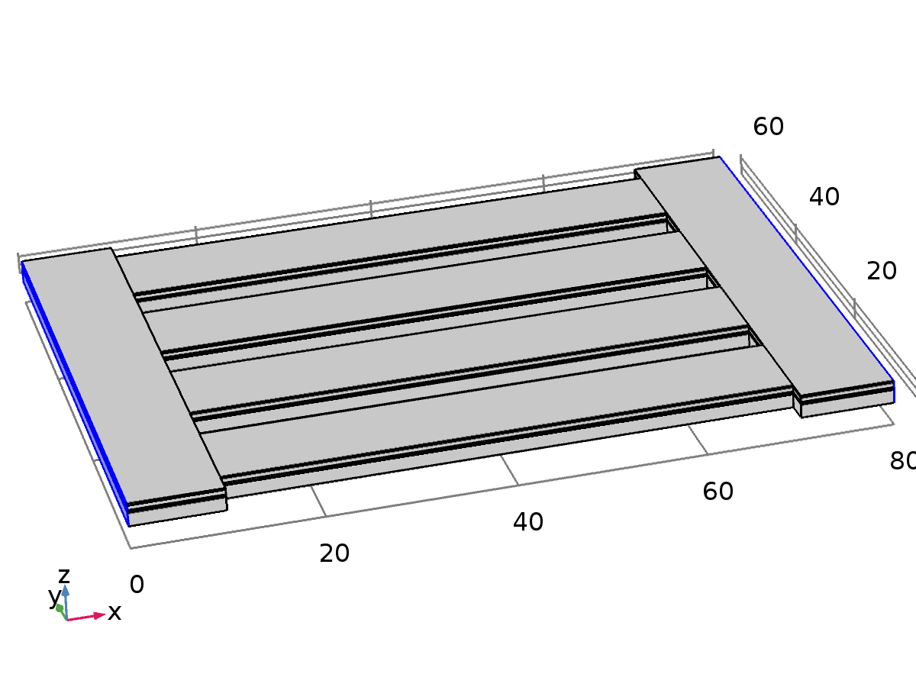

Fixed Constraint 1

Selection

|  |  |
| --- | --- |
| Geometric entity level | Boundary |
| Selection | Boundaries 1, 4, 7, 10, 13, 192–196 |

Equations



Settings

| **Description** | **Value** |
| --- | --- |
| Apply reaction terms on | All physics (symmetric) |
| Use weak constraints | Off |
| Constraint method | Elemental |

Used products

|  |
| --- |
| COMSOL Multiphysics |

#### Variables

| **Name** | **Expression** | **Unit** | **Description** | **Selection** |
| --- | --- | --- | --- | --- |
| solid.fix1.usx | u | m | Displacement, spatial coordinate system, x component | Boundaries 1, 4, 7, 10, 13, 192–196 |
| solid.fix1.usy | v | m | Displacement, spatial coordinate system, y component | Boundaries 1, 4, 7, 10, 13, 192–196 |
| solid.fix1.usz | w | m | Displacement, spatial coordinate system, z component | Boundaries 1, 4, 7, 10, 13, 192–196 |

#### Shape functions

| **Constraint** | **Constraint force** | **Shape function** | **Selection** |
| --- | --- | --- | --- |
| -solid.fix1.usx | test(-solid.fix1.usx) | Nodal serendipity (Quadratic) | Boundaries 1, 4, 7, 10, 13, 192–196 |
| -solid.fix1.usy | test(-solid.fix1.usy) | Nodal serendipity (Quadratic) | Boundaries 1, 4, 7, 10, 13, 192–196 |
| -solid.fix1.usz | test(-solid.fix1.usz) | Nodal serendipity (Quadratic) | Boundaries 1, 4, 7, 10, 13, 192–196 |

* + 1. Body Load 1



Body Load 1

Selection

|  |  |
| --- | --- |
| Geometric entity level | Domain |
| Selection | Domains 1–30 |

Equations



Settings

| **Description** | **Value** |
| --- | --- |
| Load type | Load defined as force per unit volume |
| Body load | User defined |
| Body load | {0, 0, -(solid.rho*g_const*acc)} |

Used products

|  |
| --- |
| COMSOL Multiphysics |

#### Variables

| **Name** | **Expression** | **Unit** | **Description** | **Selection** |
| --- | --- | --- | --- | --- |
| solid.bl1.ux | u | m | Displacement, x component | Domains 1–30 |
| solid.bl1.uy | v | m | Displacement, y component | Domains 1–30 |
| solid.bl1.uz | w | m | Displacement, z component | Domains 1–30 |
| solid.bl1.FperVolx | 0 | N/m³ | Body load, x component | Domains 1–30 |
| solid.bl1.FperVoly | 0 | N/m³ | Body load, y component | Domains 1–30 |
| solid.bl1.FperVolz | -solid.rho*g_const*acc | N/m³ | Body load, z component | Domains 1–30 |
| solid.bl1.FVx | solid.bl1.FperVolx | N/m³ | Body load, x component | Domains 1–30 |
| solid.bl1.FVy | solid.bl1.FperVoly | N/m³ | Body load, y component | Domains 1–30 |
| solid.bl1.FVz | solid.bl1.FperVolz | N/m³ | Body load, z component | Domains 1–30 |
| solid.FperVolx | solid.bl1.FVx | N/m³ | Body load, x component | Domains 1–30 |
| solid.FperVoly | solid.bl1.FVy | N/m³ | Body load, y component | Domains 1–30 |
| solid.FperVolz | solid.bl1.FVz | N/m³ | Body load, z component | Domains 1–30 |

#### Weak expressions

| **Weak expression** | **Integration order** | **Integration frame** | **Selection** |
| --- | --- | --- | --- |
| solid.bl1.FVx*test(solid.bl1.ux)+solid.bl1.FVy*test(solid.bl1.uy)+solid.bl1.FVz*test(solid.bl1.uz) | 4 | Material | Domains 1–30 |

* 1. Electrostatics

Used products

|  |
| --- |
| COMSOL Multiphysics |
| MEMS Module |



Electrostatics

Selection

|  |  |
| --- | --- |
| Geometric entity level | Domain |
| Selection | Domains 1–30 |

Equations





Settings

| **Description** | **Value** |
| --- | --- |
| Electric potential | Quadratic |
| Value type when using splitting of complex variables | Complex |
| Activate terminal sweep | Off |
| Reference impedance | 50[ohm] |

Variables

| **Name** | **Expression** | **Unit** | **Description** | **Selection** |
| --- | --- | --- | --- | --- |
| es.d | 1 | 1 | Contribution | Domains 1–30 |
| es.nx | nx |  | Normal vector, x component | Boundaries 6, 9, 12, 15, 27, 30, 32–33, 35–36, 38–39, 41, 53, 56, 58–59, 61–62, 64–65, 67, 79, 82, 84–85, 87–88, 90–91, 93, 105, 108, 110–111, 113–114, 116–117, 119, 136, 139, 142, 145, 147–151, 157–161, 167–171, 177–181 |
| es.ny | ny |  | Normal vector, y component | Boundaries 6, 9, 12, 15, 27, 30, 32–33, 35–36, 38–39, 41, 53, 56, 58–59, 61–62, 64–65, 67, 79, 82, 84–85, 87–88, 90–91, 93, 105, 108, 110–111, 113–114, 116–117, 119, 136, 139, 142, 145, 147–151, 157–161, 167–171, 177–181 |
| es.nz | nz |  | Normal vector, z component | Boundaries 6, 9, 12, 15, 27, 30, 32–33, 35–36, 38–39, 41, 53, 56, 58–59, 61–62, 64–65, 67, 79, 82, 84–85, 87–88, 90–91, 93, 105, 108, 110–111, 113–114, 116–117, 119, 136, 139, 142, 145, 147–151, 157–161, 167–171, 177–181 |
| es.nx | dnx |  | Normal vector, x component | Boundaries 1–5, 7–8, 10–11, 13–14, 16–26, 28–29, 31, 34, 37, 40, 42–52, 54–55, 57, 60, 63, 66, 68–78, 80–81, 83, 86, 89, 92, 94–104, 106–107, 109, 112, 115, 118, 120–135, 137–138, 140–141, 143–144, 146, 152–156, 162–166, 172–176, 182–196 |
| es.ny | dny |  | Normal vector, y component | Boundaries 1–5, 7–8, 10–11, 13–14, 16–26, 28–29, 31, 34, 37, 40, 42–52, 54–55, 57, 60, 63, 66, 68–78, 80–81, 83, 86, 89, 92, 94–104, 106–107, 109, 112, 115, 118, 120–135, 137–138, 140–141, 143–144, 146, 152–156, 162–166, 172–176, 182–196 |
| es.nz | dnz |  | Normal vector, z component | Boundaries 1–5, 7–8, 10–11, 13–14, 16–26, 28–29, 31, 34, 37, 40, 42–52, 54–55, 57, 60, 63, 66, 68–78, 80–81, 83, 86, 89, 92, 94–104, 106–107, 109, 112, 115, 118, 120–135, 137–138, 140–141, 143–144, 146, 152–156, 162–166, 172–176, 182–196 |
| es.nmeshx | nxmesh |  | Mesh normal vector, x component | Boundaries 6, 9, 12, 15, 27, 30, 32–33, 35–36, 38–39, 41, 53, 56, 58–59, 61–62, 64–65, 67, 79, 82, 84–85, 87–88, 90–91, 93, 105, 108, 110–111, 113–114, 116–117, 119, 136, 139, 142, 145, 147–151, 157–161, 167–171, 177–181 |
| es.nmeshy | nymesh |  | Mesh normal vector, y component | Boundaries 6, 9, 12, 15, 27, 30, 32–33, 35–36, 38–39, 41, 53, 56, 58–59, 61–62, 64–65, 67, 79, 82, 84–85, 87–88, 90–91, 93, 105, 108, 110–111, 113–114, 116–117, 119, 136, 139, 142, 145, 147–151, 157–161, 167–171, 177–181 |
| es.nmeshz | nzmesh |  | Mesh normal vector, z component | Boundaries 6, 9, 12, 15, 27, 30, 32–33, 35–36, 38–39, 41, 53, 56, 58–59, 61–62, 64–65, 67, 79, 82, 84–85, 87–88, 90–91, 93, 105, 108, 110–111, 113–114, 116–117, 119, 136, 139, 142, 145, 147–151, 157–161, 167–171, 177–181 |
| es.nmeshx | dnxmesh |  | Mesh normal vector, x component | Boundaries 1–5, 7–8, 10–11, 13–14, 16–26, 28–29, 31, 34, 37, 40, 42–52, 54–55, 57, 60, 63, 66, 68–78, 80–81, 83, 86, 89, 92, 94–104, 106–107, 109, 112, 115, 118, 120–135, 137–138, 140–141, 143–144, 146, 152–156, 162–166, 172–176, 182–196 |
| es.nmeshy | dnymesh |  | Mesh normal vector, y component | Boundaries 1–5, 7–8, 10–11, 13–14, 16–26, 28–29, 31, 34, 37, 40, 42–52, 54–55, 57, 60, 63, 66, 68–78, 80–81, 83, 86, 89, 92, 94–104, 106–107, 109, 112, 115, 118, 120–135, 137–138, 140–141, 143–144, 146, 152–156, 162–166, 172–176, 182–196 |
| es.nmeshz | dnzmesh |  | Mesh normal vector, z component | Boundaries 1–5, 7–8, 10–11, 13–14, 16–26, 28–29, 31, 34, 37, 40, 42–52, 54–55, 57, 60, 63, 66, 68–78, 80–81, 83, 86, 89, 92, 94–104, 106–107, 109, 112, 115, 118, 120–135, 137–138, 140–141, 143–144, 146, 152–156, 162–166, 172–176, 182–196 |
| es.unmeshx | unxmesh |  | Mesh normal vector, upside, x component | Boundaries 6, 9, 12, 15, 27, 30, 32–33, 35–36, 38–39, 41, 53, 56, 58–59, 61–62, 64–65, 67, 79, 82, 84–85, 87–88, 90–91, 93, 105, 108, 110–111, 113–114, 116–117, 119, 136, 139, 142, 145, 147–151, 157–161, 167–171, 177–181 |
| es.unmeshy | unymesh |  | Mesh normal vector, upside, y component | Boundaries 6, 9, 12, 15, 27, 30, 32–33, 35–36, 38–39, 41, 53, 56, 58–59, 61–62, 64–65, 67, 79, 82, 84–85, 87–88, 90–91, 93, 105, 108, 110–111, 113–114, 116–117, 119, 136, 139, 142, 145, 147–151, 157–161, 167–171, 177–181 |
| es.unmeshz | unzmesh |  | Mesh normal vector, upside, z component | Boundaries 6, 9, 12, 15, 27, 30, 32–33, 35–36, 38–39, 41, 53, 56, 58–59, 61–62, 64–65, 67, 79, 82, 84–85, 87–88, 90–91, 93, 105, 108, 110–111, 113–114, 116–117, 119, 136, 139, 142, 145, 147–151, 157–161, 167–171, 177–181 |
| es.dnmeshx | dnxmesh |  | Mesh normal vector, downside, x component | Boundaries 6, 9, 12, 15, 27, 30, 32–33, 35–36, 38–39, 41, 53, 56, 58–59, 61–62, 64–65, 67, 79, 82, 84–85, 87–88, 90–91, 93, 105, 108, 110–111, 113–114, 116–117, 119, 136, 139, 142, 145, 147–151, 157–161, 167–171, 177–181 |
| es.dnmeshy | dnymesh |  | Mesh normal vector, downside, y component | Boundaries 6, 9, 12, 15, 27, 30, 32–33, 35–36, 38–39, 41, 53, 56, 58–59, 61–62, 64–65, 67, 79, 82, 84–85, 87–88, 90–91, 93, 105, 108, 110–111, 113–114, 116–117, 119, 136, 139, 142, 145, 147–151, 157–161, 167–171, 177–181 |
| es.dnmeshz | dnzmesh |  | Mesh normal vector, downside, z component | Boundaries 6, 9, 12, 15, 27, 30, 32–33, 35–36, 38–39, 41, 53, 56, 58–59, 61–62, 64–65, 67, 79, 82, 84–85, 87–88, 90–91, 93, 105, 108, 110–111, 113–114, 116–117, 119, 136, 139, 142, 145, 147–151, 157–161, 167–171, 177–181 |
| es.unTx | es.unTex | Pa | Maxwell upward surface stress tensor, x component | Boundaries 1–196 |
| es.unTy | es.unTey | Pa | Maxwell upward surface stress tensor, y component | Boundaries 1–196 |
| es.unTz | es.unTez | Pa | Maxwell upward surface stress tensor, z component | Boundaries 1–196 |
| es.dnTx | es.dnTex | Pa | Maxwell downward surface stress tensor, x component | Boundaries 1–196 |
| es.dnTy | es.dnTey | Pa | Maxwell downward surface stress tensor, y component | Boundaries 1–196 |
| es.dnTz | es.dnTez | Pa | Maxwell downward surface stress tensor, z component | Boundaries 1–196 |
| es.unx | unx |  | Normal vector up direction, x component | Boundaries 1–196 |
| es.uny | uny |  | Normal vector up direction, y component | Boundaries 1–196 |
| es.unz | unz |  | Normal vector up direction, z component | Boundaries 1–196 |
| es.dnx | dnx |  | Normal vector down direction, x component | Boundaries 1–196 |
| es.dny | dny |  | Normal vector down direction, y component | Boundaries 1–196 |
| es.dnz | dnz |  | Normal vector down direction, z component | Boundaries 1–196 |
| es.unTex | -0.5*es.dnx*(real(up(es.Dx))*real(up(es.Ex))+real(up(es.Dy))*real(up(es.Ey))+real(up(es.Dz))*real(up(es.Ez)))+real(up(es.Dx))*(real(up(es.Ex))*es.dnx+real(up(es.Ey))*es.dny+real(up(es.Ez))*es.dnz) | Pa | Maxwell upward electric surface stress tensor, x component | Boundaries 1–196 |
| es.unTey | -0.5*es.dny*(real(up(es.Dx))*real(up(es.Ex))+real(up(es.Dy))*real(up(es.Ey))+real(up(es.Dz))*real(up(es.Ez)))+real(up(es.Dy))*(real(up(es.Ex))*es.dnx+real(up(es.Ey))*es.dny+real(up(es.Ez))*es.dnz) | Pa | Maxwell upward electric surface stress tensor, y component | Boundaries 1–196 |
| es.unTez | -0.5*es.dnz*(real(up(es.Dx))*real(up(es.Ex))+real(up(es.Dy))*real(up(es.Ey))+real(up(es.Dz))*real(up(es.Ez)))+real(up(es.Dz))*(real(up(es.Ex))*es.dnx+real(up(es.Ey))*es.dny+real(up(es.Ez))*es.dnz) | Pa | Maxwell upward electric surface stress tensor, z component | Boundaries 1–196 |
| es.dnTex | -0.5*es.unx*(real(down(es.Dx))*real(down(es.Ex))+real(down(es.Dy))*real(down(es.Ey))+real(down(es.Dz))*real(down(es.Ez)))+real(down(es.Dx))*(real(down(es.Ex))*es.unx+real(down(es.Ey))*es.uny+real(down(es.Ez))*es.unz) | Pa | Maxwell downward electric surface stress tensor, x component | Boundaries 1–196 |
| es.dnTey | -0.5*es.uny*(real(down(es.Dx))*real(down(es.Ex))+real(down(es.Dy))*real(down(es.Ey))+real(down(es.Dz))*real(down(es.Ez)))+real(down(es.Dy))*(real(down(es.Ex))*es.unx+real(down(es.Ey))*es.uny+real(down(es.Ez))*es.unz) | Pa | Maxwell downward electric surface stress tensor, y component | Boundaries 1–196 |
| es.dnTez | -0.5*es.unz*(real(down(es.Dx))*real(down(es.Ex))+real(down(es.Dy))*real(down(es.Ey))+real(down(es.Dz))*real(down(es.Ez)))+real(down(es.Dz))*(real(down(es.Ex))*es.unx+real(down(es.Ey))*es.uny+real(down(es.Ez))*es.unz) | Pa | Maxwell downward electric surface stress tensor, z component | Boundaries 1–196 |
| es.intWe | es.int_We(es.d*es.dWe) | J | Total electric energy | Global |
| es.Cinv11 | NaN+NaN*i | 1/F | One over capacitance | Global |
| es.C11 | NaN+NaN*i |  | Capacitance | Global |
| es.S11 | NaN+NaN*i |  | S-parameter | Global |
| es.S11dB | 10*log10(realdot(NaN+NaN*i,NaN+NaN*i)) | dB | S-parameter, dB | Global |
| es.zref | 50[ohm] | Ω | Reference impedance | Global |

* + 1. Charge Conservation 1



Charge Conservation 1

Selection

|  |  |
| --- | --- |
| Geometric entity level | Domain |
| Selection | Domains 1–3, 5–8, 10–13, 15–18, 20–23, 25–28, 30 |

Equations





Settings

| **Description** | **Value** |
| --- | --- |
| Constitutive relation | Relative permittivity |
| Relative permittivity | From material |

Used products

|  |
| --- |
| COMSOL Multiphysics |

Properties from material

| **Property** | **Material** | **Property group** |
| --- | --- | --- |
| Relative permittivity | Si - Polycrystalline Silicon | Basic |
| Relative permittivity | Au - Gold | Basic |
| Relative permittivity | SiO2 - Silicon oxide | Basic |

#### Variables

| **Name** | **Expression** | **Unit** | **Description** | **Selection** |
| --- | --- | --- | --- | --- |
| es.nD | 0 | C/m² | Surface charge density | Boundaries 1–9, 12–19, 21–24, 26–35, 38–48, 51–61, 64–74, 77–87, 90–100, 103–113, 116–126, 129–139, 142–149, 151–154, 156–159, 161–164, 166–169, 171–174, 176–179, 181–184, 186–189, 191–194, 196 |
| es.Dx | epsilon0_const*es.Ixx*es.Ex+epsilon0_const*es.Ixy*es.Ey+epsilon0_const*es.Ixz*es.Ez+es.Px | C/m² | Electric displacement field, x component | Domains 1–3, 5–8, 10–13, 15–18, 20–23, 25–28, 30 |
| es.Dy | epsilon0_const*es.Iyx*es.Ex+epsilon0_const*es.Iyy*es.Ey+epsilon0_const*es.Iyz*es.Ez+es.Py | C/m² | Electric displacement field, y component | Domains 1–3, 5–8, 10–13, 15–18, 20–23, 25–28, 30 |
| es.Dz | epsilon0_const*es.Izx*es.Ex+epsilon0_const*es.Izy*es.Ey+epsilon0_const*es.Izz*es.Ez+es.Pz | C/m² | Electric displacement field, z component | Domains 1–3, 5–8, 10–13, 15–18, 20–23, 25–28, 30 |
| es.Px | epsilon0_const*(es.chixx*es.Ex+es.chixy*es.Ey+es.chixz*es.Ez) | C/m² | Polarization, x component | Domains 1–3, 5–8, 10–13, 15–18, 20–23, 25–28, 30 |
| es.Py | epsilon0_const*(es.chiyx*es.Ex+es.chiyy*es.Ey+es.chiyz*es.Ez) | C/m² | Polarization, y component | Domains 1–3, 5–8, 10–13, 15–18, 20–23, 25–28, 30 |
| es.Pz | epsilon0_const*(es.chizx*es.Ex+es.chizy*es.Ey+es.chizz*es.Ez) | C/m² | Polarization, z component | Domains 1–3, 5–8, 10–13, 15–18, 20–23, 25–28, 30 |
| es.normD | sqrt(realdot(es.Dx,es.Dx)+realdot(es.Dy,es.Dy)+realdot(es.Dz,es.Dz)) | C/m² | Electric displacement field norm | Domains 1–3, 5–8, 10–13, 15–18, 20–23, 25–28, 30 |
| es.normP | sqrt(realdot(es.Px,es.Px)+realdot(es.Py,es.Py)+realdot(es.Pz,es.Pz)) | C/m² | Polarization norm | Domains 1–3, 5–8, 10–13, 15–18, 20–23, 25–28, 30 |
| es.I_sxx | 1 | 1 | Spatial identity matrix, xx component | Domains 1–3, 5–8, 10–13, 15–18, 20–23, 25–28, 30 |
| es.I_syx | 0 | 1 | Spatial identity matrix, yx component | Domains 1–3, 5–8, 10–13, 15–18, 20–23, 25–28, 30 |
| es.I_szx | 0 | 1 | Spatial identity matrix, zx component | Domains 1–3, 5–8, 10–13, 15–18, 20–23, 25–28, 30 |
| es.I_sxy | 0 | 1 | Spatial identity matrix, xy component | Domains 1–3, 5–8, 10–13, 15–18, 20–23, 25–28, 30 |
| es.I_syy | 1 | 1 | Spatial identity matrix, yy component | Domains 1–3, 5–8, 10–13, 15–18, 20–23, 25–28, 30 |
| es.I_szy | 0 | 1 | Spatial identity matrix, zy component | Domains 1–3, 5–8, 10–13, 15–18, 20–23, 25–28, 30 |
| es.I_sxz | 0 | 1 | Spatial identity matrix, xz component | Domains 1–3, 5–8, 10–13, 15–18, 20–23, 25–28, 30 |
| es.I_syz | 0 | 1 | Spatial identity matrix, yz component | Domains 1–3, 5–8, 10–13, 15–18, 20–23, 25–28, 30 |
| es.I_szz | 1 | 1 | Spatial identity matrix, zz component | Domains 1–3, 5–8, 10–13, 15–18, 20–23, 25–28, 30 |
| es.Ex | -Vx | V/m | Electric field, x component | Domains 1–3, 5–8, 10–13, 15–18, 20–23, 25–28, 30 |
| es.Ey | -Vy | V/m | Electric field, y component | Domains 1–3, 5–8, 10–13, 15–18, 20–23, 25–28, 30 |
| es.Ez | -Vz | V/m | Electric field, z component | Domains 1–3, 5–8, 10–13, 15–18, 20–23, 25–28, 30 |
| es.tEx | -VTx | V/m | Tangential electric field, x component | Boundaries 1–9, 12–19, 21–24, 26–35, 38–48, 51–61, 64–74, 77–87, 90–100, 103–113, 116–126, 129–139, 142–149, 151–154, 156–159, 161–164, 166–169, 171–174, 176–179, 181–184, 186–189, 191–194, 196 |
| es.tEy | -VTy | V/m | Tangential electric field, y component | Boundaries 1–9, 12–19, 21–24, 26–35, 38–48, 51–61, 64–74, 77–87, 90–100, 103–113, 116–126, 129–139, 142–149, 151–154, 156–159, 161–164, 166–169, 171–174, 176–179, 181–184, 186–189, 191–194, 196 |
| es.tEz | -VTz | V/m | Tangential electric field, z component | Boundaries 1–9, 12–19, 21–24, 26–35, 38–48, 51–61, 64–74, 77–87, 90–100, 103–113, 116–126, 129–139, 142–149, 151–154, 156–159, 161–164, 166–169, 171–174, 176–179, 181–184, 186–189, 191–194, 196 |
| es.normE | sqrt(realdot(es.Ex,es.Ex)+realdot(es.Ey,es.Ey)+realdot(es.Ez,es.Ez)) | V/m | Electric field norm | Domains 1–3, 5–8, 10–13, 15–18, 20–23, 25–28, 30 |
| es.Jx | es.Jdx | A/m² | Current density, x component | Domains 1–3, 5–8, 10–13, 15–18, 20–23, 25–28, 30 |
| es.Jy | es.Jdy | A/m² | Current density, y component | Domains 1–3, 5–8, 10–13, 15–18, 20–23, 25–28, 30 |
| es.Jz | es.Jdz | A/m² | Current density, z component | Domains 1–3, 5–8, 10–13, 15–18, 20–23, 25–28, 30 |
| es.normJ | sqrt(realdot(es.Jx,es.Jx)+realdot(es.Jy,es.Jy)+realdot(es.Jz,es.Jz)) | A/m² | Current density norm | Domains 1–3, 5–8, 10–13, 15–18, 20–23, 25–28, 30 |
| es.W | es.We | J/m³ | Energy density | Domains 1–3, 5–8, 10–13, 15–18, 20–23, 25–28, 30 |
| es.dWe | es.We | J/m³ | Integrand for total electric energy | Domains 1–3, 5–8, 10–13, 15–18, 20–23, 25–28, 30 |
| es.We | 0.5*epsilon0_const*((es.epsilonrxx*es.Ex+es.epsilonrxy*es.Ey+es.epsilonrxz*es.Ez)*es.Ex+(es.epsilonryx*es.Ex+es.epsilonryy*es.Ey+es.epsilonryz*es.Ez)*es.Ey+(es.epsilonrzx*es.Ex+es.epsilonrzy*es.Ey+es.epsilonrzz*es.Ez)*es.Ez) | J/m³ | Electric energy density | Domains 1–3, 5–8, 10–13, 15–18, 20–23, 25–28, 30 |
| es.epsilonrxx | material.epsilonr11 | 1 | Relative permittivity, xx component | Domains 1–3, 5–8, 10–13, 15–18, 20–23, 25–28, 30 |
| es.epsilonryx | material.epsilonr21 | 1 | Relative permittivity, yx component | Domains 1–3, 5–8, 10–13, 15–18, 20–23, 25–28, 30 |
| es.epsilonrzx | material.epsilonr31 | 1 | Relative permittivity, zx component | Domains 1–3, 5–8, 10–13, 15–18, 20–23, 25–28, 30 |
| es.epsilonrxy | material.epsilonr12 | 1 | Relative permittivity, xy component | Domains 1–3, 5–8, 10–13, 15–18, 20–23, 25–28, 30 |
| es.epsilonryy | material.epsilonr22 | 1 | Relative permittivity, yy component | Domains 1–3, 5–8, 10–13, 15–18, 20–23, 25–28, 30 |
| es.epsilonrzy | material.epsilonr32 | 1 | Relative permittivity, zy component | Domains 1–3, 5–8, 10–13, 15–18, 20–23, 25–28, 30 |
| es.epsilonrxz | material.epsilonr13 | 1 | Relative permittivity, xz component | Domains 1–3, 5–8, 10–13, 15–18, 20–23, 25–28, 30 |
| es.epsilonryz | material.epsilonr23 | 1 | Relative permittivity, yz component | Domains 1–3, 5–8, 10–13, 15–18, 20–23, 25–28, 30 |
| es.epsilonrzz | material.epsilonr33 | 1 | Relative permittivity, zz component | Domains 1–3, 5–8, 10–13, 15–18, 20–23, 25–28, 30 |
| es.chixx | -1+es.epsilonrxx | 1 | Electric susceptibility, xx component | Domains 1–3, 5–8, 10–13, 15–18, 20–23, 25–28, 30 |
| es.chiyx | es.epsilonryx | 1 | Electric susceptibility, yx component | Domains 1–3, 5–8, 10–13, 15–18, 20–23, 25–28, 30 |
| es.chizx | es.epsilonrzx | 1 | Electric susceptibility, zx component | Domains 1–3, 5–8, 10–13, 15–18, 20–23, 25–28, 30 |
| es.chixy | es.epsilonrxy | 1 | Electric susceptibility, xy component | Domains 1–3, 5–8, 10–13, 15–18, 20–23, 25–28, 30 |
| es.chiyy | -1+es.epsilonryy | 1 | Electric susceptibility, yy component | Domains 1–3, 5–8, 10–13, 15–18, 20–23, 25–28, 30 |
| es.chizy | es.epsilonrzy | 1 | Electric susceptibility, zy component | Domains 1–3, 5–8, 10–13, 15–18, 20–23, 25–28, 30 |
| es.chixz | es.epsilonrxz | 1 | Electric susceptibility, xz component | Domains 1–3, 5–8, 10–13, 15–18, 20–23, 25–28, 30 |
| es.chiyz | es.epsilonryz | 1 | Electric susceptibility, yz component | Domains 1–3, 5–8, 10–13, 15–18, 20–23, 25–28, 30 |
| es.chizz | -1+es.epsilonrzz | 1 | Electric susceptibility, zz component | Domains 1–3, 5–8, 10–13, 15–18, 20–23, 25–28, 30 |
| es.Ixx | es.I_sxx | 1 | Spatial identity matrix, xx component | Domains 1–3, 5–8, 10–13, 15–18, 20–23, 25–28, 30 |
| es.Iyx | es.I_syx | 1 | Spatial identity matrix, yx component | Domains 1–3, 5–8, 10–13, 15–18, 20–23, 25–28, 30 |
| es.Izx | es.I_szx | 1 | Spatial identity matrix, zx component | Domains 1–3, 5–8, 10–13, 15–18, 20–23, 25–28, 30 |
| es.Ixy | es.I_sxy | 1 | Spatial identity matrix, xy component | Domains 1–3, 5–8, 10–13, 15–18, 20–23, 25–28, 30 |
| es.Iyy | es.I_syy | 1 | Spatial identity matrix, yy component | Domains 1–3, 5–8, 10–13, 15–18, 20–23, 25–28, 30 |
| es.Izy | es.I_szy | 1 | Spatial identity matrix, zy component | Domains 1–3, 5–8, 10–13, 15–18, 20–23, 25–28, 30 |
| es.Ixz | es.I_sxz | 1 | Spatial identity matrix, xz component | Domains 1–3, 5–8, 10–13, 15–18, 20–23, 25–28, 30 |
| es.Iyz | es.I_syz | 1 | Spatial identity matrix, yz component | Domains 1–3, 5–8, 10–13, 15–18, 20–23, 25–28, 30 |
| es.Izz | es.I_szz | 1 | Spatial identity matrix, zz component | Domains 1–3, 5–8, 10–13, 15–18, 20–23, 25–28, 30 |
| es.Jdx | 0 | A/m² | Displacement current density, x component | Domains 1–3, 5–8, 10–13, 15–18, 20–23, 25–28, 30 |
| es.Jdy | 0 | A/m² | Displacement current density, y component | Domains 1–3, 5–8, 10–13, 15–18, 20–23, 25–28, 30 |
| es.Jdz | 0 | A/m² | Displacement current density, z component | Domains 1–3, 5–8, 10–13, 15–18, 20–23, 25–28, 30 |

#### Shape functions

| **Name** | **Shape function** | **Unit** | **Description** | **Shape frame** | **Selection** |
| --- | --- | --- | --- | --- | --- |
| V | Lagrange (Quadratic) | V | Electric potential | Spatial | Domains 1–3, 5–8, 10–13, 15–18, 20–23, 25–28, 30 |
| V | Lagrange (Quadratic) | V | Electric potential | Material | Domains 1–3, 5–8, 10–13, 15–18, 20–23, 25–28, 30 |

#### Weak expressions

| **Weak expression** | **Integration order** | **Integration frame** | **Selection** |
| --- | --- | --- | --- |
| -(es.Dx*test(Vx)+es.Dy*test(Vy)+es.Dz*test(Vz))*es.d | 4 | Spatial | Domains 1–3, 5–8, 10–13, 15–18, 20–23, 25–28, 30 |

* + 1. Zero Charge 1

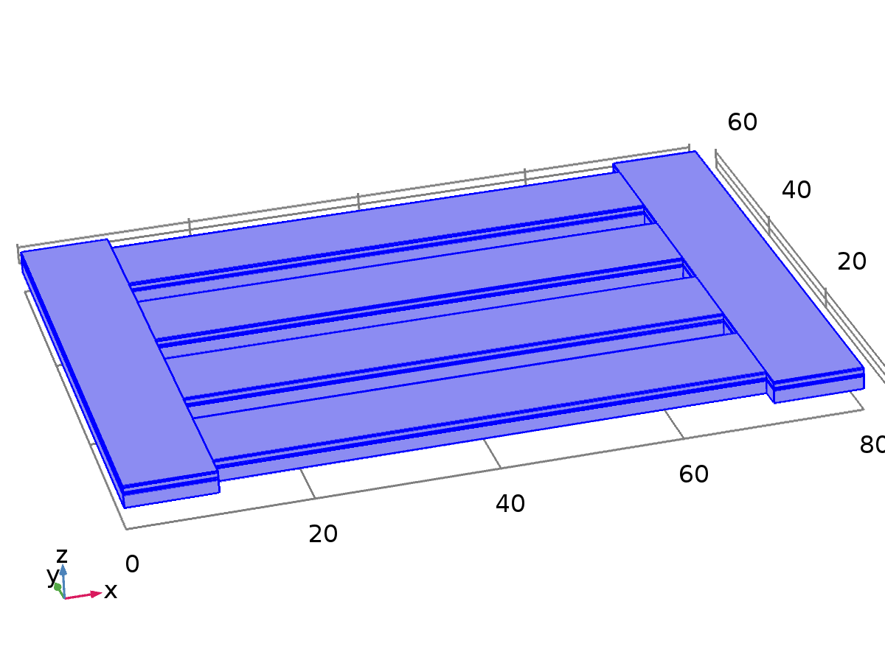

Zero Charge 1

Selection

|  |  |
| --- | --- |
| Geometric entity level | Boundary |
| Selection | Boundaries 1–5, 7–8, 10–11, 13–14, 16–26, 28–29, 31, 34, 37, 40, 42–52, 54–55, 57, 60, 63, 66, 68–78, 80–81, 83, 86, 89, 92, 94–104, 106–107, 109, 112, 115, 118, 120–135, 137–138, 140–141, 143–144, 146, 152–156, 162–166, 172–176, 182–196 |

Equations



Used products

|  |
| --- |
| COMSOL Multiphysics |

#### Variables

| **Name** | **Expression** | **Unit** | **Description** | **Selection** |
| --- | --- | --- | --- | --- |
| es.nD | 0 | C/m² | Surface charge density | Boundaries 1–5, 7–8, 10–11, 13–14, 16–26, 28–29, 31, 34, 37, 40, 42–52, 54–55, 57, 60, 63, 66, 68–78, 80–81, 83, 86, 89, 92, 94–104, 106–107, 109, 112, 115, 118, 120–135, 137–138, 140–141, 143–144, 146, 152–156, 162–166, 172–176, 182–196 |

#### Shape functions

| **Name** | **Shape function** | **Unit** | **Description** | **Shape frame** | **Selection** |
| --- | --- | --- | --- | --- | --- |
| V | Lagrange (Quadratic) | V | Electric potential | Spatial | No boundaries |
| V | Lagrange (Quadratic) | V | Electric potential | Material | No boundaries |

* + 1. Initial Values 1



Initial Values 1

Selection

|  |  |
| --- | --- |
| Geometric entity level | Domain |
| Selection | Domains 1–30 |

Settings

| **Description** | **Value** |
| --- | --- |
| Electric potential | 0 |

Used products

|  |
| --- |
| COMSOL Multiphysics |

* + 1. Charge Conservation, Piezoelectric 1



Charge Conservation, Piezoelectric 1

Selection

|  |  |
| --- | --- |
| Geometric entity level | Domain |
| Selection | Domains 4, 9, 14, 19, 24, 29 |

Equations





#### Variables

| **Name** | **Expression** | **Unit** | **Description** | **Selection** |
| --- | --- | --- | --- | --- |
| es.DX | epsilon0_const*es.IXX*es.EX+epsilon0_const*es.IXY*es.EY+epsilon0_const*es.IXZ*es.EZ+es.PX | C/m² | Electric displacement field, X component | Domains 4, 9, 14, 19, 24, 29 |
| es.DY | epsilon0_const*es.IYX*es.EX+epsilon0_const*es.IYY*es.EY+epsilon0_const*es.IYZ*es.EZ+es.PY | C/m² | Electric displacement field, Y component | Domains 4, 9, 14, 19, 24, 29 |
| es.DZ | epsilon0_const*es.IZX*es.EX+epsilon0_const*es.IZY*es.EY+epsilon0_const*es.IZZ*es.EZ+es.PZ | C/m² | Electric displacement field, Z component | Domains 4, 9, 14, 19, 24, 29 |
| es.PX | epsilon0_const*(es.chiXX*es.EX+es.chiXY*es.EY+es.chiXZ*es.EZ) | C/m² | Polarization, X component | Domains 4, 9, 14, 19, 24, 29 |
| es.PY | epsilon0_const*(es.chiYX*es.EX+es.chiYY*es.EY+es.chiYZ*es.EZ) | C/m² | Polarization, Y component | Domains 4, 9, 14, 19, 24, 29 |
| es.PZ | epsilon0_const*(es.chiZX*es.EX+es.chiZY*es.EY+es.chiZZ*es.EZ) | C/m² | Polarization, Z component | Domains 4, 9, 14, 19, 24, 29 |
| es.EX | -VX | V/m | Electric field, X component | Domains 4, 9, 14, 19, 24, 29 |
| es.EY | -VY | V/m | Electric field, Y component | Domains 4, 9, 14, 19, 24, 29 |
| es.EZ | -VZ | V/m | Electric field, Z component | Domains 4, 9, 14, 19, 24, 29 |
| es.nD | 0 | C/m² | Surface charge density | Domains 4, 9, 14, 19, 24, 29 |
| es.Dx | (spatial.F11*es.DX+spatial.F21*es.DY+spatial.F31*es.DZ)*spatial.detInvF | C/m² | Electric displacement field, x component | Domains 4, 9, 14, 19, 24, 29 |
| es.Dy | (spatial.F12*es.DX+spatial.F22*es.DY+spatial.F32*es.DZ)*spatial.detInvF | C/m² | Electric displacement field, y component | Domains 4, 9, 14, 19, 24, 29 |
| es.Dz | (spatial.F13*es.DX+spatial.F23*es.DY+spatial.F33*es.DZ)*spatial.detInvF | C/m² | Electric displacement field, z component | Domains 4, 9, 14, 19, 24, 29 |
| es.Px | (spatial.F11*es.PX+spatial.F21*es.PY+spatial.F31*es.PZ)*spatial.detInvF | C/m² | Polarization, x component | Domains 4, 9, 14, 19, 24, 29 |
| es.Py | (spatial.F12*es.PX+spatial.F22*es.PY+spatial.F32*es.PZ)*spatial.detInvF | C/m² | Polarization, y component | Domains 4, 9, 14, 19, 24, 29 |
| es.Pz | (spatial.F13*es.PX+spatial.F23*es.PY+spatial.F33*es.PZ)*spatial.detInvF | C/m² | Polarization, z component | Domains 4, 9, 14, 19, 24, 29 |
| es.normD | sqrt(realdot(es.Dx,es.Dx)+realdot(es.Dy,es.Dy)+realdot(es.Dz,es.Dz)) | C/m² | Electric displacement field norm | Domains 4, 9, 14, 19, 24, 29 |
| es.normP | sqrt(realdot(es.Px,es.Px)+realdot(es.Py,es.Py)+realdot(es.Pz,es.Pz)) | C/m² | Polarization norm | Domains 4, 9, 14, 19, 24, 29 |
| es.I_sxx | 1 | 1 | Spatial identity matrix, xx component | Domains 4, 9, 14, 19, 24, 29 |
| es.I_syx | 0 | 1 | Spatial identity matrix, yx component | Domains 4, 9, 14, 19, 24, 29 |
| es.I_szx | 0 | 1 | Spatial identity matrix, zx component | Domains 4, 9, 14, 19, 24, 29 |
| es.I_sxy | 0 | 1 | Spatial identity matrix, xy component | Domains 4, 9, 14, 19, 24, 29 |
| es.I_syy | 1 | 1 | Spatial identity matrix, yy component | Domains 4, 9, 14, 19, 24, 29 |
| es.I_szy | 0 | 1 | Spatial identity matrix, zy component | Domains 4, 9, 14, 19, 24, 29 |
| es.I_sxz | 0 | 1 | Spatial identity matrix, xz component | Domains 4, 9, 14, 19, 24, 29 |
| es.I_syz | 0 | 1 | Spatial identity matrix, yz component | Domains 4, 9, 14, 19, 24, 29 |
| es.I_szz | 1 | 1 | Spatial identity matrix, zz component | Domains 4, 9, 14, 19, 24, 29 |
| es.Ex | spatial.invF11*es.EX+spatial.invF12*es.EY+spatial.invF13*es.EZ | V/m | Electric field, x component | Domains 4, 9, 14, 19, 24, 29 |
| es.Ey | spatial.invF21*es.EX+spatial.invF22*es.EY+spatial.invF23*es.EZ | V/m | Electric field, y component | Domains 4, 9, 14, 19, 24, 29 |
| es.Ez | spatial.invF31*es.EX+spatial.invF32*es.EY+spatial.invF33*es.EZ | V/m | Electric field, z component | Domains 4, 9, 14, 19, 24, 29 |
| es.tEx | spatial.invF11*es.tEX+spatial.invF12*es.tEY+spatial.invF13*es.tEZ | V/m | Tangential electric field, x component | Boundaries 10–12, 15, 20, 25, 36–38, 41, 49–50, 62–64, 67, 75–76, 88–90, 93, 101–102, 114–116, 119, 127–128, 140–142, 145, 150, 155, 160, 165, 170, 175, 180, 185, 190, 195 |
| es.tEy | spatial.invF21*es.tEX+spatial.invF22*es.tEY+spatial.invF23*es.tEZ | V/m | Tangential electric field, y component | Boundaries 10–12, 15, 20, 25, 36–38, 41, 49–50, 62–64, 67, 75–76, 88–90, 93, 101–102, 114–116, 119, 127–128, 140–142, 145, 150, 155, 160, 165, 170, 175, 180, 185, 190, 195 |
| es.tEz | spatial.invF31*es.tEX+spatial.invF32*es.tEY+spatial.invF33*es.tEZ | V/m | Tangential electric field, z component | Boundaries 10–12, 15, 20, 25, 36–38, 41, 49–50, 62–64, 67, 75–76, 88–90, 93, 101–102, 114–116, 119, 127–128, 140–142, 145, 150, 155, 160, 165, 170, 175, 180, 185, 190, 195 |
| es.normE | sqrt(realdot(es.Ex,es.Ex)+realdot(es.Ey,es.Ey)+realdot(es.Ez,es.Ez)) | V/m | Electric field norm | Domains 4, 9, 14, 19, 24, 29 |
| es.Jx | (spatial.F11*es.JX+spatial.F21*es.JY+spatial.F31*es.JZ)*spatial.detInvF | A/m² | Current density, x component | Domains 4, 9, 14, 19, 24, 29 |
| es.Jy | (spatial.F12*es.JX+spatial.F22*es.JY+spatial.F32*es.JZ)*spatial.detInvF | A/m² | Current density, y component | Domains 4, 9, 14, 19, 24, 29 |
| es.Jz | (spatial.F13*es.JX+spatial.F23*es.JY+spatial.F33*es.JZ)*spatial.detInvF | A/m² | Current density, z component | Domains 4, 9, 14, 19, 24, 29 |
| es.normJ | sqrt(realdot(es.JX,es.JX)+realdot(es.JY,es.JY)+realdot(es.JZ,es.JZ))*spatial.detInvF^2 | A/m² | Current density norm | Domains 4, 9, 14, 19, 24, 29 |
| es.W | es.We | J/m³ | Energy density | Domains 4, 9, 14, 19, 24, 29 |
| es.dWe | es.We | J/m³ | Integrand for total electric energy | Domains 4, 9, 14, 19, 24, 29 |
| es.We | 0.5*epsilon0_const*((es.epsilonrXX*es.EX+es.epsilonrXY*es.EY+es.epsilonrXZ*es.EZ)*es.EX+(es.epsilonrYX*es.EX+es.epsilonrYY*es.EY+es.epsilonrYZ*es.EZ)*es.EY+(es.epsilonrZX*es.EX+es.epsilonrZY*es.EY+es.epsilonrZZ*es.EZ)*es.EZ) | J/m³ | Electric energy density | Domains 4, 9, 14, 19, 24, 29 |
| es.epsilonrS11 | material.epsilonrS11 | 1 | Relative permittivity, 11 component | Domains 4, 9, 14, 19, 24, 29 |
| es.epsilonrS21 | material.epsilonrS21 | 1 | Relative permittivity, 21 component | Domains 4, 9, 14, 19, 24, 29 |
| es.epsilonrS31 | material.epsilonrS31 | 1 | Relative permittivity, 31 component | Domains 4, 9, 14, 19, 24, 29 |
| es.epsilonrS12 | material.epsilonrS12 | 1 | Relative permittivity, 12 component | Domains 4, 9, 14, 19, 24, 29 |
| es.epsilonrS22 | material.epsilonrS22 | 1 | Relative permittivity, 22 component | Domains 4, 9, 14, 19, 24, 29 |
| es.epsilonrS32 | material.epsilonrS32 | 1 | Relative permittivity, 32 component | Domains 4, 9, 14, 19, 24, 29 |
| es.epsilonrS13 | material.epsilonrS13 | 1 | Relative permittivity, 13 component | Domains 4, 9, 14, 19, 24, 29 |
| es.epsilonrS23 | material.epsilonrS23 | 1 | Relative permittivity, 23 component | Domains 4, 9, 14, 19, 24, 29 |
| es.epsilonrS33 | material.epsilonrS33 | 1 | Relative permittivity, 33 component | Domains 4, 9, 14, 19, 24, 29 |
| es.chiXX | -1+es.epsilonrXX | 1 | Electric susceptibility, XX component | Domains 4, 9, 14, 19, 24, 29 |
| es.chiYX | es.epsilonrYX | 1 | Electric susceptibility, YX component | Domains 4, 9, 14, 19, 24, 29 |
| es.chiZX | es.epsilonrZX | 1 | Electric susceptibility, ZX component | Domains 4, 9, 14, 19, 24, 29 |
| es.chiXY | es.epsilonrXY | 1 | Electric susceptibility, XY component | Domains 4, 9, 14, 19, 24, 29 |
| es.chiYY | -1+es.epsilonrYY | 1 | Electric susceptibility, YY component | Domains 4, 9, 14, 19, 24, 29 |
| es.chiZY | es.epsilonrZY | 1 | Electric susceptibility, ZY component | Domains 4, 9, 14, 19, 24, 29 |
| es.chiXZ | es.epsilonrXZ | 1 | Electric susceptibility, XZ component | Domains 4, 9, 14, 19, 24, 29 |
| es.chiYZ | es.epsilonrYZ | 1 | Electric susceptibility, YZ component | Domains 4, 9, 14, 19, 24, 29 |
| es.chiZZ | -1+es.epsilonrZZ | 1 | Electric susceptibility, ZZ component | Domains 4, 9, 14, 19, 24, 29 |
| es.IXX | (spatial.invF11*(spatial.invF11*es.I_sxx+spatial.invF21*es.I_syx+spatial.invF31*es.I_szx)+spatial.invF21*(spatial.invF11*es.I_sxy+spatial.invF21*es.I_syy+spatial.invF31*es.I_szy)+spatial.invF31*(spatial.invF11*es.I_sxz+spatial.invF21*es.I_syz+spatial.invF31*es.I_szz))*spatial.detF | 1 | Spatial identity matrix, XX component | Domains 4, 9, 14, 19, 24, 29 |
| es.IYX | (spatial.invF11*(spatial.invF12*es.I_sxx+spatial.invF22*es.I_syx+spatial.invF32*es.I_szx)+spatial.invF21*(spatial.invF12*es.I_sxy+spatial.invF22*es.I_syy+spatial.invF32*es.I_szy)+spatial.invF31*(spatial.invF12*es.I_sxz+spatial.invF22*es.I_syz+spatial.invF32*es.I_szz))*spatial.detF | 1 | Spatial identity matrix, YX component | Domains 4, 9, 14, 19, 24, 29 |
| es.IZX | (spatial.invF11*(spatial.invF13*es.I_sxx+spatial.invF23*es.I_syx+spatial.invF33*es.I_szx)+spatial.invF21*(spatial.invF13*es.I_sxy+spatial.invF23*es.I_syy+spatial.invF33*es.I_szy)+spatial.invF31*(spatial.invF13*es.I_sxz+spatial.invF23*es.I_syz+spatial.invF33*es.I_szz))*spatial.detF | 1 | Spatial identity matrix, ZX component | Domains 4, 9, 14, 19, 24, 29 |
| es.IXY | (spatial.invF12*(spatial.invF11*es.I_sxx+spatial.invF21*es.I_syx+spatial.invF31*es.I_szx)+spatial.invF22*(spatial.invF11*es.I_sxy+spatial.invF21*es.I_syy+spatial.invF31*es.I_szy)+spatial.invF32*(spatial.invF11*es.I_sxz+spatial.invF21*es.I_syz+spatial.invF31*es.I_szz))*spatial.detF | 1 | Spatial identity matrix, XY component | Domains 4, 9, 14, 19, 24, 29 |
| es.IYY | (spatial.invF12*(spatial.invF12*es.I_sxx+spatial.invF22*es.I_syx+spatial.invF32*es.I_szx)+spatial.invF22*(spatial.invF12*es.I_sxy+spatial.invF22*es.I_syy+spatial.invF32*es.I_szy)+spatial.invF32*(spatial.invF12*es.I_sxz+spatial.invF22*es.I_syz+spatial.invF32*es.I_szz))*spatial.detF | 1 | Spatial identity matrix, YY component | Domains 4, 9, 14, 19, 24, 29 |
| es.IZY | (spatial.invF12*(spatial.invF13*es.I_sxx+spatial.invF23*es.I_syx+spatial.invF33*es.I_szx)+spatial.invF22*(spatial.invF13*es.I_sxy+spatial.invF23*es.I_syy+spatial.invF33*es.I_szy)+spatial.invF32*(spatial.invF13*es.I_sxz+spatial.invF23*es.I_syz+spatial.invF33*es.I_szz))*spatial.detF | 1 | Spatial identity matrix, ZY component | Domains 4, 9, 14, 19, 24, 29 |
| es.IXZ | (spatial.invF13*(spatial.invF11*es.I_sxx+spatial.invF21*es.I_syx+spatial.invF31*es.I_szx)+spatial.invF23*(spatial.invF11*es.I_sxy+spatial.invF21*es.I_syy+spatial.invF31*es.I_szy)+spatial.invF33*(spatial.invF11*es.I_sxz+spatial.invF21*es.I_syz+spatial.invF31*es.I_szz))*spatial.detF | 1 | Spatial identity matrix, XZ component | Domains 4, 9, 14, 19, 24, 29 |
| es.IYZ | (spatial.invF13*(spatial.invF12*es.I_sxx+spatial.invF22*es.I_syx+spatial.invF32*es.I_szx)+spatial.invF23*(spatial.invF12*es.I_sxy+spatial.invF22*es.I_syy+spatial.invF32*es.I_szy)+spatial.invF33*(spatial.invF12*es.I_sxz+spatial.invF22*es.I_syz+spatial.invF32*es.I_szz))*spatial.detF | 1 | Spatial identity matrix, YZ component | Domains 4, 9, 14, 19, 24, 29 |
| es.IZZ | (spatial.invF13*(spatial.invF13*es.I_sxx+spatial.invF23*es.I_syx+spatial.invF33*es.I_szx)+spatial.invF23*(spatial.invF13*es.I_sxy+spatial.invF23*es.I_syy+spatial.invF33*es.I_szy)+spatial.invF33*(spatial.invF13*es.I_sxz+spatial.invF23*es.I_syz+spatial.invF33*es.I_szz))*spatial.detF | 1 | Spatial identity matrix, ZZ component | Domains 4, 9, 14, 19, 24, 29 |
| es.tEX | -VTX | V/m | Tangential electric field, X component | Boundaries 10–12, 15, 20, 25, 36–38, 41, 49–50, 62–64, 67, 75–76, 88–90, 93, 101–102, 114–116, 119, 127–128, 140–142, 145, 150, 155, 160, 165, 170, 175, 180, 185, 190, 195 |
| es.tEY | -VTY | V/m | Tangential electric field, Y component | Boundaries 10–12, 15, 20, 25, 36–38, 41, 49–50, 62–64, 67, 75–76, 88–90, 93, 101–102, 114–116, 119, 127–128, 140–142, 145, 150, 155, 160, 165, 170, 175, 180, 185, 190, 195 |
| es.tEZ | -VTZ | V/m | Tangential electric field, Z component | Boundaries 10–12, 15, 20, 25, 36–38, 41, 49–50, 62–64, 67, 75–76, 88–90, 93, 101–102, 114–116, 119, 127–128, 140–142, 145, 150, 155, 160, 165, 170, 175, 180, 185, 190, 195 |
| es.JX | es.JdX | A/m² | Current density, X component | Domains 4, 9, 14, 19, 24, 29 |
| es.JY | es.JdY | A/m² | Current density, Y component | Domains 4, 9, 14, 19, 24, 29 |
| es.JZ | es.JdZ | A/m² | Current density, Z component | Domains 4, 9, 14, 19, 24, 29 |
| es.JdX | 0 | A/m² | Displacement current density, X component | Domains 4, 9, 14, 19, 24, 29 |
| es.JdY | 0 | A/m² | Displacement current density, Y component | Domains 4, 9, 14, 19, 24, 29 |
| es.JdZ | 0 | A/m² | Displacement current density, Z component | Domains 4, 9, 14, 19, 24, 29 |
| es.epsilonrXX | es.epsilonrS11 | 1 | Relative permittivity, XX component | Domains 4, 9, 14, 19, 24, 29 |
| es.epsilonrYX | es.epsilonrS21 | 1 | Relative permittivity, YX component | Domains 4, 9, 14, 19, 24, 29 |
| es.epsilonrZX | es.epsilonrS31 | 1 | Relative permittivity, ZX component | Domains 4, 9, 14, 19, 24, 29 |
| es.epsilonrXY | es.epsilonrS12 | 1 | Relative permittivity, XY component | Domains 4, 9, 14, 19, 24, 29 |
| es.epsilonrYY | es.epsilonrS22 | 1 | Relative permittivity, YY component | Domains 4, 9, 14, 19, 24, 29 |
| es.epsilonrZY | es.epsilonrS32 | 1 | Relative permittivity, ZY component | Domains 4, 9, 14, 19, 24, 29 |
| es.epsilonrXZ | es.epsilonrS13 | 1 | Relative permittivity, XZ component | Domains 4, 9, 14, 19, 24, 29 |
| es.epsilonrYZ | es.epsilonrS23 | 1 | Relative permittivity, YZ component | Domains 4, 9, 14, 19, 24, 29 |
| es.epsilonrZZ | es.epsilonrS33 | 1 | Relative permittivity, ZZ component | Domains 4, 9, 14, 19, 24, 29 |

#### Shape functions

| **Name** | **Shape function** | **Unit** | **Description** | **Shape frame** | **Selection** |
| --- | --- | --- | --- | --- | --- |
| V | Lagrange (Quadratic) | V | Electric potential | Material | Domains 4, 9, 14, 19, 24, 29 |
| V | Lagrange (Quadratic) | V | Electric potential | Spatial | Domains 4, 9, 14, 19, 24, 29 |

#### Weak expressions

| **Weak expression** | **Integration order** | **Integration frame** | **Selection** |
| --- | --- | --- | --- |
| (es.DX*test(es.EX)+es.DY*test(es.EY)+es.DZ*test(es.EZ))*es.d | 4 | Material | Domains 4, 9, 14, 19, 24, 29 |

* + 1. Terminal 1

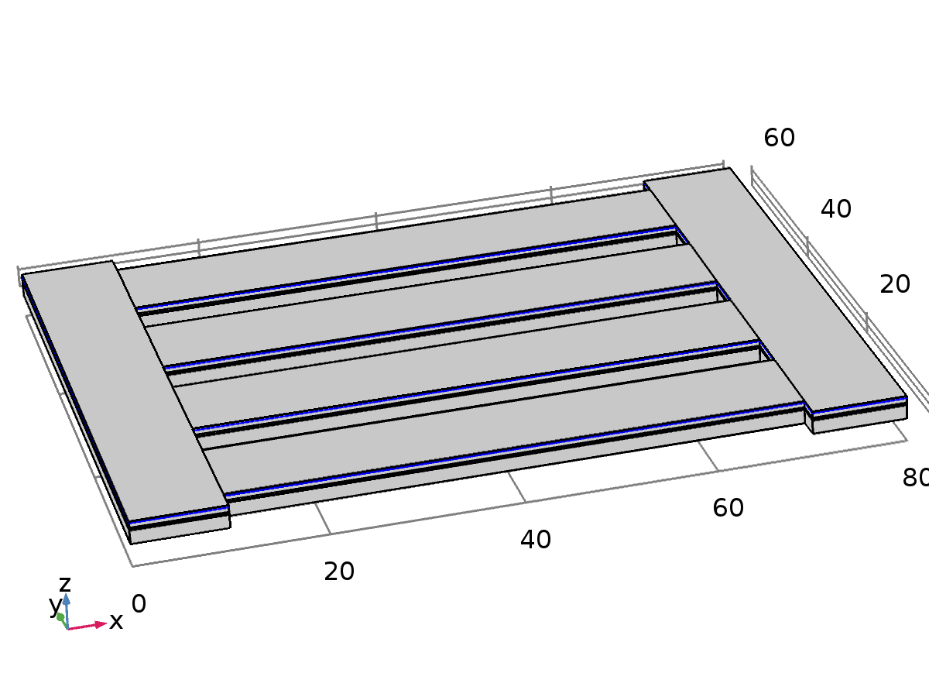

Terminal 1

Selection

|  |  |
| --- | --- |
| Geometric entity level | Boundary |
| Selection | Boundaries 15, 41, 67, 93, 119, 145 |

Equations



Settings

| **Description** | **Value** |
| --- | --- |
| Terminal name | 1 |
| Terminal type | Charge |
| Charge | 0 |
| Initial value for voltage | 0 |
| Apply reaction terms on | All physics (symmetric) |
| Use weak constraints | Off |
| Constraint method | Elemental |

#### Variables

| **Name** | **Expression** | **Unit** | **Description** | **Selection** |
| --- | --- | --- | --- | --- |
| es.nD | es.unx*(down(es.Dx)-up(es.Dx))+es.uny*(down(es.Dy)-up(es.Dy))+es.unz*(down(es.Dz)-up(es.Dz)) | C/m² | Surface charge density | Boundaries 15, 41, 67, 93, 119, 145 |
| es.term1.Q0 | 0 | C | Charge | Global |
| es.term1.I_cir | model.input.I_cir | A | Current | Global |
| es.term1.Vinit | 0 | V | Initial value for voltage | Global |
| es.Q0_1 | es.term1.Q0 | C | Terminal charge | Global |
| es.V0_1 | es.term1.V0_ode | V | Terminal voltage | Global |

#### Shape functions

| **Name** | **Shape function** | **Unit** | **Description** | **Shape frame** | **Selection** |
| --- | --- | --- | --- | --- | --- |
| es.term1.V0_ode | ODE | V | Terminal voltage |  | Global |

#### Weak expressions

| **Weak expression** | **Integration order** | **Integration frame** | **Selection** |
| --- | --- | --- | --- |
| -es.Q0_1*test(es.term1.V0_ode) | 4 |  | Global |

#### Shape functions

| **Constraint** | **Constraint force** | **Shape function** | **Selection** |
| --- | --- | --- | --- |
| es.term1.V0_ode-V | test(es.term1.V0_ode-V) | Lagrange (Quadratic) | Boundaries 15, 41, 67, 93, 119, 145 |

* + 1. Ground 1

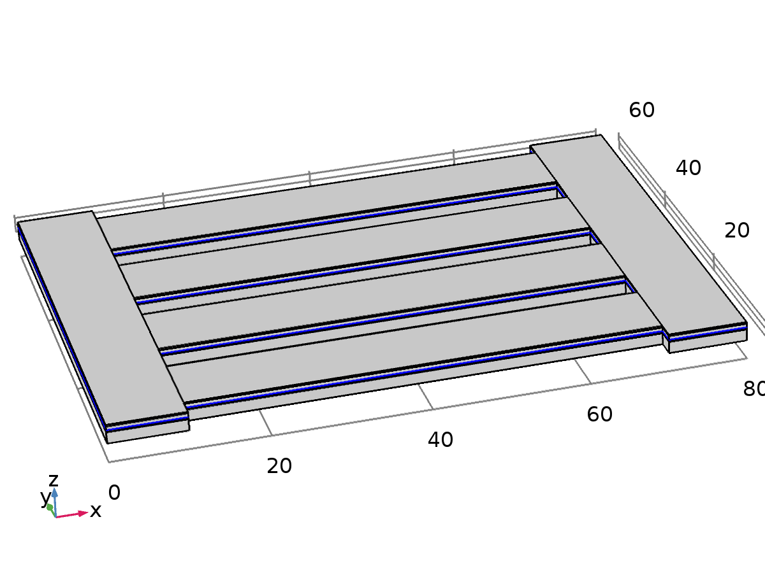

Ground 1

Selection

|  |  |
| --- | --- |
| Geometric entity level | Boundary |
| Selection | Boundaries 12, 38, 64, 90, 116, 142 |

Equations



Settings

| **Description** | **Value** |
| --- | --- |
| Apply reaction terms on | All physics (symmetric) |
| Use weak constraints | Off |
| Constraint method | Elemental |

Used products

|  |
| --- |
| COMSOL Multiphysics |

#### Variables

| **Name** | **Expression** | **Unit** | **Description** | **Selection** |
| --- | --- | --- | --- | --- |
| es.nD | es.unx*(down(es.Dx)-up(es.Dx))+es.uny*(down(es.Dy)-up(es.Dy))+es.unz*(down(es.Dz)-up(es.Dz)) | C/m² | Surface charge density | Boundaries 12, 38, 64, 90, 116, 142 |

#### Shape functions

| **Constraint** | **Constraint force** | **Shape function** | **Selection** |
| --- | --- | --- | --- |
| -V | test(-V) | Lagrange (Quadratic) | Boundaries 12, 38, 64, 90, 116, 142 |

* 1. Electrical Circuit

Used products

|  |
| --- |
| COMSOL Multiphysics |
| MEMS Module |

Selection

|  |  |
| --- | --- |
| Geometric entity level | Entire model |

Equations

Settings

| **Description** | **Value** |
| --- | --- |
| Value type when using splitting of complex variables | {Complex, Complex, Complex, Complex} |
| Resistance in parallel to pn junctions | 1e12[Ω] |
| Create unique nodes for new devices | On |

Variables

| **Name** | **Expression** | **Unit** | **Description** | **Selection** |
| --- | --- | --- | --- | --- |
| cir.Rj | 1.0E12[Ω] | Ω | Resistance in parallel to pn junctions | Global |
| cir.v_0 | cir.R1.v1 | V | Voltage at node 0 | Global |
| cir.v_1 | cir.R1.v0 | V | Voltage at node 1 | Global |

* + 1. Ground Node 1

Selection

|  |  |
| --- | --- |
| Geometric entity level | Entire model |

Settings

| **Description** | **Value** |
| --- | --- |
| Node name | 0 |
| Label | p |

* + 1. External I-Terminal 1

Selection

|  |  |
| --- | --- |
| Geometric entity level | Entire model |

Settings

| **Description** | **Value** |
| --- | --- |
| Electric potential | User defined |
| Electric potential | 0 |
| Node name | 1 |

#### Variables

| **Name** | **Expression** | **Unit** | **Description** | **Selection** |
| --- | --- | --- | --- | --- |
| cir.termI1.V | 0 | V | Electric potential | Global |

* + 1. Resistor 1

Selection

|  |  |
| --- | --- |
| Geometric entity level | Entire model |

Settings

| **Description** | **Value** |
| --- | --- |
| Resistance | R_load |
| Device name | 1 |
| Node names, 1 component | 1 |
| Node names, 2 component | 0 |
| Label, 1 component | p |
| Label, 2 component | n |

#### Variables

| **Name** | **Expression** | **Unit** | **Description** | **Selection** |
| --- | --- | --- | --- | --- |
| cir.R1.R | R_load | Ω | Resistance | Global |

* 1. Multiphysics
     1. Piezoelectric Effect 1

Used products

|  |
| --- |
| COMSOL Multiphysics |
| MEMS Module |



Piezoelectric Effect 1

Selection

|  |  |
| --- | --- |
| Geometric entity level | Domain |
| Selection | Domains 4, 9, 14, 19, 24, 29 |

Settings

| **Description** | **Value** |
| --- | --- |
|  | 1 |
| Solid mechanics | Solid Mechanics (solid) |
| Electrostatics | Electrostatics (es) |

Variables

| **Name** | **Expression** | **Unit** | **Description** | **Selection** |
| --- | --- | --- | --- | --- |
| solid.EpzeX | es.EX | V/m | Electric field, X component | Domains 4, 9, 14, 19, 24, 29 |
| solid.EpzeY | es.EY | V/m | Electric field, Y component | Domains 4, 9, 14, 19, 24, 29 |
| solid.EpzeZ | es.EZ | V/m | Electric field, Z component | Domains 4, 9, 14, 19, 24, 29 |
| solid.DpzeX | es.DX | C/m² | Electric displacement field, X component | Domains 4, 9, 14, 19, 24, 29 |
| solid.DpzeY | es.DY | C/m² | Electric displacement field, Y component | Domains 4, 9, 14, 19, 24, 29 |
| solid.DpzeZ | es.DZ | C/m² | Electric displacement field, Z component | Domains 4, 9, 14, 19, 24, 29 |
| es.PX | solid.PpzeX+solid.DrX | C/m² | Polarization, X component | Domains 4, 9, 14, 19, 24, 29 |
| es.PY | solid.PpzeY+solid.DrY | C/m² | Polarization, Y component | Domains 4, 9, 14, 19, 24, 29 |
| es.PZ | solid.PpzeZ+solid.DrZ | C/m² | Polarization, Z component | Domains 4, 9, 14, 19, 24, 29 |

* 1. Mesh 1

Mesh statistics

| **Description** | **Value** |
| --- | --- |
| Minimum element quality | 2.083E-4 |
| Average element quality | 0.3407 |
| Tetrahedral elements | 81264 |
| Triangular elements | 36990 |
| Edge elements | 4166 |
| Vertex elements | 144 |

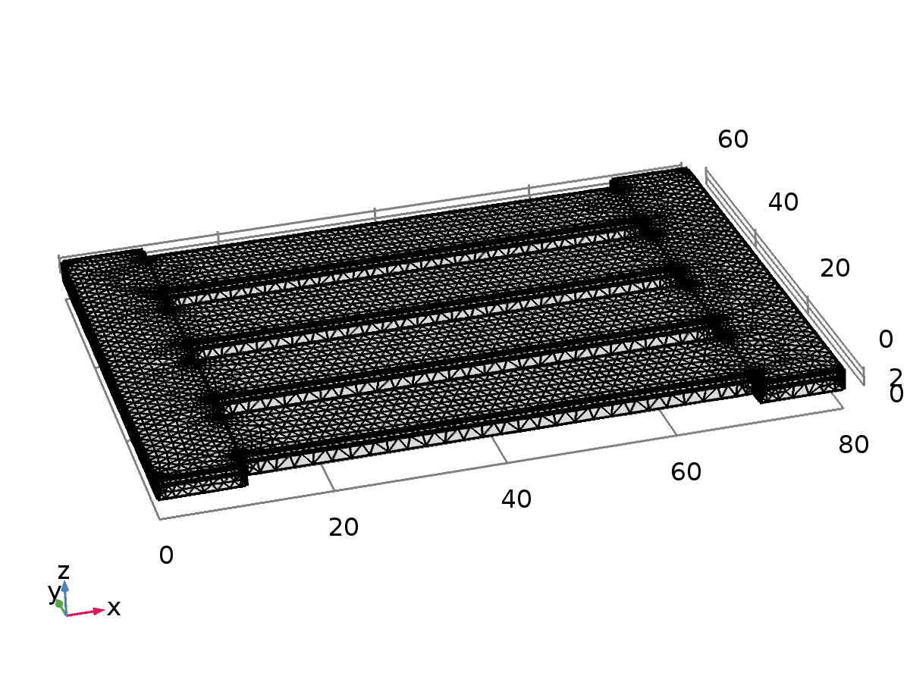

Mesh 1

* + 1. Size (size)

Settings

| **Description** | **Value** |
| --- | --- |
| Maximum element size | 8 |
| Minimum element size | 1.44 |
| Curvature factor | 0.6 |
| Resolution of narrow regions | 0.5 |
| Maximum element growth rate | 1.5 |

* + 1. Free Tetrahedral 1 (ftet1)

Selection

|  |  |
| --- | --- |
| Geometric entity level | Remaining |



Free Tetrahedral 1

#### Problems 1 (prob1)

##### Warning 1 (warning1)

Selection

|  |  |
| --- | --- |
| Geometric entity level | Edge |
| Selection | Edges 4, 20, 31, 43, 60, 77, 94, 111, 128, 145, 162, 177, 184, 200, 211, 222, 233, 244, 255, 266, 277, 288, 299, 309 |

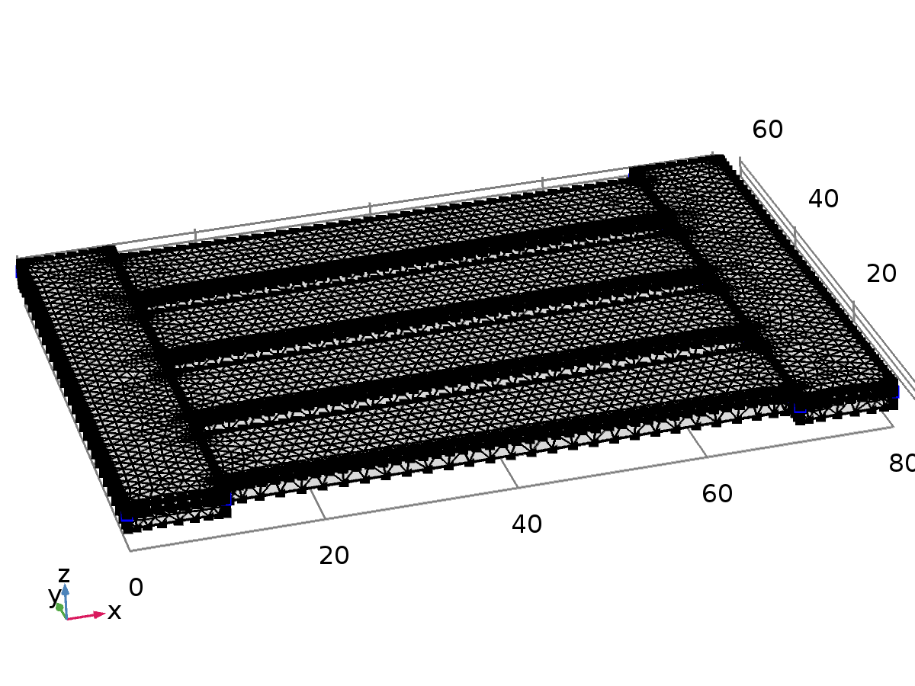

Warning 1

Settings

| **Description** | **Value** |
| --- | --- |
| Warning message | Edge_is_much_shorter_than_specified_minimum_element_size |

##### Warning 2 (warning2)

Selection

|  |  |
| --- | --- |
| Geometric entity level | Boundary |
| Selection | Boundaries 4–5, 18, 23, 30–31, 45–46, 56–57, 71–72, 82–83, 97–98, 108–109, 123–124, 134–135, 148, 153, 158, 163, 168, 173, 178, 183, 188, 193 |

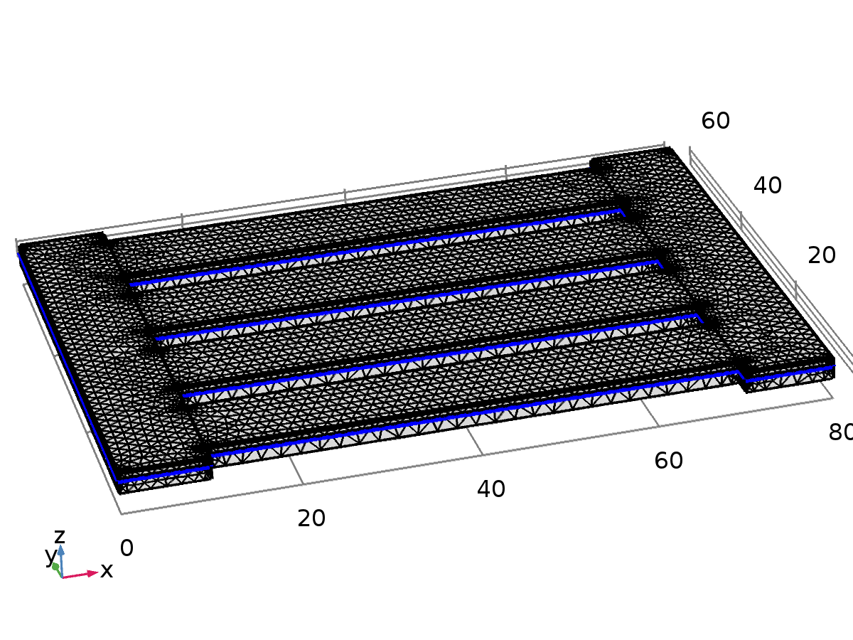

Warning 2

Settings

| **Description** | **Value** |
| --- | --- |
| Warning message | Face_is_much_smaller_than_specified_minimum_element_size |

1. Study 1

Computation information

|  |  |
| --- | --- |
| Computation time | 8 min 29 s |
| CPU | 12th Gen Intel(R) Core(TM) i5-1240P, 16 cores |
| Operating system | Windows 10 |

* 1. Parametric Sweep

| **Parameter name** | **Parameter value list** |
| --- | --- |
| R_load | range(1,1,5) |

* 1. Stationary

Study settings

| **Description** | **Value** |
| --- | --- |
| Include geometric nonlinearity | Off |

Physics and variables selection

| **Physics interface** | **Discretization** |
| --- | --- |
| Solid Mechanics (solid) | physics |
| Electrostatics (es) | physics |
| Electrical Circuit (cir) | physics |

Mesh selection

| **Geometry** | **Mesh** |
| --- | --- |
| Geometry 1 (geom1) | mesh1 |

* 1. Solver Configurations
     1. Solution 1

#### Compile Equations: Stationary (st1)

Study and step

| **Description** | **Value** |
| --- | --- |
| Use study | Study 1 |
| Use study step | Stationary |

#### Dependent Variables 1 (v1)

General

| **Description** | **Value** |
| --- | --- |
| Defined by study step | Stationary |

Initial value calculation constants

| **Description** | **Value** |
| --- | --- |
| Parameter initial value list | range(1, 1, 5) |

##### Displacement field (Material) (comp1.u) (comp1_u)

General

| **Description** | **Value** |
| --- | --- |
| Field components | {comp1.u, comp1.v, comp1.w} |

##### Electric potential (comp1.V) (comp1_V)

General

| **Description** | **Value** |
| --- | --- |
| Field components | comp1.V |

##### Terminal voltage (comp1.es.term1.V0_ode) (comp1_es_term1_V0_ode)

General

| **Description** | **Value** |
| --- | --- |
| State components | comp1.es.term1.V0_ode |

##### Current through device R1 (comp1.currents) (comp1_currents)

General

| **Description** | **Value** |
| --- | --- |
| State components | comp1.cir.R1_i |

#### Stationary Solver 1 (s1)

General

| **Description** | **Value** |
| --- | --- |
| Defined by study step | Stationary |

Results while solving

| **Description** | **Value** |
| --- | --- |
| Probes | None |

Log

Stationary Solver 1 in Study 1/Solution 1 (sol1) started at 18-Apr-2025 11:05:20.

Continuation solver

Segregated solver

Number of degrees of freedom solved for: 492090.

Continuation parameter acc = 1.

Segregated solver iteration 1.

Segregated Step 1

Symmetric matrices found.

Scales for dependent variables:

Current through device R1 (comp1.currents): 1

Orthonormal null-space function used.

Iter      SolEst     Damping    Stepsize #Res #Jac #Sol   LinErr   LinRes

   1           0   1.0000000           0    2    1    1        0        0

Segregated Step 2

Symmetric matrices found.

Scales for dependent variables:

Displacement field (Material) (comp1.u): 1.9e-010

Electric potential (comp1.V): 1

Terminal voltage (comp1.es.term1.V0_ode): 2.6e-008

Sparse null-space function used.

Iter      SolEst     Damping    Stepsize #Res #Jac #Sol   LinErr   LinRes

   1         0.8   1.0000000         0.8    2    1    1 2.9e-008 2.5e-009

Solution error estimates for segregated groups

0, 0.8

Residual error estimates for segregated groups

0, 1.9e+003

Segregated solver iteration 2.

Segregated Step 1

Iter      SolEst     Damping    Stepsize #Res #Jac #Sol   LinErr   LinRes

   1           0   1.0000000           0    4    1    2        0        0

Segregated Step 2

Scales for dependent variables:

Displacement field (Material) (comp1.u): 1.3e-014

Electric potential (comp1.V): 7.4e-009

Terminal voltage (comp1.es.term1.V0_ode): 2.4e-008

Iter      SolEst     Damping    Stepsize #Res #Jac #Sol   LinErr   LinRes

   1    4.8e-011   1.0000000    4.8e-011    4    2    2 2.7e-008 3.5e-011

Solution error estimates for segregated groups

0, 4.8e-011

Residual error estimates for segregated groups

0, 9.8e-008

Continuation parameter acc = 2.

Segregated solver iteration 1.

Segregated Step 1

Iter      SolEst     Damping    Stepsize #Res #Jac #Sol   LinErr   LinRes

   1           0   1.0000000           0    7    1    3        0        0

Segregated Step 2

Iter      SolEst     Damping    Stepsize #Res #Jac #Sol   LinErr   LinRes

   1         0.8   1.0000000         0.8    7    2    3 4.3e-008 2.4e-009

Solution error estimates for segregated groups

0, 0.8

Residual error estimates for segregated groups

0, 1.9e+003

Segregated solver iteration 2.

Segregated Step 1

Iter      SolEst     Damping    Stepsize #Res #Jac #Sol   LinErr   LinRes

   1           0   1.0000000           0    9    1    4        0        0

Segregated Step 2

Iter      SolEst     Damping    Stepsize #Res #Jac #Sol   LinErr   LinRes

   1    6.8e-011   1.0000000    6.8e-011    9    2    4 4.4e-008 6.2e-011

Solution error estimates for segregated groups

0, 6.8e-011

Residual error estimates for segregated groups

0, 1e-007

Continuation parameter acc = 3.

Segregated solver iteration 1.

Segregated Step 1

Iter      SolEst     Damping    Stepsize #Res #Jac #Sol   LinErr   LinRes

   1           0   1.0000000           0   12    1    5        0        0

Segregated Step 2

Iter      SolEst     Damping    Stepsize #Res #Jac #Sol   LinErr   LinRes

   1         0.8   1.0000000         0.8   12    2    5 3.9e-008 2.4e-009

Solution error estimates for segregated groups

0, 0.8

Residual error estimates for segregated groups

0, 1.9e+003

Segregated solver iteration 2.

Segregated Step 1

Iter      SolEst     Damping    Stepsize #Res #Jac #Sol   LinErr   LinRes

   1           0   1.0000000           0   14    1    6        0        0

Segregated Step 2

Iter      SolEst     Damping    Stepsize #Res #Jac #Sol   LinErr   LinRes

   1    6.8e-011   1.0000000    6.8e-011   14    2    6 5.6e-008 6.2e-011

Solution error estimates for segregated groups

0, 6.8e-011

Residual error estimates for segregated groups

0, 1.1e-007

Continuation parameter acc = 4.

Segregated solver iteration 1.

Segregated Step 1

Iter      SolEst     Damping    Stepsize #Res #Jac #Sol   LinErr   LinRes

   1           0   1.0000000           0   17    1    7        0        0

Segregated Step 2

Iter      SolEst     Damping    Stepsize #Res #Jac #Sol   LinErr   LinRes

   1         0.8   1.0000000         0.8   17    2    7 4.3e-008 2.4e-009

Solution error estimates for segregated groups

0, 0.8

Residual error estimates for segregated groups

0, 1.9e+003

Segregated solver iteration 2.

Segregated Step 1

Iter      SolEst     Damping    Stepsize #Res #Jac #Sol   LinErr   LinRes

   1           0   1.0000000           0   19    1    8        0        0

Segregated Step 2

Iter      SolEst     Damping    Stepsize #Res #Jac #Sol   LinErr   LinRes

   1    6.8e-011   1.0000000    6.8e-011   19    2    8 3.7e-008 6.3e-011

Solution error estimates for segregated groups

0, 6.8e-011

Residual error estimates for segregated groups

0, 9.9e-008

Continuation parameter acc = 5.

Segregated solver iteration 1.

Segregated Step 1

Iter      SolEst     Damping    Stepsize #Res #Jac #Sol   LinErr   LinRes

   1           0   1.0000000           0   22    1    9        0        0

Segregated Step 2

Iter      SolEst     Damping    Stepsize #Res #Jac #Sol   LinErr   LinRes

   1         0.8   1.0000000         0.8   22    2    9 3.3e-008 2.4e-009

Solution error estimates for segregated groups

0, 0.8

Residual error estimates for segregated groups

0, 1.9e+003

Segregated solver iteration 2.

Segregated Step 1

Iter      SolEst     Damping    Stepsize #Res #Jac #Sol   LinErr   LinRes

   1           0   1.0000000           0   24    1   10        0        0

Segregated Step 2

Iter      SolEst     Damping    Stepsize #Res #Jac #Sol   LinErr   LinRes

   1    6.8e-011   1.0000000    6.8e-011   24    2   10 3.9e-008 6.3e-011

Solution error estimates for segregated groups

0, 6.8e-011

Residual error estimates for segregated groups

0, 1.1e-007

Stationary Solver 1 in Study 1/Solution 1 (sol1): Solution time: 99 s (1 minute, 39 seconds)

                                                  Physical memory: 5.15 GB

                                                  Virtual memory: 6.13 GB

##### Parametric 1 (p1)

General

| **Description** | **Value** |
| --- | --- |
| Defined by study step | Stationary |
| Parameter value list | range(1, 1, 5) |

##### Segregated 1 (se1)

###### Segregated Step 1 (ss1)

General

| **Description** | **Value** |
| --- | --- |
| Variables | Current through device R1 (comp1.currents) |
| Linear solver | Direct |

###### Segregated Step 2 (ss2)

General

| **Description** | **Value** |
| --- | --- |
| Variables | {Displacement field (Material) (comp1.u), Electric potential (comp1.V), Terminal voltage (comp1.es.term1.V0_ode)} |
| Linear solver | Direct |

* + 1. Parametric Solutions 1

#### R_load=1 (su1)

General

| **Description** | **Value** |
| --- | --- |
| Solution | R_load=1 |

Log

Stationary Solver 1 in Study 1/Solution 1 (sol1) started at 18-Apr-2025 10:58:34.

Continuation solver

Segregated solver

Number of degrees of freedom solved for: 492090.

Continuation parameter acc = 1.

Segregated solver iteration 1.

Segregated Step 1

Symmetric matrices found.

Scales for dependent variables:

Current through device R1 (comp1.currents): 1

Orthonormal null-space function used.

Iter      SolEst     Damping    Stepsize #Res #Jac #Sol   LinErr   LinRes

   1           0   1.0000000           0    2    1    1        0        0

Segregated Step 2

Symmetric matrices found.

Scales for dependent variables:

Displacement field (Material) (comp1.u): 1.9e-010

Electric potential (comp1.V): 1

Terminal voltage (comp1.es.term1.V0_ode): 2.6e-008

Sparse null-space function used.

Iter      SolEst     Damping    Stepsize #Res #Jac #Sol   LinErr   LinRes

   1         0.8   1.0000000         0.8    2    1    1 3.3e-008 2.5e-009

Solution error estimates for segregated groups

0, 0.8

Residual error estimates for segregated groups

0, 1.9e+003

Segregated solver iteration 2.

Segregated Step 1

Iter      SolEst     Damping    Stepsize #Res #Jac #Sol   LinErr   LinRes

   1           0   1.0000000           0    4    1    2        0        0

Segregated Step 2

Scales for dependent variables:

Displacement field (Material) (comp1.u): 1.3e-014

Electric potential (comp1.V): 7.4e-009

Terminal voltage (comp1.es.term1.V0_ode): 2.4e-008

Iter      SolEst     Damping    Stepsize #Res #Jac #Sol   LinErr   LinRes

   1    4.2e-011   1.0000000    4.2e-011    4    2    2 2.6e-008 3.3e-011

Solution error estimates for segregated groups

0, 4.2e-011

Residual error estimates for segregated groups

0, 1e-007

Continuation parameter acc = 2.

Segregated solver iteration 1.

Segregated Step 1

Iter      SolEst     Damping    Stepsize #Res #Jac #Sol   LinErr   LinRes

   1           0   1.0000000           0    7    1    3        0        0

Segregated Step 2

Iter      SolEst     Damping    Stepsize #Res #Jac #Sol   LinErr   LinRes

   1         0.8   1.0000000         0.8    7    2    3 3.4e-008 2.4e-009

Solution error estimates for segregated groups

0, 0.8

Residual error estimates for segregated groups

0, 1.9e+003

Segregated solver iteration 2.

Segregated Step 1

Iter      SolEst     Damping    Stepsize #Res #Jac #Sol   LinErr   LinRes

   1           0   1.0000000           0    9    1    4        0        0

Segregated Step 2

Iter      SolEst     Damping    Stepsize #Res #Jac #Sol   LinErr   LinRes

   1    5.6e-011   1.0000000    5.6e-011    9    2    4 3.5e-008 3.8e-011

Solution error estimates for segregated groups

0, 5.6e-011

Residual error estimates for segregated groups

0, 9.8e-008

Continuation parameter acc = 3.

Segregated solver iteration 1.

Segregated Step 1

Iter      SolEst     Damping    Stepsize #Res #Jac #Sol   LinErr   LinRes

   1           0   1.0000000           0   12    1    5        0        0

Segregated Step 2

Iter      SolEst     Damping    Stepsize #Res #Jac #Sol   LinErr   LinRes

   1         0.8   1.0000000         0.8   12    2    5 3.9e-008 2.4e-009

Solution error estimates for segregated groups

0, 0.8

Residual error estimates for segregated groups

0, 1.9e+003

Segregated solver iteration 2.

Segregated Step 1

Iter      SolEst     Damping    Stepsize #Res #Jac #Sol   LinErr   LinRes

   1           0   1.0000000           0   14    1    6        0        0

Segregated Step 2

Iter      SolEst     Damping    Stepsize #Res #Jac #Sol   LinErr   LinRes

   1    5.6e-011   1.0000000    5.6e-011   14    2    6   4e-008 3.8e-011

Solution error estimates for segregated groups

0, 5.6e-011

Residual error estimates for segregated groups

0, 1.1e-007

Continuation parameter acc = 4.

Segregated solver iteration 1.

Segregated Step 1

Iter      SolEst     Damping    Stepsize #Res #Jac #Sol   LinErr   LinRes

   1           0   1.0000000           0   17    1    7        0        0

Segregated Step 2

Iter      SolEst     Damping    Stepsize #Res #Jac #Sol   LinErr   LinRes

   1         0.8   1.0000000         0.8   17    2    7   4e-008 2.4e-009

Solution error estimates for segregated groups

0, 0.8

Residual error estimates for segregated groups

0, 1.9e+003

Segregated solver iteration 2.

Segregated Step 1

Iter      SolEst     Damping    Stepsize #Res #Jac #Sol   LinErr   LinRes

   1           0   1.0000000           0   19    1    8        0        0

Segregated Step 2

Iter      SolEst     Damping    Stepsize #Res #Jac #Sol   LinErr   LinRes

   1    5.6e-011   1.0000000    5.6e-011   19    2    8 1.3e-008 3.8e-011

Solution error estimates for segregated groups

0, 5.6e-011

Residual error estimates for segregated groups

0, 9.9e-008

Continuation parameter acc = 5.

Segregated solver iteration 1.

Segregated Step 1

Iter      SolEst     Damping    Stepsize #Res #Jac #Sol   LinErr   LinRes

   1           0   1.0000000           0   22    1    9        0        0

Segregated Step 2

Iter      SolEst     Damping    Stepsize #Res #Jac #Sol   LinErr   LinRes

   1         0.8   1.0000000         0.8   22    2    9 2.2e-008 2.4e-009

Solution error estimates for segregated groups

0, 0.8

Residual error estimates for segregated groups

0, 1.9e+003

Segregated solver iteration 2.

Segregated Step 1

Iter      SolEst     Damping    Stepsize #Res #Jac #Sol   LinErr   LinRes

   1           0   1.0000000           0   24    1   10        0        0

Segregated Step 2

Iter      SolEst     Damping    Stepsize #Res #Jac #Sol   LinErr   LinRes

   1    5.6e-011   1.0000000    5.6e-011   24    2   10 2.8e-008 3.7e-011

Solution error estimates for segregated groups

0, 5.6e-011

Residual error estimates for segregated groups

0, 1.1e-007

Stationary Solver 1 in Study 1/Solution 1 (sol1): Solution time: 98 s (1 minute, 38 seconds)

                                                  Physical memory: 4.71 GB

                                                  Virtual memory: 5.57 GB

#### R_load=2 (su2)

General

| **Description** | **Value** |
| --- | --- |
| Solution | R_load=2 |

Log

Stationary Solver 1 in Study 1/Solution 1 (sol1) started at 18-Apr-2025 11:00:15.

Continuation solver

Segregated solver

Number of degrees of freedom solved for: 492090.

Continuation parameter acc = 1.

Segregated solver iteration 1.

Segregated Step 1

Symmetric matrices found.

Scales for dependent variables:

Current through device R1 (comp1.currents): 1

Orthonormal null-space function used.

Iter      SolEst     Damping    Stepsize #Res #Jac #Sol   LinErr   LinRes

   1           0   1.0000000           0    2    1    1        0        0

Segregated Step 2

Symmetric matrices found.

Scales for dependent variables:

Displacement field (Material) (comp1.u): 1.9e-010

Electric potential (comp1.V): 1

Terminal voltage (comp1.es.term1.V0_ode): 2.6e-008

Sparse null-space function used.

Iter      SolEst     Damping    Stepsize #Res #Jac #Sol   LinErr   LinRes

   1         0.8   1.0000000         0.8    2    1    1 2.4e-008 2.5e-009

Solution error estimates for segregated groups

0, 0.8

Residual error estimates for segregated groups

0, 1.9e+003

Segregated solver iteration 2.

Segregated Step 1

Iter      SolEst     Damping    Stepsize #Res #Jac #Sol   LinErr   LinRes

   1           0   1.0000000           0    4    1    2        0        0

Segregated Step 2

Scales for dependent variables:

Displacement field (Material) (comp1.u): 1.3e-014

Electric potential (comp1.V): 7.4e-009

Terminal voltage (comp1.es.term1.V0_ode): 2.4e-008

Iter      SolEst     Damping    Stepsize #Res #Jac #Sol   LinErr   LinRes

   1    5.4e-011   1.0000000    5.4e-011    4    2    2 2.3e-008   4e-011

Solution error estimates for segregated groups

0, 5.4e-011

Residual error estimates for segregated groups

0, 1e-007

Continuation parameter acc = 2.

Segregated solver iteration 1.

Segregated Step 1

Iter      SolEst     Damping    Stepsize #Res #Jac #Sol   LinErr   LinRes

   1           0   1.0000000           0    7    1    3        0        0

Segregated Step 2

Iter      SolEst     Damping    Stepsize #Res #Jac #Sol   LinErr   LinRes

   1         0.8   1.0000000         0.8    7    2    3 2.7e-008 2.4e-009

Solution error estimates for segregated groups

0, 0.8

Residual error estimates for segregated groups

0, 1.9e+003

Segregated solver iteration 2.

Segregated Step 1

Iter      SolEst     Damping    Stepsize #Res #Jac #Sol   LinErr   LinRes

   1           0   1.0000000           0    9    1    4        0        0

Segregated Step 2

Iter      SolEst     Damping    Stepsize #Res #Jac #Sol   LinErr   LinRes

   1    6.2e-011   1.0000000    6.2e-011    9    2    4 4.3e-008 5.2e-011

Solution error estimates for segregated groups

0, 6.2e-011

Residual error estimates for segregated groups

0, 9.8e-008

Continuation parameter acc = 3.

Segregated solver iteration 1.

Segregated Step 1

Iter      SolEst     Damping    Stepsize #Res #Jac #Sol   LinErr   LinRes

   1           0   1.0000000           0   12    1    5        0        0

Segregated Step 2

Iter      SolEst     Damping    Stepsize #Res #Jac #Sol   LinErr   LinRes

   1         0.8   1.0000000         0.8   12    2    5 3.5e-008 2.4e-009

Solution error estimates for segregated groups

0, 0.8

Residual error estimates for segregated groups

0, 1.9e+003

Segregated solver iteration 2.

Segregated Step 1

Iter      SolEst     Damping    Stepsize #Res #Jac #Sol   LinErr   LinRes

   1           0   1.0000000           0   14    1    6        0        0

Segregated Step 2

Iter      SolEst     Damping    Stepsize #Res #Jac #Sol   LinErr   LinRes

   1    6.2e-011   1.0000000    6.2e-011   14    2    6 4.3e-008 5.2e-011

Solution error estimates for segregated groups

0, 6.2e-011

Residual error estimates for segregated groups

0, 1.1e-007

Continuation parameter acc = 4.

Segregated solver iteration 1.

Segregated Step 1

Iter      SolEst     Damping    Stepsize #Res #Jac #Sol   LinErr   LinRes

   1           0   1.0000000           0   17    1    7        0        0

Segregated Step 2

Iter      SolEst     Damping    Stepsize #Res #Jac #Sol   LinErr   LinRes

   1         0.8   1.0000000         0.8   17    2    7 2.4e-008 2.4e-009

Solution error estimates for segregated groups

0, 0.8

Residual error estimates for segregated groups

0, 1.9e+003

Segregated solver iteration 2.

Segregated Step 1

Iter      SolEst     Damping    Stepsize #Res #Jac #Sol   LinErr   LinRes

   1           0   1.0000000           0   19    1    8        0        0

Segregated Step 2

Iter      SolEst     Damping    Stepsize #Res #Jac #Sol   LinErr   LinRes

   1    6.2e-011   1.0000000    6.2e-011   19    2    8 5.7e-008 5.1e-011

Solution error estimates for segregated groups

0, 6.2e-011

Residual error estimates for segregated groups

0, 1e-007

Continuation parameter acc = 5.

Segregated solver iteration 1.

Segregated Step 1

Iter      SolEst     Damping    Stepsize #Res #Jac #Sol   LinErr   LinRes

   1           0   1.0000000           0   22    1    9        0        0

Segregated Step 2

Iter      SolEst     Damping    Stepsize #Res #Jac #Sol   LinErr   LinRes

   1         0.8   1.0000000         0.8   22    2    9   3e-008 2.4e-009

Solution error estimates for segregated groups

0, 0.8

Residual error estimates for segregated groups

0, 1.9e+003

Segregated solver iteration 2.

Segregated Step 1

Iter      SolEst     Damping    Stepsize #Res #Jac #Sol   LinErr   LinRes

   1           0   1.0000000           0   24    1   10        0        0

Segregated Step 2

Iter      SolEst     Damping    Stepsize #Res #Jac #Sol   LinErr   LinRes

   1    6.2e-011   1.0000000    6.2e-011   24    2   10 3.4e-008 5.1e-011

Solution error estimates for segregated groups

0, 6.2e-011

Residual error estimates for segregated groups

0, 1e-007

Stationary Solver 1 in Study 1/Solution 1 (sol1): Solution time: 97 s (1 minute, 37 seconds)

                                                  Physical memory: 4.83 GB

                                                  Virtual memory: 5.76 GB

#### R_load=3 (su3)

General

| **Description** | **Value** |
| --- | --- |
| Solution | R_load=3 |

Log

Stationary Solver 1 in Study 1/Solution 1 (sol1) started at 18-Apr-2025 11:01:55.

Continuation solver

Segregated solver

Number of degrees of freedom solved for: 492090.

Continuation parameter acc = 1.

Segregated solver iteration 1.

Segregated Step 1

Symmetric matrices found.

Scales for dependent variables:

Current through device R1 (comp1.currents): 1

Orthonormal null-space function used.

Iter      SolEst     Damping    Stepsize #Res #Jac #Sol   LinErr   LinRes

   1           0   1.0000000           0    2    1    1        0        0

Segregated Step 2

Symmetric matrices found.

Scales for dependent variables:

Displacement field (Material) (comp1.u): 1.9e-010

Electric potential (comp1.V): 1

Terminal voltage (comp1.es.term1.V0_ode): 2.6e-008

Sparse null-space function used.

Iter      SolEst     Damping    Stepsize #Res #Jac #Sol   LinErr   LinRes

   1         0.8   1.0000000         0.8    2    1    1 2.6e-008 2.4e-009

Solution error estimates for segregated groups

0, 0.8

Residual error estimates for segregated groups

0, 1.9e+003

Segregated solver iteration 2.

Segregated Step 1

Iter      SolEst     Damping    Stepsize #Res #Jac #Sol   LinErr   LinRes

   1           0   1.0000000           0    4    1    2        0        0

Segregated Step 2

Scales for dependent variables:

Displacement field (Material) (comp1.u): 1.3e-014

Electric potential (comp1.V): 7.4e-009

Terminal voltage (comp1.es.term1.V0_ode): 2.4e-008

Iter      SolEst     Damping    Stepsize #Res #Jac #Sol   LinErr   LinRes

   1    6.9e-011   1.0000000    6.9e-011    4    2    2 1.7e-008 5.6e-011

Solution error estimates for segregated groups

0, 6.9e-011

Residual error estimates for segregated groups

0, 9.9e-008

Continuation parameter acc = 2.

Segregated solver iteration 1.

Segregated Step 1

Iter      SolEst     Damping    Stepsize #Res #Jac #Sol   LinErr   LinRes

   1           0   1.0000000           0    7    1    3        0        0

Segregated Step 2

Iter      SolEst     Damping    Stepsize #Res #Jac #Sol   LinErr   LinRes

   1         0.8   1.0000000         0.8    7    2    3 2.9e-008 2.3e-009

Solution error estimates for segregated groups

0, 0.8

Residual error estimates for segregated groups

0, 1.9e+003

Segregated solver iteration 2.

Segregated Step 1

Iter      SolEst     Damping    Stepsize #Res #Jac #Sol   LinErr   LinRes

   1           0   1.0000000           0    9    1    4        0        0

Segregated Step 2

Iter      SolEst     Damping    Stepsize #Res #Jac #Sol   LinErr   LinRes

   1    7.5e-011   1.0000000    7.5e-011    9    2    4 2.7e-008 6.3e-011

Solution error estimates for segregated groups

0, 7.5e-011

Residual error estimates for segregated groups

0, 9.9e-008

Continuation parameter acc = 3.

Segregated solver iteration 1.

Segregated Step 1

Iter      SolEst     Damping    Stepsize #Res #Jac #Sol   LinErr   LinRes

   1           0   1.0000000           0   12    1    5        0        0

Segregated Step 2

Iter      SolEst     Damping    Stepsize #Res #Jac #Sol   LinErr   LinRes

   1         0.8   1.0000000         0.8   12    2    5 3.4e-008 2.4e-009

Solution error estimates for segregated groups

0, 0.8

Residual error estimates for segregated groups

0, 1.9e+003

Segregated solver iteration 2.

Segregated Step 1

Iter      SolEst     Damping    Stepsize #Res #Jac #Sol   LinErr   LinRes

   1           0   1.0000000           0   14    1    6        0        0

Segregated Step 2

Iter      SolEst     Damping    Stepsize #Res #Jac #Sol   LinErr   LinRes

   1    7.5e-011   1.0000000    7.5e-011   14    2    6 2.8e-008 6.3e-011

Solution error estimates for segregated groups

0, 7.5e-011

Residual error estimates for segregated groups

0, 1.1e-007

Continuation parameter acc = 4.

Segregated solver iteration 1.

Segregated Step 1

Iter      SolEst     Damping    Stepsize #Res #Jac #Sol   LinErr   LinRes

   1           0   1.0000000           0   17    1    7        0        0

Segregated Step 2

Iter      SolEst     Damping    Stepsize #Res #Jac #Sol   LinErr   LinRes

   1         0.8   1.0000000         0.8   17    2    7 2.8e-008 2.4e-009

Solution error estimates for segregated groups

0, 0.8

Residual error estimates for segregated groups

0, 1.9e+003

Segregated solver iteration 2.

Segregated Step 1

Iter      SolEst     Damping    Stepsize #Res #Jac #Sol   LinErr   LinRes

   1           0   1.0000000           0   19    1    8        0        0

Segregated Step 2

Iter      SolEst     Damping    Stepsize #Res #Jac #Sol   LinErr   LinRes

   1    7.5e-011   1.0000000    7.5e-011   19    2    8 4.1e-008 6.2e-011

Solution error estimates for segregated groups

0, 7.5e-011

Residual error estimates for segregated groups

0, 9.9e-008

Continuation parameter acc = 5.

Segregated solver iteration 1.

Segregated Step 1

Iter      SolEst     Damping    Stepsize #Res #Jac #Sol   LinErr   LinRes

   1           0   1.0000000           0   22    1    9        0        0

Segregated Step 2

Iter      SolEst     Damping    Stepsize #Res #Jac #Sol   LinErr   LinRes

   1         0.8   1.0000000         0.8   22    2    9 3.8e-008 2.4e-009

Solution error estimates for segregated groups

0, 0.8

Residual error estimates for segregated groups

0, 1.9e+003

Segregated solver iteration 2.

Segregated Step 1

Iter      SolEst     Damping    Stepsize #Res #Jac #Sol   LinErr   LinRes

   1           0   1.0000000           0   24    1   10        0        0

Segregated Step 2

Iter      SolEst     Damping    Stepsize #Res #Jac #Sol   LinErr   LinRes

   1    7.5e-011   1.0000000    7.5e-011   24    2   10 2.9e-008 6.2e-011

Solution error estimates for segregated groups

0, 7.5e-011

Residual error estimates for segregated groups

0, 1.1e-007

Stationary Solver 1 in Study 1/Solution 1 (sol1): Solution time: 101 s (1 minute, 41 seconds)

                                                  Physical memory: 4.98 GB

                                                  Virtual memory: 5.94 GB

#### R_load=4 (su4)

General

| **Description** | **Value** |
| --- | --- |
| Solution | R_load=4 |

Log

Stationary Solver 1 in Study 1/Solution 1 (sol1) started at 18-Apr-2025 11:03:39.

Continuation solver

Segregated solver

Number of degrees of freedom solved for: 492090.

Continuation parameter acc = 1.

Segregated solver iteration 1.

Segregated Step 1

Symmetric matrices found.

Scales for dependent variables:

Current through device R1 (comp1.currents): 1

Orthonormal null-space function used.

Iter      SolEst     Damping    Stepsize #Res #Jac #Sol   LinErr   LinRes

   1           0   1.0000000           0    2    1    1        0        0

Segregated Step 2

Symmetric matrices found.

Scales for dependent variables:

Displacement field (Material) (comp1.u): 1.9e-010

Electric potential (comp1.V): 1

Terminal voltage (comp1.es.term1.V0_ode): 2.6e-008

Sparse null-space function used.

Iter      SolEst     Damping    Stepsize #Res #Jac #Sol   LinErr   LinRes

   1         0.8   1.0000000         0.8    2    1    1 3.5e-008 2.5e-009

Solution error estimates for segregated groups

0, 0.8

Residual error estimates for segregated groups

0, 1.9e+003

Segregated solver iteration 2.

Segregated Step 1

Iter      SolEst     Damping    Stepsize #Res #Jac #Sol   LinErr   LinRes

   1           0   1.0000000           0    4    1    2        0        0

Segregated Step 2

Scales for dependent variables:

Displacement field (Material) (comp1.u): 1.3e-014

Electric potential (comp1.V): 7.4e-009

Terminal voltage (comp1.es.term1.V0_ode): 2.4e-008

Iter      SolEst     Damping    Stepsize #Res #Jac #Sol   LinErr   LinRes

   1    6.2e-011   1.0000000    6.2e-011    4    2    2 9.2e-009   5e-011

Solution error estimates for segregated groups

0, 6.2e-011

Residual error estimates for segregated groups

0, 9.8e-008

Continuation parameter acc = 2.

Segregated solver iteration 1.

Segregated Step 1

Iter      SolEst     Damping    Stepsize #Res #Jac #Sol   LinErr   LinRes

   1           0   1.0000000           0    7    1    3        0        0

Segregated Step 2

Iter      SolEst     Damping    Stepsize #Res #Jac #Sol   LinErr   LinRes

   1         0.8   1.0000000         0.8    7    2    3 2.5e-008 2.3e-009

Solution error estimates for segregated groups

0, 0.8

Residual error estimates for segregated groups

0, 1.9e+003

Segregated solver iteration 2.

Segregated Step 1

Iter      SolEst     Damping    Stepsize #Res #Jac #Sol   LinErr   LinRes

   1           0   1.0000000           0    9    1    4        0        0

Segregated Step 2

Iter      SolEst     Damping    Stepsize #Res #Jac #Sol   LinErr   LinRes

   1    3.7e-011   1.0000000    3.7e-011    9    2    4   2e-008 2.5e-011

Solution error estimates for segregated groups

0, 3.7e-011

Residual error estimates for segregated groups

0, 9.9e-008

Continuation parameter acc = 3.

Segregated solver iteration 1.

Segregated Step 1

Iter      SolEst     Damping    Stepsize #Res #Jac #Sol   LinErr   LinRes

   1           0   1.0000000           0   12    1    5        0        0

Segregated Step 2

Iter      SolEst     Damping    Stepsize #Res #Jac #Sol   LinErr   LinRes

   1         0.8   1.0000000         0.8   12    2    5 1.6e-008 2.4e-009

Solution error estimates for segregated groups

0, 0.8

Residual error estimates for segregated groups

0, 1.9e+003

Segregated solver iteration 2.

Segregated Step 1

Iter      SolEst     Damping    Stepsize #Res #Jac #Sol   LinErr   LinRes

   1           0   1.0000000           0   14    1    6        0        0

Segregated Step 2

Iter      SolEst     Damping    Stepsize #Res #Jac #Sol   LinErr   LinRes

   1    3.7e-011   1.0000000    3.7e-011   14    2    6 2.7e-008 2.5e-011

Solution error estimates for segregated groups

0, 3.7e-011

Residual error estimates for segregated groups

0, 1.1e-007

Continuation parameter acc = 4.

Segregated solver iteration 1.

Segregated Step 1

Iter      SolEst     Damping    Stepsize #Res #Jac #Sol   LinErr   LinRes

   1           0   1.0000000           0   17    1    7        0        0

Segregated Step 2

Iter      SolEst     Damping    Stepsize #Res #Jac #Sol   LinErr   LinRes

   1         0.8   1.0000000         0.8   17    2    7 2.8e-008 2.3e-009

Solution error estimates for segregated groups

0, 0.8

Residual error estimates for segregated groups

0, 1.9e+003

Segregated solver iteration 2.

Segregated Step 1

Iter      SolEst     Damping    Stepsize #Res #Jac #Sol   LinErr   LinRes

   1           0   1.0000000           0   19    1    8        0        0

Segregated Step 2

Iter      SolEst     Damping    Stepsize #Res #Jac #Sol   LinErr   LinRes

   1    3.7e-011   1.0000000    3.7e-011   19    2    8 3.2e-008 2.6e-011

Solution error estimates for segregated groups

0, 3.7e-011

Residual error estimates for segregated groups

0, 9.8e-008

Continuation parameter acc = 5.

Segregated solver iteration 1.

Segregated Step 1

Iter      SolEst     Damping    Stepsize #Res #Jac #Sol   LinErr   LinRes

   1           0   1.0000000           0   22    1    9        0        0

Segregated Step 2

Iter      SolEst     Damping    Stepsize #Res #Jac #Sol   LinErr   LinRes

   1         0.8   1.0000000         0.8   22    2    9 1.5e-008 2.4e-009

Solution error estimates for segregated groups

0, 0.8

Residual error estimates for segregated groups

0, 1.9e+003

Segregated solver iteration 2.

Segregated Step 1

Iter      SolEst     Damping    Stepsize #Res #Jac #Sol   LinErr   LinRes

   1           0   1.0000000           0   24    1   10        0        0

Segregated Step 2

Iter      SolEst     Damping    Stepsize #Res #Jac #Sol   LinErr   LinRes

   1    3.7e-011   1.0000000    3.7e-011   24    2   10 1.2e-008 2.5e-011

Solution error estimates for segregated groups

0, 3.7e-011

Residual error estimates for segregated groups

0, 1.1e-007

Stationary Solver 1 in Study 1/Solution 1 (sol1): Solution time: 98 s (1 minute, 38 seconds)

                                                  Physical memory: 5.12 GB

                                                  Virtual memory: 6.05 GB

#### R_load=5 (su5)

General

| **Description** | **Value** |
| --- | --- |
| Solution | R_load=5 |

Log

Stationary Solver 1 in Study 1/Solution 1 (sol1) started at 18-Apr-2025 11:05:20.

Continuation solver

Segregated solver

Number of degrees of freedom solved for: 492090.

Continuation parameter acc = 1.

Segregated solver iteration 1.

Segregated Step 1

Symmetric matrices found.

Scales for dependent variables:

Current through device R1 (comp1.currents): 1

Orthonormal null-space function used.

Iter      SolEst     Damping    Stepsize #Res #Jac #Sol   LinErr   LinRes

   1           0   1.0000000           0    2    1    1        0        0

Segregated Step 2

Symmetric matrices found.

Scales for dependent variables:

Displacement field (Material) (comp1.u): 1.9e-010

Electric potential (comp1.V): 1

Terminal voltage (comp1.es.term1.V0_ode): 2.6e-008

Sparse null-space function used.

Iter      SolEst     Damping    Stepsize #Res #Jac #Sol   LinErr   LinRes

   1         0.8   1.0000000         0.8    2    1    1 2.9e-008 2.5e-009

Solution error estimates for segregated groups

0, 0.8

Residual error estimates for segregated groups

0, 1.9e+003

Segregated solver iteration 2.

Segregated Step 1

Iter      SolEst     Damping    Stepsize #Res #Jac #Sol   LinErr   LinRes

   1           0   1.0000000           0    4    1    2        0        0

Segregated Step 2

Scales for dependent variables:

Displacement field (Material) (comp1.u): 1.3e-014

Electric potential (comp1.V): 7.4e-009

Terminal voltage (comp1.es.term1.V0_ode): 2.4e-008

Iter      SolEst     Damping    Stepsize #Res #Jac #Sol   LinErr   LinRes

   1    4.8e-011   1.0000000    4.8e-011    4    2    2 2.7e-008 3.5e-011

Solution error estimates for segregated groups

0, 4.8e-011

Residual error estimates for segregated groups

0, 9.8e-008

Continuation parameter acc = 2.

Segregated solver iteration 1.

Segregated Step 1

Iter      SolEst     Damping    Stepsize #Res #Jac #Sol   LinErr   LinRes

   1           0   1.0000000           0    7    1    3        0        0

Segregated Step 2

Iter      SolEst     Damping    Stepsize #Res #Jac #Sol   LinErr   LinRes

   1         0.8   1.0000000         0.8    7    2    3 4.3e-008 2.4e-009

Solution error estimates for segregated groups

0, 0.8

Residual error estimates for segregated groups

0, 1.9e+003

Segregated solver iteration 2.

Segregated Step 1

Iter      SolEst     Damping    Stepsize #Res #Jac #Sol   LinErr   LinRes

   1           0   1.0000000           0    9    1    4        0        0

Segregated Step 2

Iter      SolEst     Damping    Stepsize #Res #Jac #Sol   LinErr   LinRes

   1    6.8e-011   1.0000000    6.8e-011    9    2    4 4.4e-008 6.2e-011

Solution error estimates for segregated groups

0, 6.8e-011

Residual error estimates for segregated groups

0, 1e-007

Continuation parameter acc = 3.

Segregated solver iteration 1.

Segregated Step 1

Iter      SolEst     Damping    Stepsize #Res #Jac #Sol   LinErr   LinRes

   1           0   1.0000000           0   12    1    5        0        0

Segregated Step 2

Iter      SolEst     Damping    Stepsize #Res #Jac #Sol   LinErr   LinRes

   1         0.8   1.0000000         0.8   12    2    5 3.9e-008 2.4e-009

Solution error estimates for segregated groups

0, 0.8

Residual error estimates for segregated groups

0, 1.9e+003

Segregated solver iteration 2.

Segregated Step 1

Iter      SolEst     Damping    Stepsize #Res #Jac #Sol   LinErr   LinRes

   1           0   1.0000000           0   14    1    6        0        0

Segregated Step 2

Iter      SolEst     Damping    Stepsize #Res #Jac #Sol   LinErr   LinRes

   1    6.8e-011   1.0000000    6.8e-011   14    2    6 5.6e-008 6.2e-011

Solution error estimates for segregated groups

0, 6.8e-011

Residual error estimates for segregated groups

0, 1.1e-007

Continuation parameter acc = 4.

Segregated solver iteration 1.

Segregated Step 1

Iter      SolEst     Damping    Stepsize #Res #Jac #Sol   LinErr   LinRes

   1           0   1.0000000           0   17    1    7        0        0

Segregated Step 2

Iter      SolEst     Damping    Stepsize #Res #Jac #Sol   LinErr   LinRes

   1         0.8   1.0000000         0.8   17    2    7 4.3e-008 2.4e-009

Solution error estimates for segregated groups

0, 0.8

Residual error estimates for segregated groups

0, 1.9e+003

Segregated solver iteration 2.

Segregated Step 1

Iter      SolEst     Damping    Stepsize #Res #Jac #Sol   LinErr   LinRes

   1           0   1.0000000           0   19    1    8        0        0

Segregated Step 2

Iter      SolEst     Damping    Stepsize #Res #Jac #Sol   LinErr   LinRes

   1    6.8e-011   1.0000000    6.8e-011   19    2    8 3.7e-008 6.3e-011

Solution error estimates for segregated groups

0, 6.8e-011

Residual error estimates for segregated groups

0, 9.9e-008

Continuation parameter acc = 5.

Segregated solver iteration 1.

Segregated Step 1

Iter      SolEst     Damping    Stepsize #Res #Jac #Sol   LinErr   LinRes

   1           0   1.0000000           0   22    1    9        0        0

Segregated Step 2

Iter      SolEst     Damping    Stepsize #Res #Jac #Sol   LinErr   LinRes

   1         0.8   1.0000000         0.8   22    2    9 3.3e-008 2.4e-009

Solution error estimates for segregated groups

0, 0.8

Residual error estimates for segregated groups

0, 1.9e+003

Segregated solver iteration 2.

Segregated Step 1

Iter      SolEst     Damping    Stepsize #Res #Jac #Sol   LinErr   LinRes

   1           0   1.0000000           0   24    1   10        0        0

Segregated Step 2

Iter      SolEst     Damping    Stepsize #Res #Jac #Sol   LinErr   LinRes

   1    6.8e-011   1.0000000    6.8e-011   24    2   10 3.9e-008 6.3e-011

Solution error estimates for segregated groups

0, 6.8e-011

Residual error estimates for segregated groups

0, 1.1e-007

Stationary Solver 1 in Study 1/Solution 1 (sol1): Solution time: 99 s (1 minute, 39 seconds)

                                                  Physical memory: 5.15 GB

                                                  Virtual memory: 6.13 GB

1. Results
   1. Data Sets
      1. Study 1/Solution 1

Solution

| **Description** | **Value** |
| --- | --- |
| Solution | Solution 1 |
| Component | Save Point Geometry 1 |

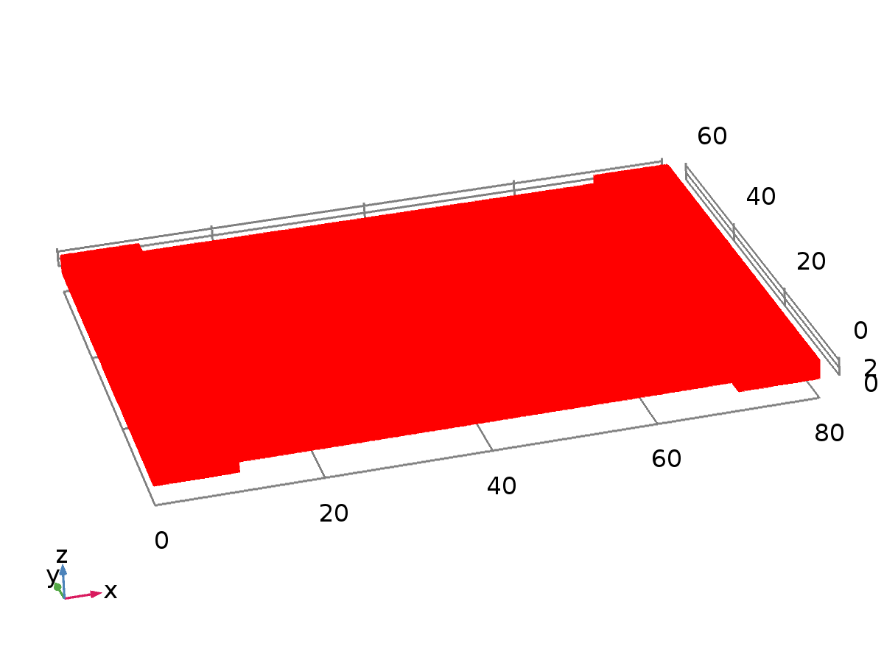

Data set: Study 1/Solution 1

* + 1. Study 1/Parametric Solutions 1

Solution

| **Description** | **Value** |
| --- | --- |
| Solution | Parametric Solutions 1 |
| Component | Save Point Geometry 1 |



Data set: Study 1/Parametric Solutions 1

* 1. Plot Groups
     1. Stress (solid)

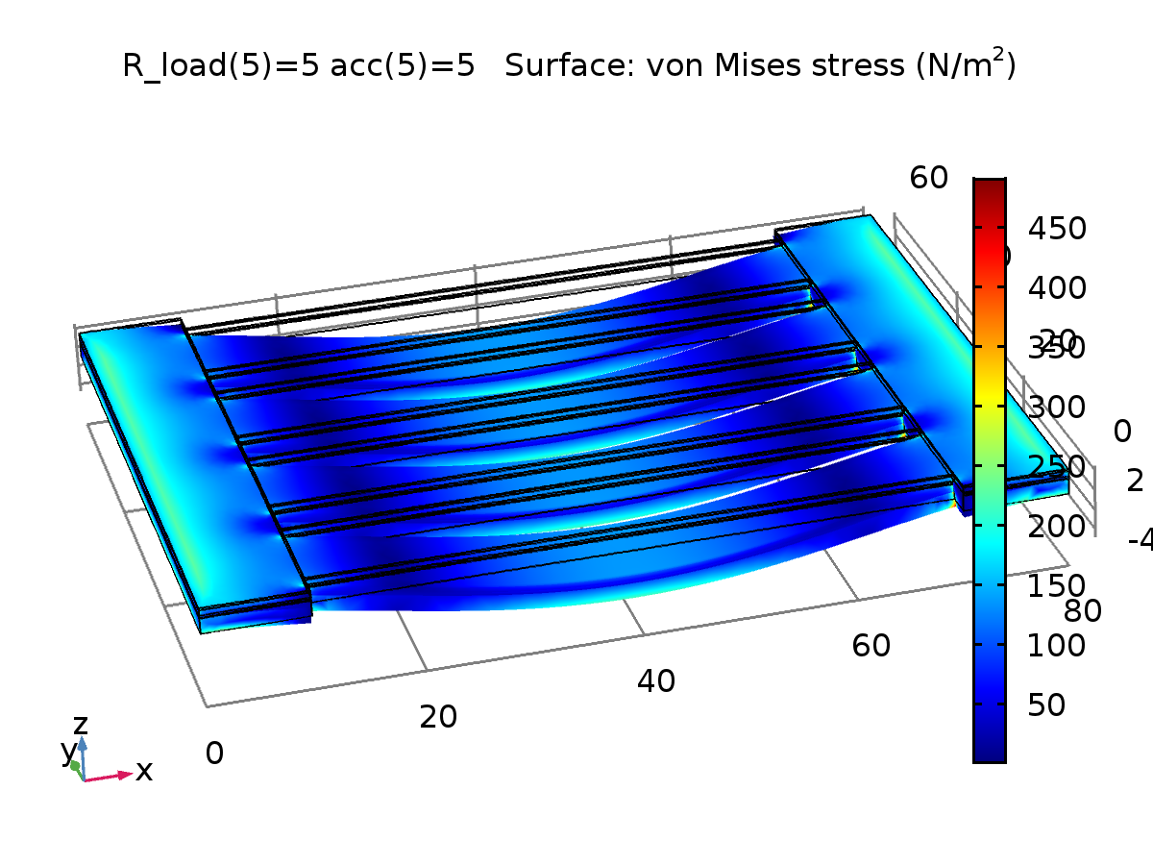

R_load(5)=5 acc(5)=5 Surface: von Mises stress (N/m2)

* + 1. Electric Potential (es)

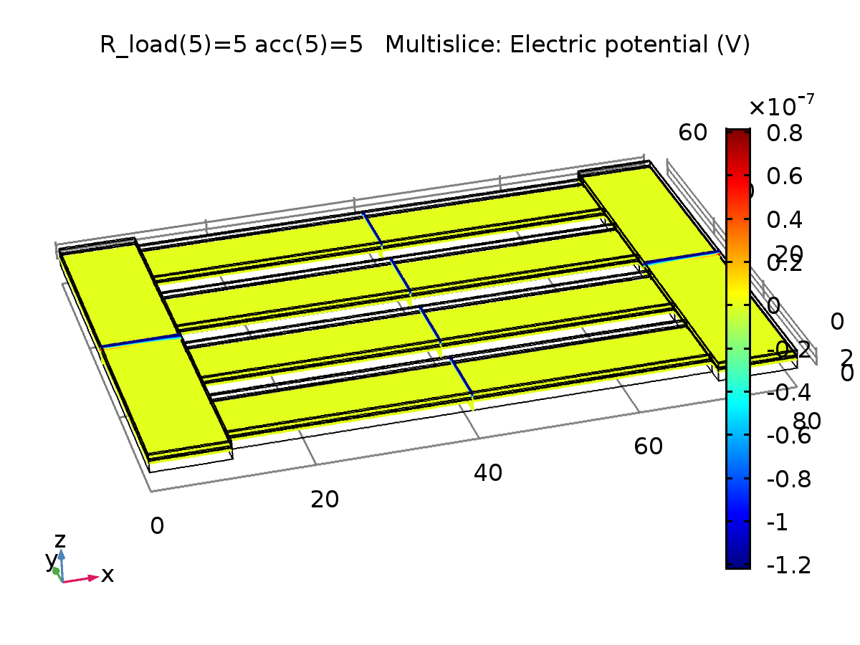

R_load(5)=5 acc(5)=5 Multislice: Electric potential (V)

* + 1. Displacement

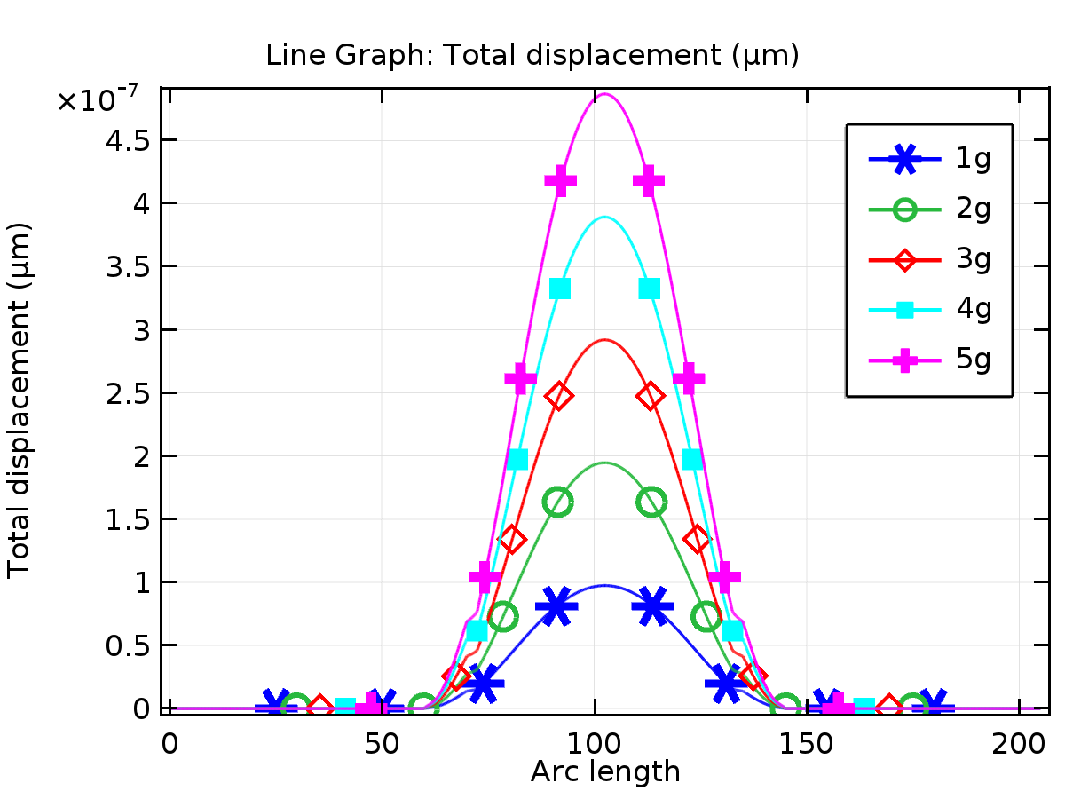

Line Graph: Total displacement (µm)

* + 1. Stress

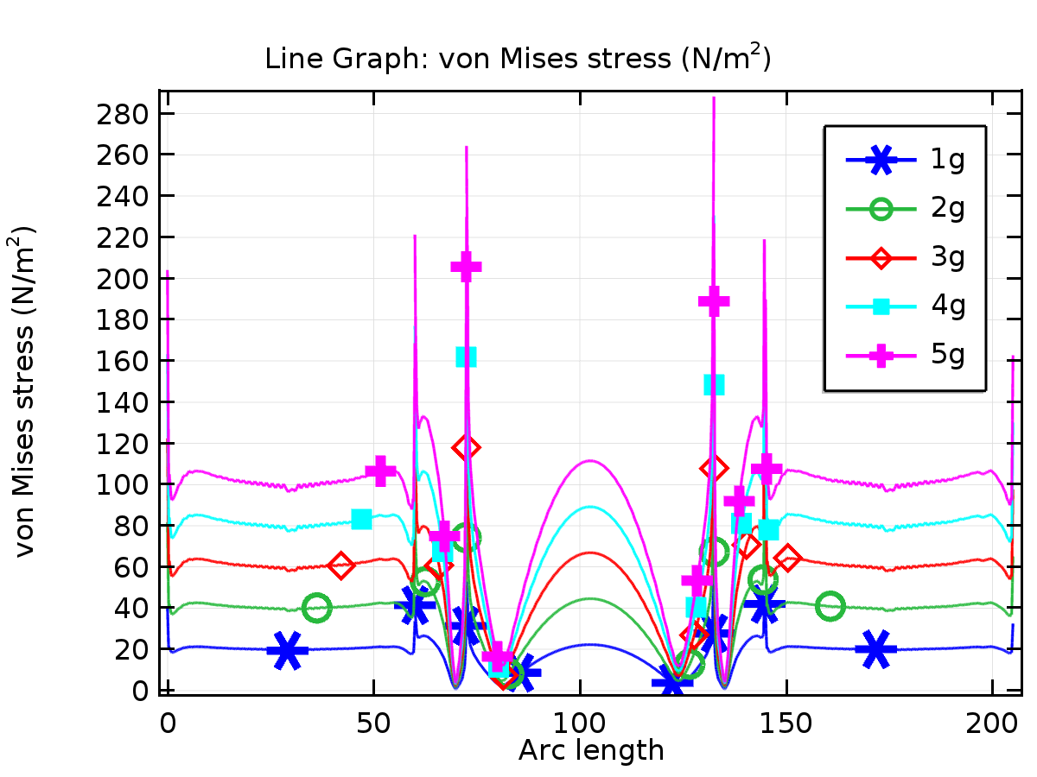

Line Graph: von Mises stress (N/m2)

* + 1. potential

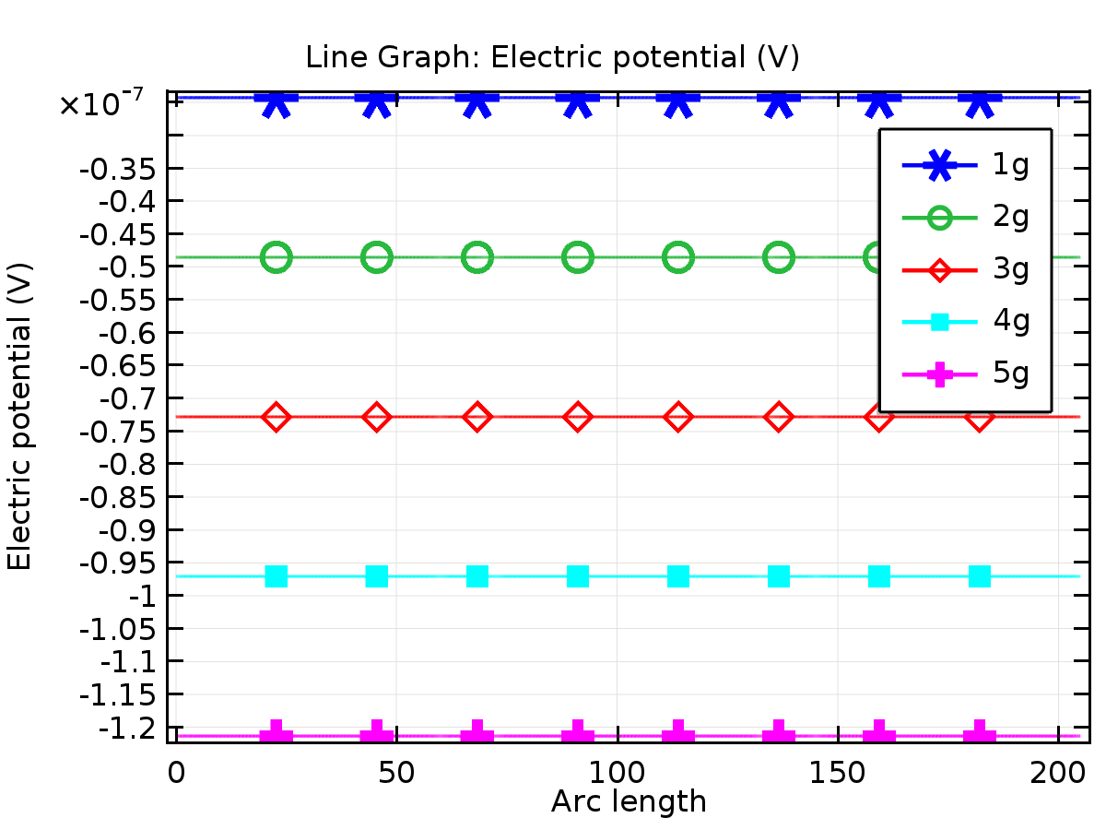

Line Graph: Electric potential (V)

* + 1. energy

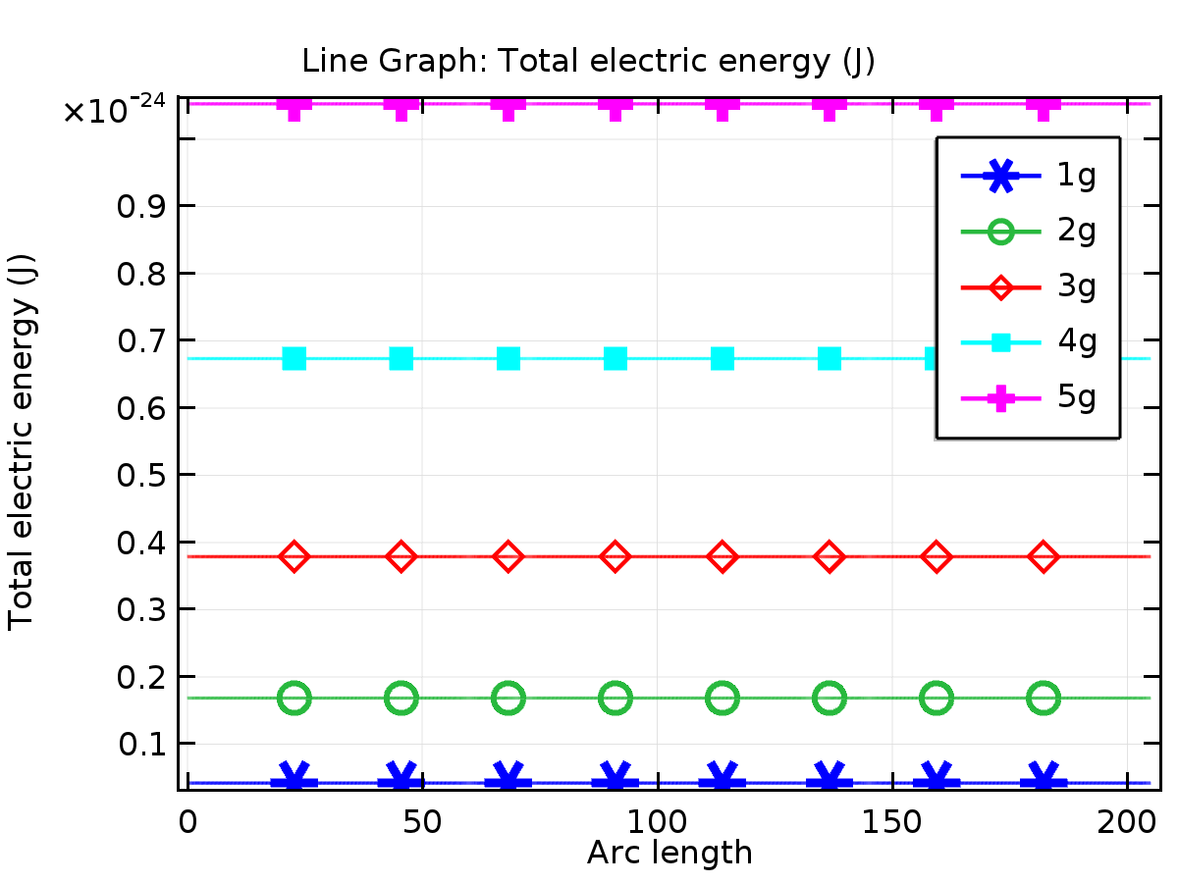

Line Graph: Total electric energy (J)